|  |
| --- |
| STATEMENT OF WORK |
| Service de Cardiologie  Hôpitaux Universitaires de Genève |
|  |
|  |
|  |





Contents

Executive Summary 3

Functional Requirements 4

Design Requirements 5

Internet Business Solution Navigational Site map 6

WSI Digital Marketing System - Support Services 8

WSI Project Updates and Communications 9

WSI & Client Deliverables 10

Project Timeline 11

# Executive Summary

WSI is a company whose entire mission is based on the concept: “We Simplify the Internet.”

WSI’s philosophy is driven by the desire to offer effective internet marketing solutions in our marketplace. We partner with the best developers in the industry to provide the most economical online solutions to our clients. We are committed to improving the profitability of our customers through the use of leading-edge Internet technologies, delivered by knowledgeable and service-oriented staff. As more businesses realize the importance of the Internet to their continued success and growth, WSI is ready to serve their needs with profitable e-business solutions.

The ¬WSI Digital Marketing SystemTM developed for Service de Cardiologie Hôpitaux Universitaires de Genève is designed to maximize your presence online, while keeping a consistent representation of Service de Cardiologie Hôpitaux Universitaires de Genève image and brand.

This Statement of Work highlights the features/functionalities, the deliverables and the timelines involved in the Information Architecture of the WSI Digital Marketing SystemTM.

The project will follow the phased development approach of the WSI Digital Marketing LifecycleTM. Our lifecycle provides processes and deliverables that ensure a clear communication of scope, progress and status during each phase of the project.

At WSI, our goal is to provide leading edge web technologies, build targeted traffic and improve conversion to increase your company’s profitability.

On behalf of the entire WSI team, we thank you for your support and we look forward to building a strong working relationship with Service de Cardiologie Hôpitaux Universitaires de Genève.

Sincerely,

Gabor Markus & Elisa Chédel

24.03.21

# Functional Requirements

WSI will deliver the following features/functionalities for the Internet Business Solution:

| Check off functional requirements to be used in project: | | |
| --- | --- | --- |
| * FAQ * News Announcements * Website Advertising rotation system ok * Comments * Photo gallery * Sitemap * CRM * Site content administration | * Blog * Event bookings * Secure member zones * Forum * External database integration * Web Forms with auto responder | * Email Marketing System * Search Input & Results * Site workflow notifications * External API integrations |
| Other Requirements | | |
| <http://cardiology-geneva.com/>  <https://www.hug.ch/cardiologie#>  Model: <https://www.columbiacardiology.org/>  Template :  <http://medicare.bold-themes.com/cardiology/> | | |

………………………………………… ………… …………………………

Client Signature Date

………………………………………… ………… …………………………

DM Consultant Signature Date

# Design Requirements

WSI will create and apply the website design for the Internet Business Solution:

| Website Design provided by: | WSI Consultant |
| --- | --- |
| Website layout has been agreed upon | No |
| Website colors have been agreed upon | Yes or No |
| Website images have been agreed upon | Yes or No |

The client hereby understands and accepts that the WSI consultant will produce concept designs to demonstrate the final design of the website. It is the client’s responsibility to review the website design concept and produce a descriptive change order of items to be changed within the website design, should it be required.

The WSI consultant will make a total of 3 concept design changes after which the client will be then responsible for any additional time added to the project and/or additional costs.

………………………………………… ………… …………………………

Client Signature Date

………………………………………… ………… …………………………

IM Consultant Signature Date

# Internet Business Solution Navigational Sitemap

WSI will create and build the website for HUG Service de Cardiologie based on the proposed site map and wireframe

1. Sitemap

Available : <https://miro.com/app/board/o9J_lPNaF98=/>

1. Navigation

Logo / À propos / Patients / Formation / Recherche

**Wireframe design**

# Header:

Contact us (+address + emergency service), book an appointment, donate, search

Navigation: Logo / About us/ Patients / Training / Research

Button 1: “Contact us” → contact form, send to info@cardiologie-universitaire-geneve.ch

Button 2: “Trainings” → redirect to page “Training for doctors”

Button 3: “Donate” → redirect to the page “Donations and support”

Button 4: “Research” → redirect to page “Research”

Search button

# 2. Footer:

About us, training, research, contact us, address, legal notice, social medias (Facebook)



# Home page

Mockup: https://cardiologygeneva.viewmysitenow.com/concept/02/index.htmll

1. Carrousel:



Subject 1: **About us**

* Image:

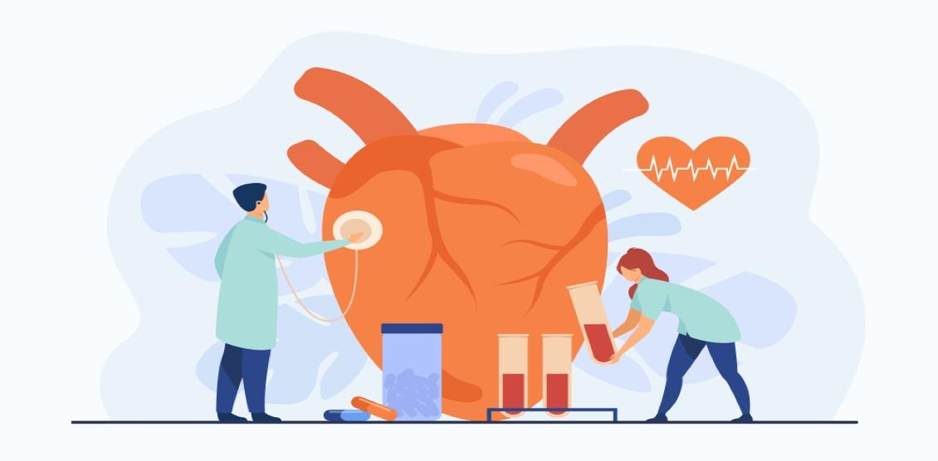

* Header : « Your health is the heart of our work »
* Small text:

« The cardiology division ensures the optimal care of adult patients suffering from cardiovascular disease in a setting where high skills meet cutting-edge care and technology.»

button 1: “more informations” dirigeant à la page “About us”, button 2: “Your symptoms” dirigeant à la page “symptoms”

Subject 2: **Typical patients**

* Image:



* Text:

«The clinical purpose is at the center of the activity of our service. The cardiology department takes care of a wide range of patients, from outpatient to hospitalization.»

button 1 :“Discover our typical patients” dirigeant à la page “patients”, button 2: “doctors directory” dirigeant à la page “doctors directory”

Subject 3: **Training**

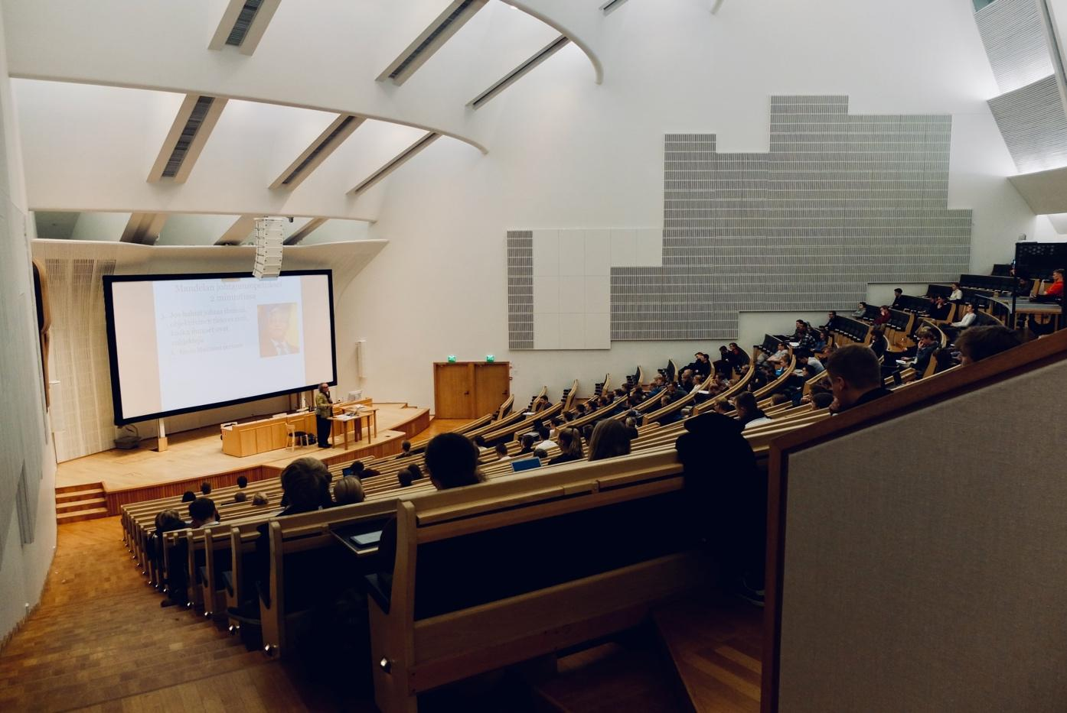

* Text:

« Our academic and university connection allows us to offer high-level pre- and post-graduate education, particularly aimed at the medical community around Lake Geneva.»

button 1: “Discover our trainings” dirigeant à la page “trainings”, button 2 :“Symposiums agenda” dirigeant à la page “symposiums”

Subject 4: **Research**,



* Text:

« Within the cardiology department, several groups carry out clinical and / or fundamental research activities covering different areas of cardiovascular disease ranging from arteries to devices.»

button 1 :“Discover our last publications” dirigeant à la page publications, button 2 “Researchers directory” dirigeant à la page “researchers directory”

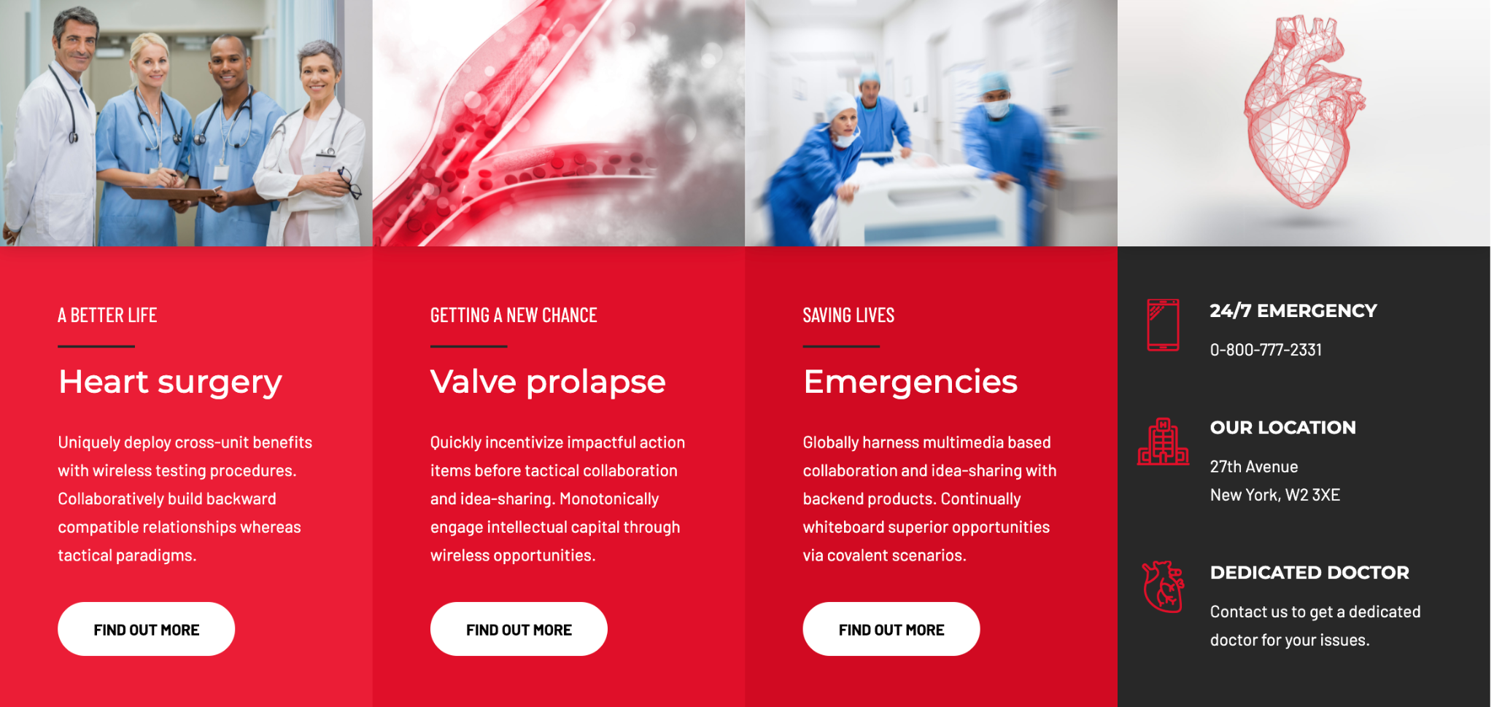Column 1:

* Header: “Patients”
* Button “Check” redirect to page “Patients”
* Image:

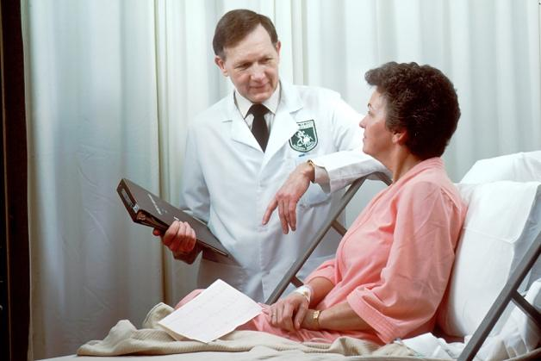

* Text

« Our typical patients, our activities, symptoms and treatments guide, find your doctor»

Column 2

* Header: “Training”
* Button “Explore” redirect to page “Training”
* Image



* Text

« Colloquiums, conferences and presentations. Continuing education, for pre and post-graduates»

Column 3

* Header: “Research”
* Button: “Discover” redirect to page “Research”
* Image:



* Text:

«Clinical or fundamental studies, researchers and publications »

Column 4

* Header 1: Emergency phone number
* Text 1: 144
* Header 2: Address
* Text 2: Rue Gabrielle-Perret-Gentil 4, 1205 Genève
* Button “Doctors directory”
* Image:

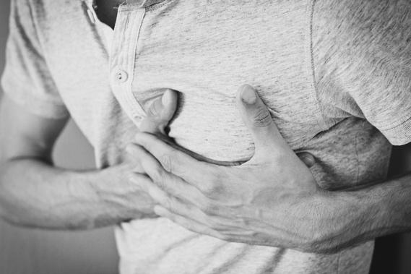

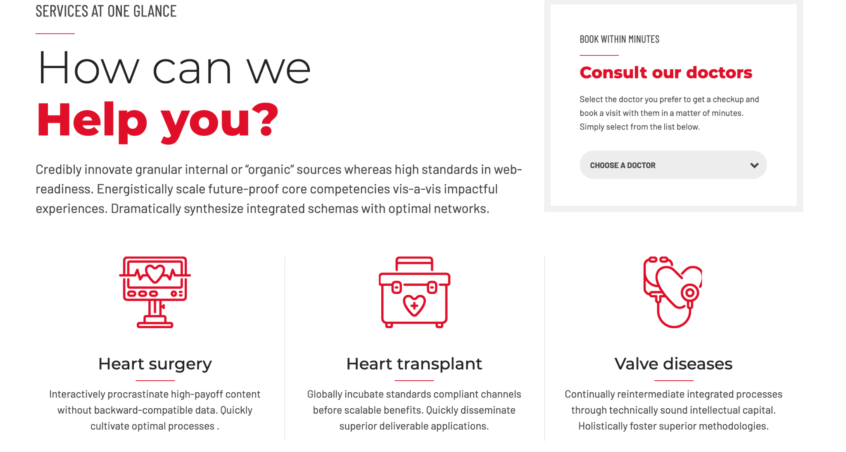

How can we help you → “The cardiology division”

Text: « The cardiology department consists of several specialized units and additional areas of specialized activities. It also has its own outpatient clinic and offers a complete rehabilitation program.»

Consult our doctors → “See our specialized activities” . Choose a doctor → “Choose”

* Pictogramme 1: 
* Title 1: Cardiogeriatric activity
* Description 1: « The cardio-geriatric consultation offers multidisciplinary care within the internal medicine and rehabilitation service, in connection with all the specialties of the Cardiology service. »
* Redirection: <https://www.hug.ch/cardiologie/cardiogeriatrie>
* Pictogramme 2: 
* Title 2: Preventive cardiology activity
* Description 2: « We offer cardiovascular risk advice, principally in primary prevention but also, for optimization, in secondary prevention, typically in the context of a family history with early infarction or cholesterol or arterial hypertension problem, as part of a multi-disciplinary approach.»
* Redirection:

Preventive cardiology (cardiovascular risk, cholesterol, hypertension, INR at the fingertip)

cardiopreventive@hcuge.ch

secretary: Ms. Lizana: +41 (0) 22 37 27 207

nurse: Mme Guillermet: +41 (0) 79 55 35 508

doctors: Prof. Georg Ehret, Prof. François Mach, Dr Elena Tessitore, Dr Baris Gencer

Preventive cardiology assesses and advises on cardiovascular risk: the likelihood of suffering from a myocardial infarction, a stroke or an arterial disease of the lower limbs in the future. This risk is largely explained by modifiable factors (blood pressure, cholesterol level, diabetes, tobacco dependence) and non-modifiable (age, heredity, etc.). We are working with different types of imaging to further predict this risk (coronary calcium score, search for vascular plaques).

Among the risk factors, we are particularly interested in the level of lipids in the blood and arterial hypertension which are cardiovascular risk factors with great impact and easy to modify in the majority of our patients. In addition to pharmacological approaches, therapeutic education is also useful to reduce the risk.

* Pictogramme 3: 
* Title 3: “Cardiac MRI activity”
* Description 3: « Cardiac MRI (Magnetic Resonance Imaging) provides a non-invasive assessment of myocardial anatomy, function and perfusion as well as the sequelae of heart attacks and structural abnormalities. These examinations are carried out in collaboration with the radiology department.»
* Redirection: <https://www.hug.ch/cardiologie/irm-cardiaque>
* Pictogramme 4: 
* Title 4: Cardiovascular rehabilitation programs
* Description 4: «Cardiovascular rehabilitation is an effective treatment for people who have heart failure or had a recent cardiac event (myocardial infarction, coronary angioplasty, cardiac surgery, etc.).»
* Redirection: <https://www.hug.ch/cardiologie/programme-de-readaptation-cardiaque>
* Pictogramme 5: 
* Title 5: Interventional cardiology unit
* Text 5: « The Interventional Cardiology Unit of the Department offers a wide range of cardiac and non-cardiac endovascular services.»
* Redirection: <https://www.hug.ch/cardiologie/cardiologie-interventionnelle>
* Pictogramme 6: 
* Title 6: Nuclear Cardiology Unit
* Description 6: « Nuclear medicine makes it possible to assess the suffering of the heart muscle as well as the sequelae of a heart attack.»
* Redirection: <https://www.hug.ch/cardiologie/cardiologie-nucleaire>
* Pictogramme 7: 
* Title 7: Structural Cardiology Unit
* Description 7: « The Structural Cardiology Unit specializes in the management of patients with heart conditions unrelated to atherosclerosis, such as valve disease or congenital pathologies in adulthood.»
* Redirection: <https://www.hug.ch/cardiologie/unite-cardiologie-structurelle>
* Pictogramme 8: 
* Title 8: Echocardiography unit
* Description 8: «Echocardiography is a technique that uses ultrasound to explore the structures of the heart, their movements and the different blood flows in the chambers of the heart.
* The basic examination is a transthoracic echocardiography performed by a sensor placed on the chest.»
* Redirection: <https://www.hug.ch/cardiologie/echocardiographie>
* Pictogramme 9: 
* Title 9: Electrophysiology unit
* Description 9: «The electrophysiology unit treats inpatients and outpatients with cardiac arrhythmias.»
* Redirection: <https://www.hug.ch/cardiologie/rythmologie-et-electrophysiologie>
* Pictogramme 10: 
* Title 10: Acute heart failure unit
* Description 10: «
* The Acute Heart Failure Unit takes care of patients with advanced heart failure with all therapeutic means ranging from medication to device. »
* Redirection:

Acute heart failure unit

secretary: Ms. Brugger: +41 (0) 22 37 29 565

nurses: Mrs ARTIGE: +41 79 55 34 717

doctors: Dr P. Meyer CC, Dr A. Testuz, Dr N. Poku

The Acute Heart Failure Unit takes care of patients with weak heart function and supports these patients with innovative treatment modalities. The HUG team has all the means at its disposal, from pharmacotherapy to heart transplantation.

* Pictogramme 11: 
* Title 11: Cardiac stimulation unit
* Description 11: « The stimulating unit supports hospitalized and ambulatory patients who require cardiac stimulation by a pacemaker or defibrillator.»
* Redirection:

Stimulation unit

secretary : Ms Béatrice GARAIX 022 37 27 210

doctors : Pr H. Burri, Dr E Bakelants

The cardiac stimulation unit takes care of patients with pacemakers and cardiac defibrillators. We are a reference center for difficult cases in particular (extraction of probes, stimulation of the His bundle and others). Prof. H. Burri is an international expert with an important role in the Swiss and European cardiological society.

[esc365.escardio.org/Person/4016-prof-burri-haran](http://esc365.escardio.org/Person/4016-prof-burri-haran)

* Pictogramme 12: 
* Title 12: Therapeutic education activity
* Description 12:  «The Cardiology Department at HUG has set up a Therapeutic Patient Education Team (PET). Their activities relate to secondary prevention and cardiovascular rehabilitation programs for patients attending two poles: Preventive Cardiology and Secondary Prevention.»
* Redirection:

secretary Ms. Zellweger: + 41 (0) 22 37 27 214

nurses

Ms. A. Bevand: +41 (0) 79 55 34 065

Mrs. E. Guillermet: +41 (0) 79 55 35 508

doctor Dr F. Sittarame

The Cardiology Department of the HUG has set up a therapeutic patient education team (PET) with the support of the GECOR foundation. Their activities concern patients attending two poles: Preventive Cardiology and Secondary Prevention. Dr Frédéric Sittarame, specializing in therapeutic education, supported at 50% by the GECOR foundation, coordinates and leads the PET activities of secondary prevention and cardiovascular rehabilitation programs which combine technical learning, theoretical knowledge, cultural and artistic activities. The latter component is the subject of a MEG-HUG partnership agreement which aims to implement art and culture as an essential complement to supporting patients in their care.



* Pictogramme 13: 
* Title 13: Congenital heart disease activity
* Description 13: « Any patient with a cardiac birth defect requires follow-up that is offered to patients. This follow-up includes ultrasound imaging and cardiac MRI.»
* Redirection:

Redirection:

Congenital heart disease activity

Secretary: Ms Brugger: +41 (0) 22 37 29 565

Nurses: Mme ARTIGE: +41 79 55 34 717

Doctors: Dr J. Bouchardy, Dr C. Blanche

Any patient with a cardiac birth defect requires follow-up that is offered to patients. This follow-up includes ultrasound imaging and cardiac MRI.

* Pictogramme 14: 
* Title 14: Cardio-oncology activity
* Description 14: « We advise and treat any patient with a vascular or cardiac risk or abnormality in connection with an oncological treatment.»
* Redirection:

Cardio-oncology activity

Secretary: Ms Brugger: +41 (0) 22 37 29 565

Doctor: Dr N. Poku

We advise and treat any patient with a vascular or cardiac risk or abnormality in connection with an oncological treatment.

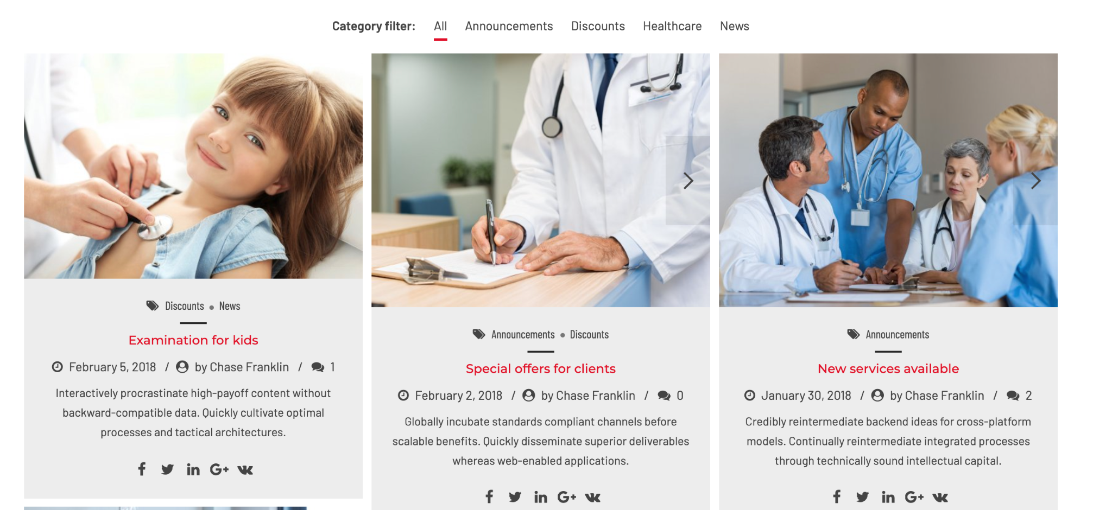

Add title above: “Symposiums”

Column 1:

* Title: LDL-cholesterol, the silence age
* Date: 27.05.2021
* “by chase franklin”: Prof François Mach
* Text: « Inclisiran is a new small, synthetic interfering ribonucleic acid that lowers circulating LDL-C levels by using RNA silencing technology to reduce PCSK9 production. Administered subcutaneously at 0 and 3 months, then every 6 months, inclisiran has been shown to reduce LDL-C by approximately 50% in patients at high and very high cardiovascular risk or with a diagnosis of 'familial hypercholesterolemia, but also in statin intolerant patients. New data are awaited, in particular on cardiovascular clinical outcomes, as well as the safety of use in adolescents.»
* Image

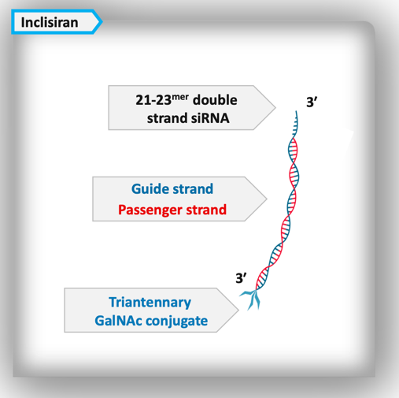

Column 2:

* Title: On-Pump vs Off-Pump Coronary Artery Bypass Grafting
* Date: 20.05.2021
* “by chase franklin”: Dr Cikirilkcioglu
* Text: « “Off-pump CABG” is CABG performed without the use of a heart-lung machine (cardiopulmonary bypass). This means the heart continues to provide blood to the rest of the body during the surgery. In off-pump CABG, the area around the blocked coronary artery is stabilized while the surgeon grafts the blood vessel on the ”beating” heart. In “on-pump CABG”, the heart is stopped with the body's blood supply being maintained by the cardio-pulmonary bypass (CPB) machine.»
* Image

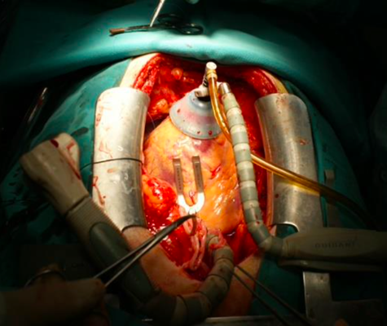

Column 3:

* Title: Cardiovascular rehabilitation
* Date: 15.04.2021
* “by chase franklin”: Dre Tessitore
* Text: «
* “Cardiovascular rehabilitation comprises a set of activities favorably influencing the evolutionary process of the disease; it brings patients better physical, mental and social condition. Thus and by their own efforts, they preserve or resume as normal a place as possible in all areas of their life. Correct secondary prevention strategies can prevent up to 45% of deaths from myocardial infarction. In Switzerland, it is considered that 50% of eligible patients participate in a post-infarction rehabilitation program (75% at HUG)»
* Image

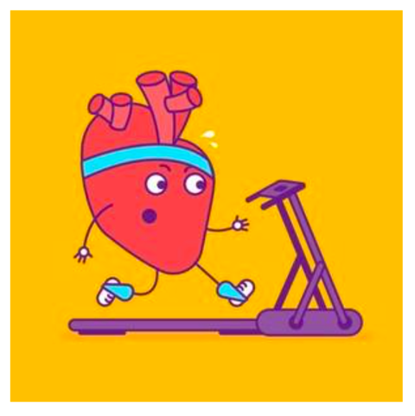



Medicare updates → “News“

Column 1:

Title: An alternative for resistant hypertension

Text: “In the event of drug treatment inefficiency, an interventional approach targeting the innervation of the kidneys may be offered.»

Button “Read” → direction: https://pulsations.hug.ch/article/une-alternative-pour-les-hypertensions-resistantes

Column 2:

Title: Something new to relieve angina pectoris

Text: Unprecedented in French-speaking Switzerland, the operation that took place at the end of March at the HUG in a patient with a severe form of angina pectoris could change the lives of many other patients.

Button “Read” → direction: https://pulsations.hug.ch/article/du-nouveau-pour-soulager-langine-de-poitrine

Column 3:

Title: Limit cardiovascular risk

Text: The Cardiology Department, in partnership with other specialties, relies heavily on prevention for effective management of people at high cardiovascular risk.

Button “Read” → direction:

https://pulsations.hug.ch/article/limiter-les-risques-cardiovasculaires

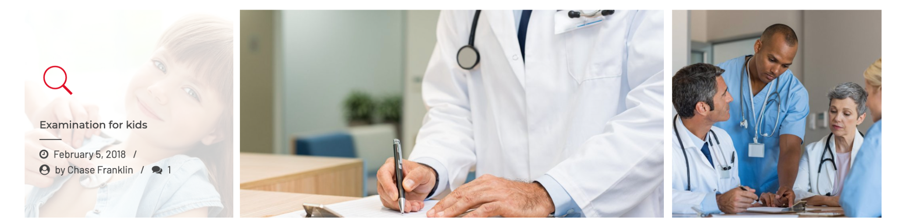

* Put title above: “Research”



* We have some good news → “Suscribe to our newsletter”
* Type in your email adress → “Type in your email adress”
* Subscribe → “Subscribe”
* Send to : info@cardiologie-universitaire-geneve.ch
* Image:



**B. À Propos**

Mockup: https://cardiologygeneva.viewmysitenow.com/concept/02/about.html

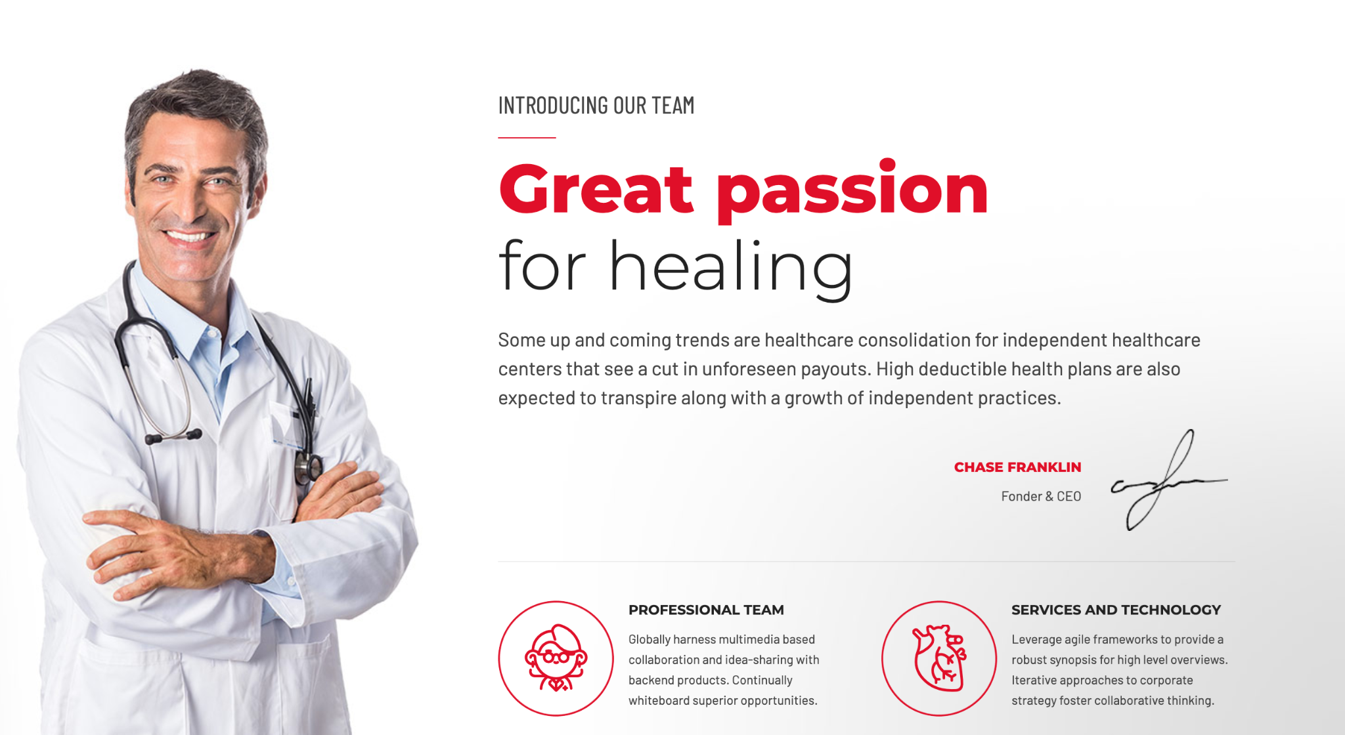

* Great passion for healing → “Your health is the heart of our work”
* Text: We believe in a better way of taking care of your heart. Our multidisciplinary center of excellence is made up of thousands of specialists providing you with personalized support, 24/7, with the advantages of a service of public interest.
* Button 1 “The GEcor Foundation” redirect to page “GEcor Foundation”, button 2: “Donate” redirect to page “Donations and support”
* Image

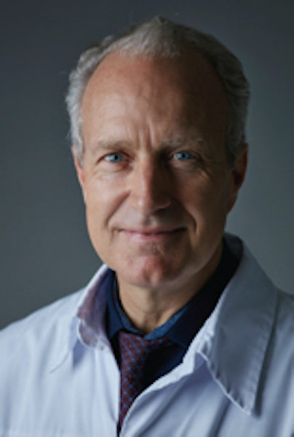

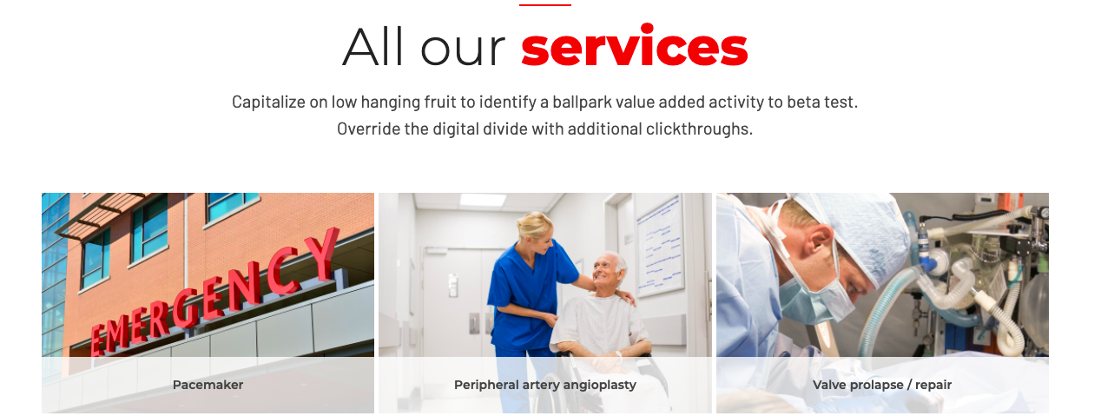

All our services → “Our areas of activity”: random display of three out of the 12 services

Image 1:

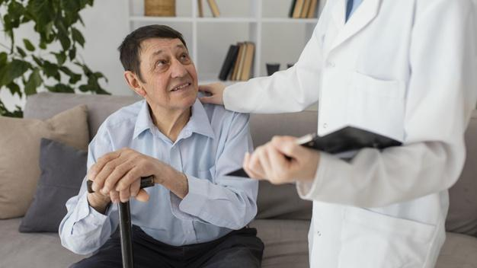

Text 1: Cardio-Geriatrics

Image 2:

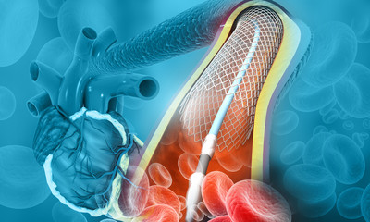

Text 2: Interventional cardiology

Image 3:

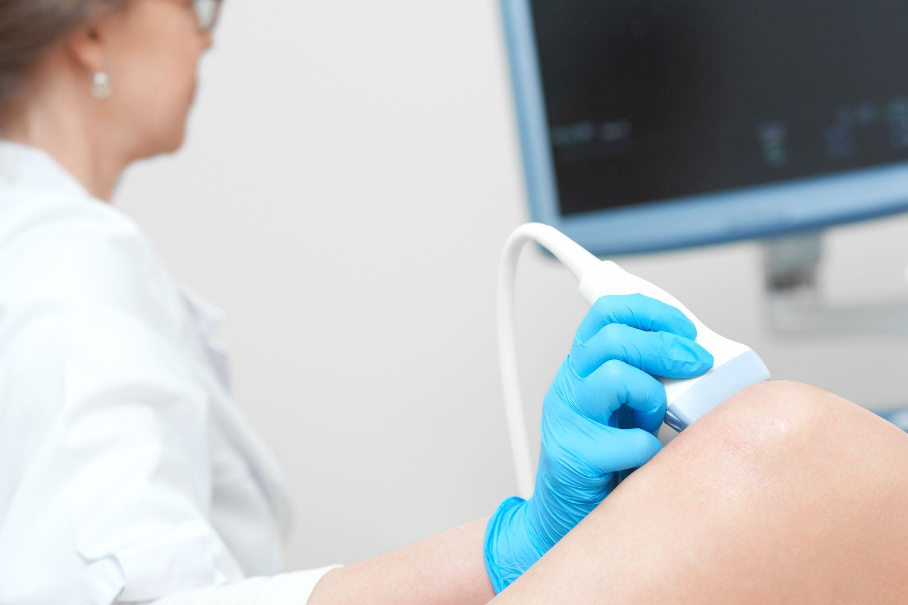

Text 3: Echocardiography

Put button below: “see our specialized activities” → Redirection to page “Cardiology service”

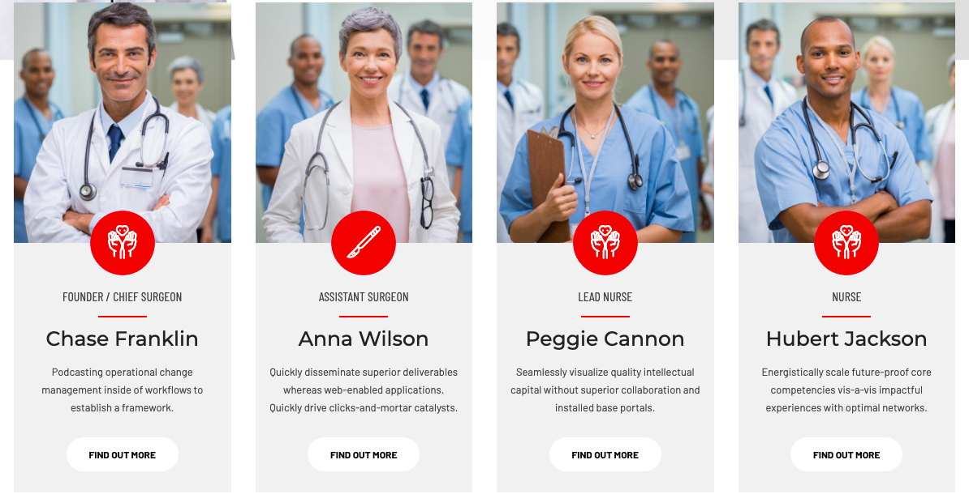

Put a header above: “The physicians”

Column 1:

Image:

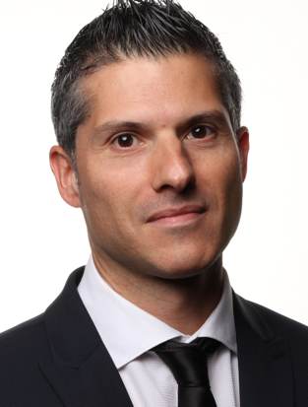

Text:

PD Dr Juan F. Iglesias MD, FESC, FACC

Médecin Adjoint agrégé

Interventional Cardiology Unit

Cardiology service

Linkedin button (juan-f-iglesias-760b1aa2)

Twitter button (@JuanFIglesias1)

Column 2:

Image:

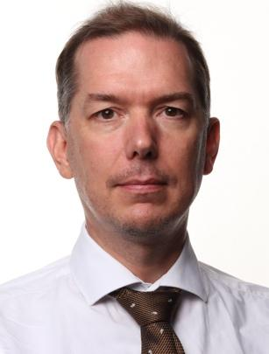

Text:

Pr Georg Ehret

Preventive cardiology, respondent in cardio-geriatrics

Cardiology service activities at Trois-Chêne hospital

Linkedin button (georg-b-ehret-4b965635 )

Twitter button (@georgehret)

Column 3:

Image:

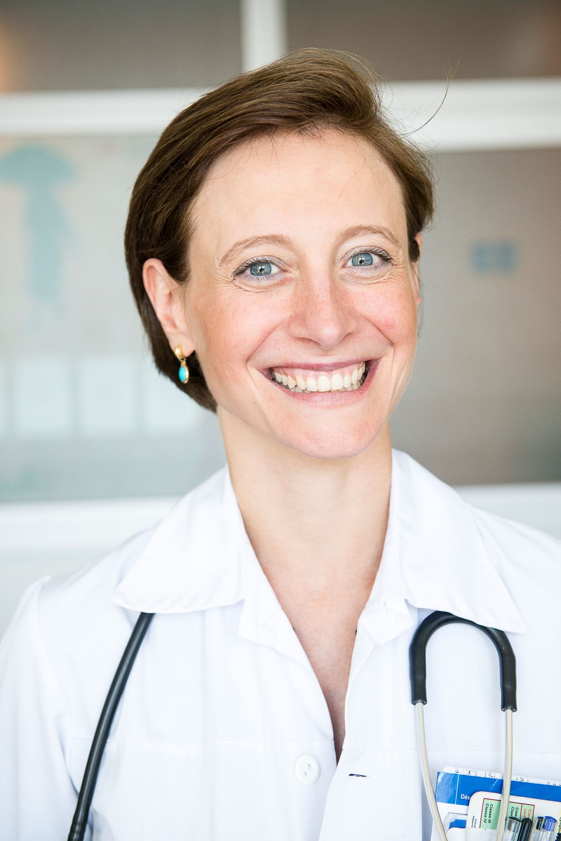

Text:

Dre Elena Tessitore

Cheffe de Clinique

Cardio-gériatrics

Cardiology service activities at Trois-Chêne hospital

Column 4:

Image:



Text:

Pr François Mach

Médecin-chef de service

Cardiology

Add button below: “See all physicians” → Redirect to page “Doctors directory”

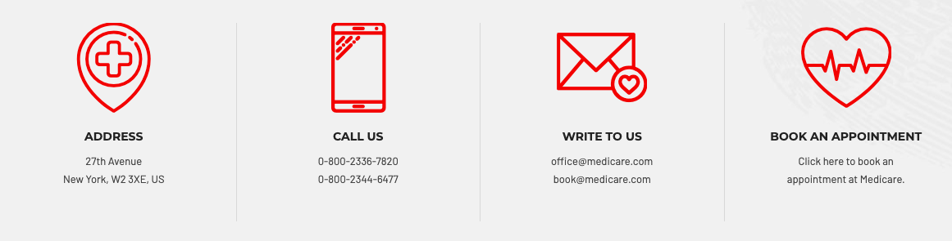

* Address → “Adress”
* Text: “Rue Gabrielle-Perret-Gentil 4, 1205 Genève”
* Call us → “Call us”
* Text: “+41 (0) 22 372 72 00”
* Book an appointment → “Book an appointment”
* Text: “Click to Book an appointment”

**B1. Donations and support**

Mockup: https://cardiologygeneva.viewmysitenow.com/concept/02/donation.html



* Heart transplant → “Our donors”
* Text: «The activities of the cardiology service of the Geneva University Hospitals are supported in particular by:

b.

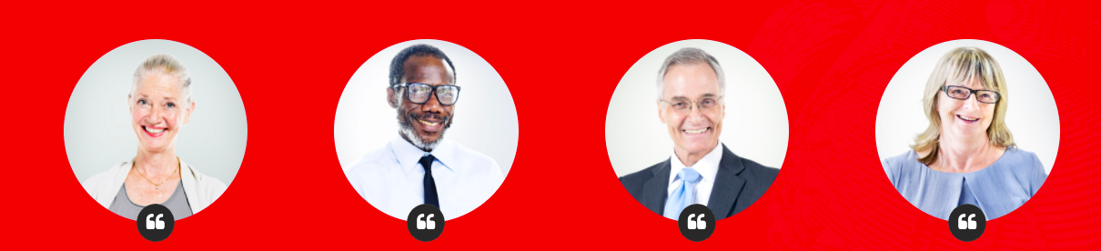

* Put all these names below the circles:

Swiss National Science Foundation

Fondation Suisse de Cardiologie

Fondation Carlos et Elsie de Reuter

Fondation Helmut Horten

Fondation Ernst et Lucie Schmidheiny

Fondation Novartis

Fondation Roche

Fondation Gustave Prévot

Fondation Sir Jules Thorn

Guidant

Medtronic

Johnson & Johnson

Biotronik

Pfizer

Vitatron

Ela Medical

MSD

Servier

Glaxosmithkline

Bristol Myers Squibb

Ecosol

AstraZeneca

Quintiles

Boehringer Ingelheim

Ivantec

Hamilton Health Sciences

Roche

Philips

Merck

Eli Lilly

St Jude

Mepha Pharma

AC Atrium Concept SA

Bakken Research

Sankyo

Menarini

Takeda Pharma

Abbott

Bracco Suisse

* For those in the list who have a logo, please add it instead of the people’s face in the template. You can find the logos in this folder:

<https://drive.google.com/drive/u/0/folders/1jxg-XAKdjQtGgF40VQVMYP5bQMNP50mg>

* If no logo, leave blank
* Also remove the  **“** .
* Add this text below:

“And all the anonymous donors whom we warmly thank.”

“To participate in the support of the GEcor foundation:

… contact details … "

c.

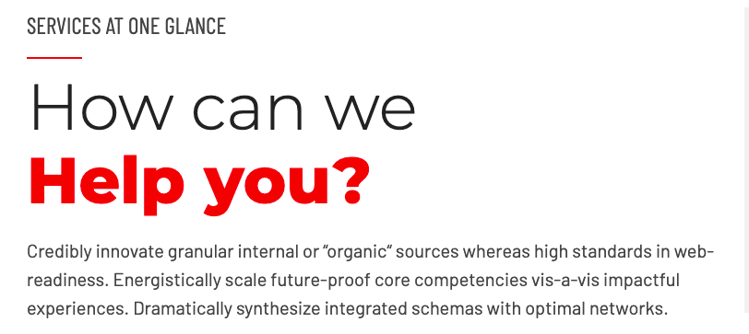

* How can we help you? → “Support the GEcor foundation”,
* Text: **«**The Cardiology Division conducts and participates in numerous clinical and fundamental research studies made possible by research nurses and laboratory staff. It is thanks to the support of generous donors that this research can fund important projects.»

D.

Add text: “Donate”

Add this form:

My details:

Last name:

First name:

Email address:

I donate:

Other:

Total:

I pay using:

money transfer

payment form

My message

Will be transmitted to HUG people, signed with your name

My address

Required for the shipping of your donation tax certificate

Address

City

Postal code

Country

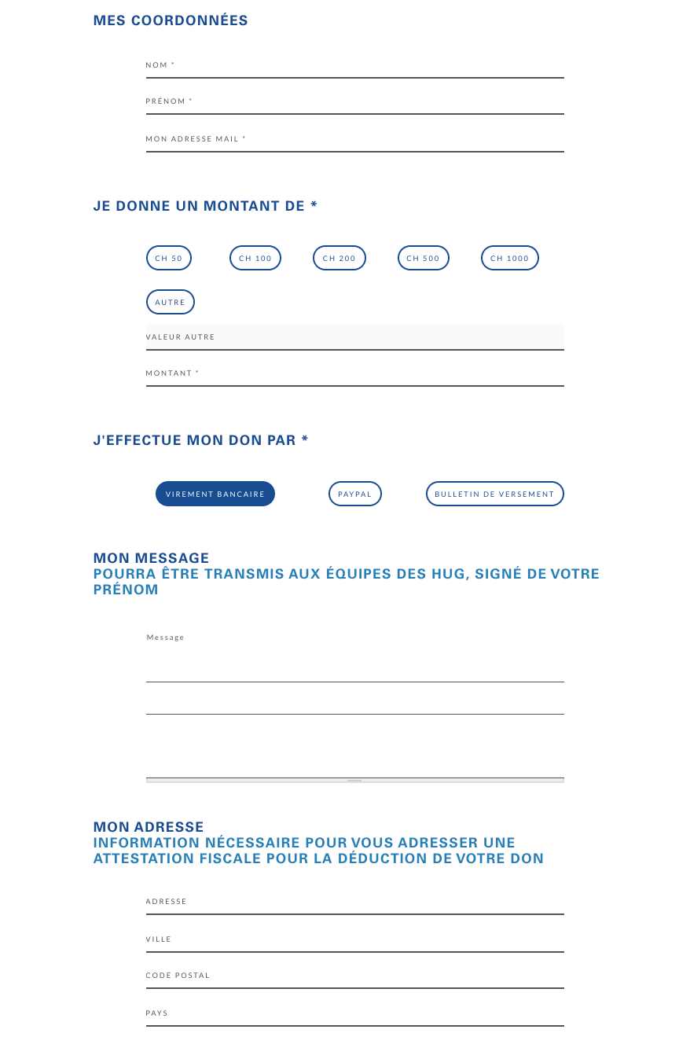

At the end of the form, put button “Faire un don”

PS: once the form has been completed, one mail should be sent to GEcor, and one mail to the user.

* Add button “Know more about us” et redirection vers la page “GEcor Foundation”

**B2. GEcor Foundation**

1. Heart transplant → “The GEcor Foundation”



1. Great passion for healing → « Geneva foundation for university research in cardiology »

**Text:**

« Active since 2003, the GEcor Foundation aims to encourage research and scientific exchanges in the field of cardiovascular diseases for the benefit of the cardiology service of the University Hospitals of Geneva.».

**Image:**



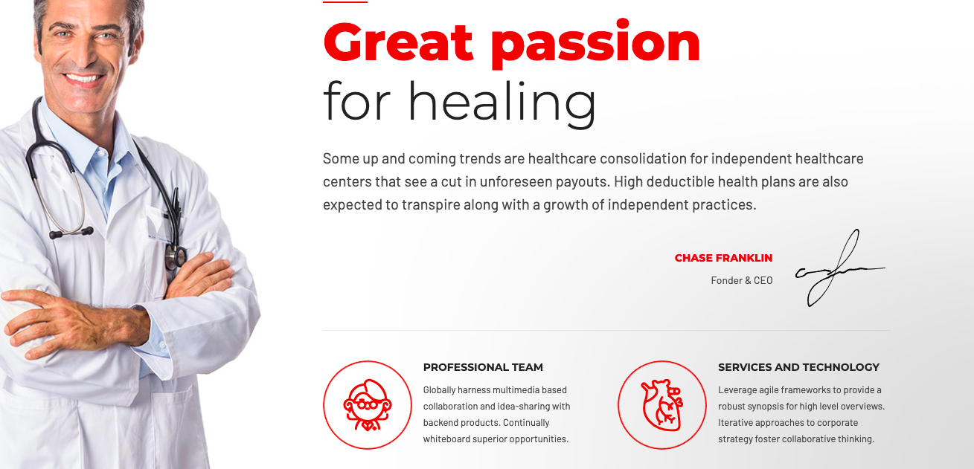

1. Our core-values → **Our core-values**
2. 4 pictograms with the following texts:

* to improve the care at HUG of patients suffering from cardiovascular pathologies



* to support clinical research projects as well as congresses and symposia in Geneva and Switzerland



* to contribute to the training of medical and scientific staff in the cardiology department



* to assist communication between the cardiology department / HUG, practicing physicians and patients. 

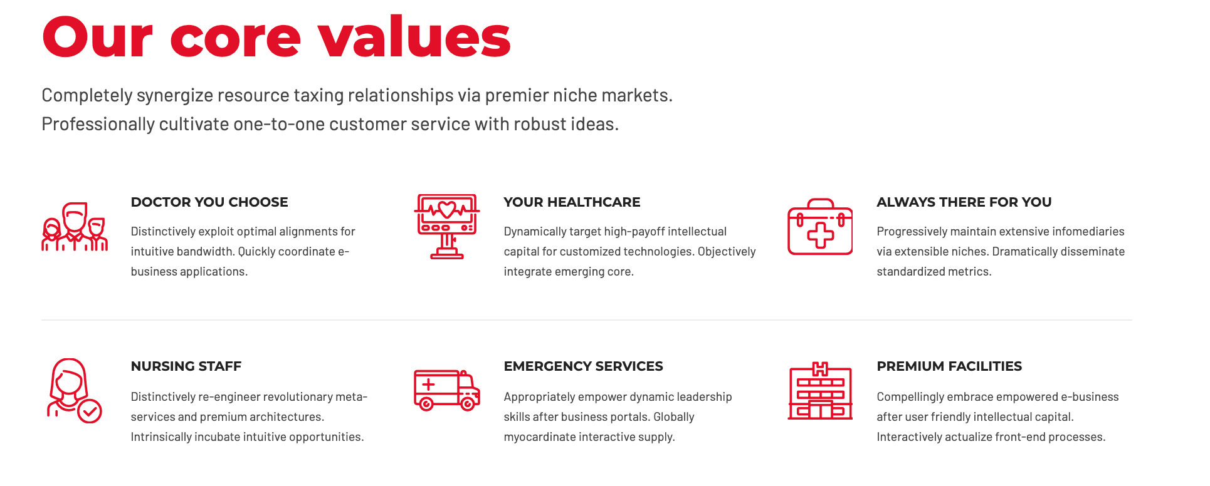

All our services → “Our specilalized activities”: random display of three out of the 11 services

Image 1:



Text 1: Cardio-geriatric

Image 2:



Text 2: Interventional cardiology

Image 3:



Text 3: Echocardiography

Put button below: “see all units and activities” → Redirection to page “Cardiology service”



Put a header above: “The physicians”

→ display 4 doctors’ profiles randomly and add button “voir tous les médecins” with redirection to the page “Doctors directory” 

1. Add button → “Donate to the GEcor foundation” with redirection to page “Donations and support”

**B3. Cardiology service**

1. Heart transplant → “Cardiology service”



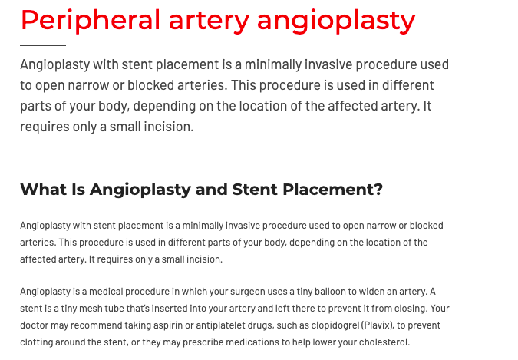

* Peripheral artery angioplasty → “Presentation”

« Led by Professor François Mach, the HUG cardiology service aims for healthcare optimization through multidisciplinary management of cardiovascular conditions. Everything is organized around the patient so that he can benefit from the diagnostic investigations and the treatments he needs in the best conditions and as quickly as possible. »

* What is angioplasty…..→ Our expertise

«The clinical mission is at the center of our service activity. The cardiology department takes care of a wide range of patients, from outpatient to hospitalization. In addition, doctors from the department are called upon to act as consultants for other medical services in the Geneva University Hospitals, especially intensive care and medico-surgical emergencies.

Patient management can be done in inpatient units, but the use of modern technology allows an increasing number of situations to be managed on an outpatient basis.

The cardiology division ensures the optimal care of adult patients suffering from cardiovascular disease in a setting where high skills meet cutting-edge care and technology. It also develops innovative prevention and education strategies to promote health. Its academic and university attachment allows it to offer high-level pre- and post-graduate education, aimed particularly at the medical community around Lake Geneva. Finally, several groups within the cardiology department carry out research activities, mostly clinical but also fundamental, in the field of cardiovascular diseases with a wide coverage going from arteries to devices.»

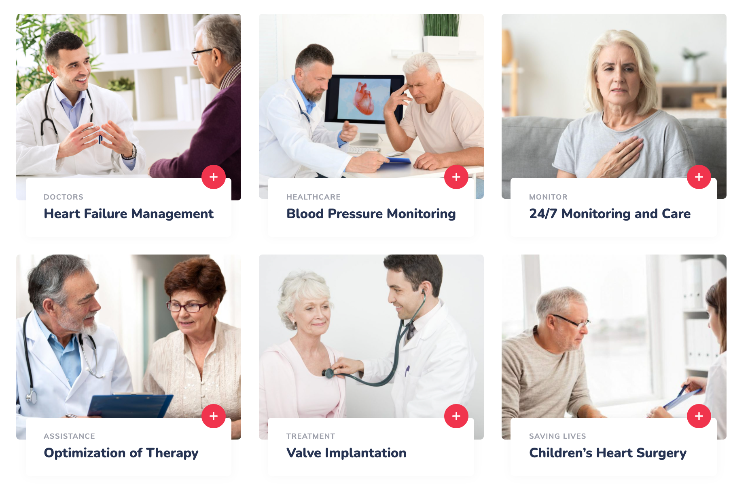

1. Add title above: “Our aeras of activity”
2. Note:

When there is a redirection, the button “+” leads to the page directly

When there is text, the button “+” opens a pop-up box containing the text

* “Cardiogeriatrics activity”

Image:



Redirection:https://www.hug.ch/cardiologie/cardiogeriatrie

* “Preventive cardiology activity”

Image:

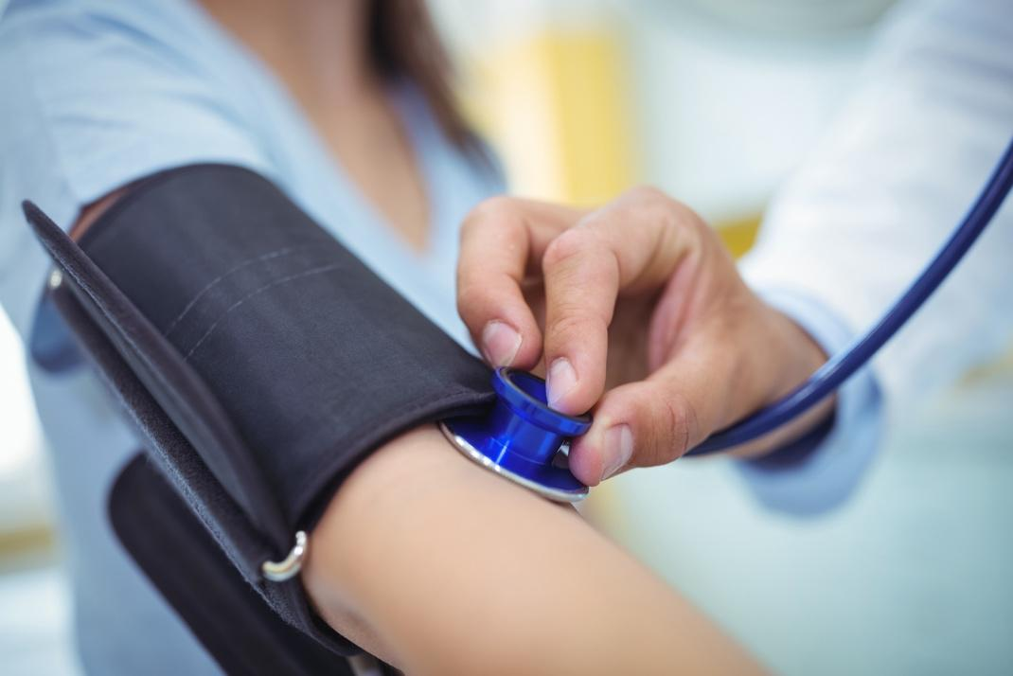

Redirection:

Preventive cardiology (cardiovascular risk, cholesterol, hypertension, INR at the fingertip)

cardiopreventive@hcuge.ch

secretary: Ms. Lizana: +41 (0) 22 37 27 207

nurse: Mme Guillermet: +41 (0) 79 55 35 508

doctors: Prof. Georg Ehret, Prof. François Mach, Dr Elena Tessitore, Dr Baris Gencer

Preventive cardiology assesses and advises on cardiovascular risk: the likelihood of suffering from a myocardial infarction, a stroke or an arterial disease of the lower limbs in the future. This risk is largely explained by modifiable factors (blood pressure, cholesterol level, diabetes, tobacco dependence) and non-modifiable (age, heredity, etc.). We are working with different types of imaging to further predict this risk (coronary calcium score, search for vascular plaques).

Among the risk factors, we are particularly interested in the level of lipids in the blood and arterial hypertension which are cardiovascular risk factors with great impact and easy to modify in the majority of our patients. In addition to pharmacological approaches, therapeutic education is also useful to reduce the risk.

* “Cardiac MRI activity”

Image:

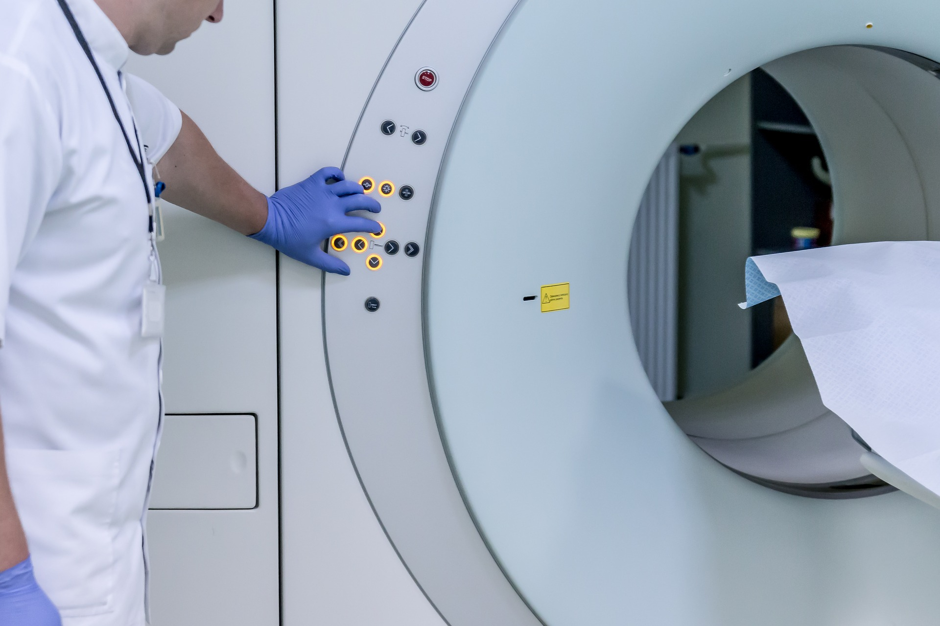

Redirection:https://www.hug.ch/cardiologie/irm-cardiaque

* “Cardiovascular rehabilitation programs”

Image:

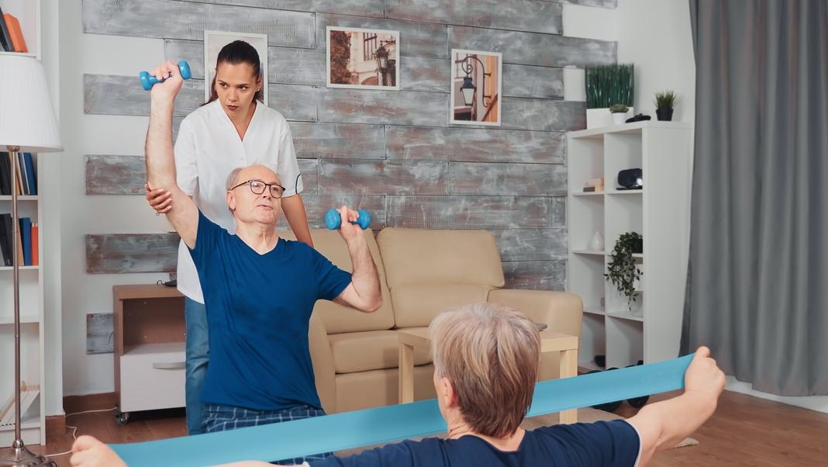

Redirection: <https://www.hug.ch/cardiologie/programme-de-readaptation-cardiaque>

* “Interventional cardiology unit”

Image:

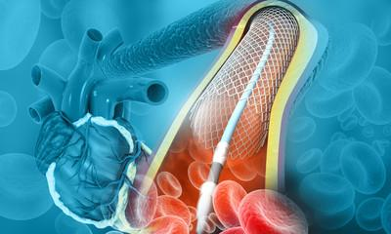

Redirection: https://www.hug.ch/cardiologie/cardiologie-interventionnelle

* “Nuclear Cardiology Unit”

Image:

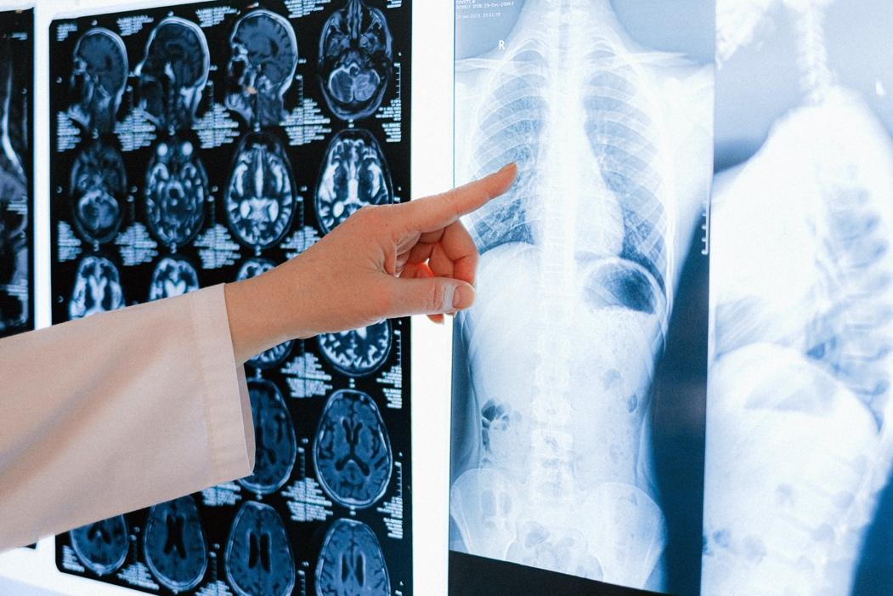

Redirection: https://www.hug.ch/cardiologie/cardiologie-nucleaire

* “S[tructur](https://www.hug.ch/node/25036)al cardiology unit”

Image:

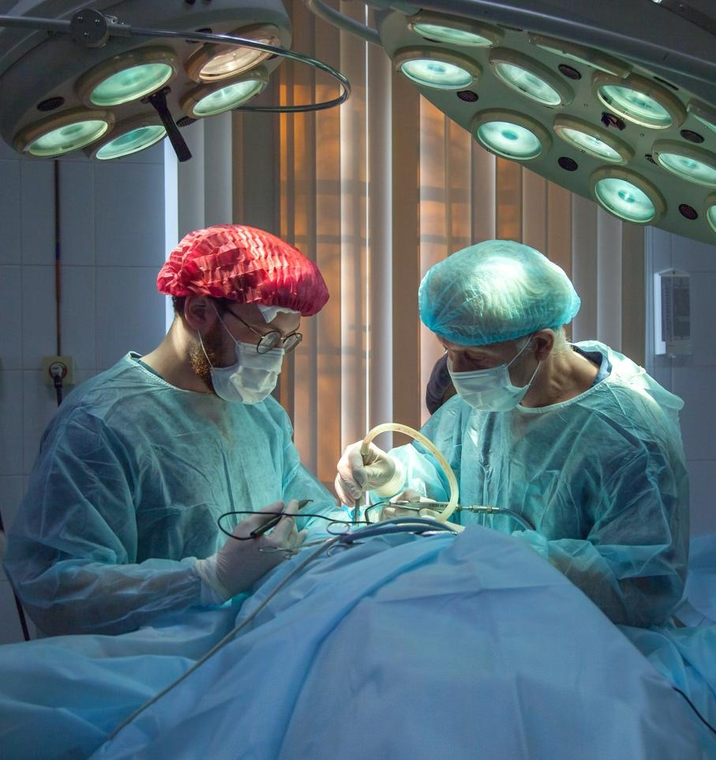

Redirection: https://www.hug.ch/node/25036

* “Echocardiography unit”

Image:



Redirection: https://www.hug.ch/cardiologie/echocardiographie

* “Electrophysiology unit”

Image:

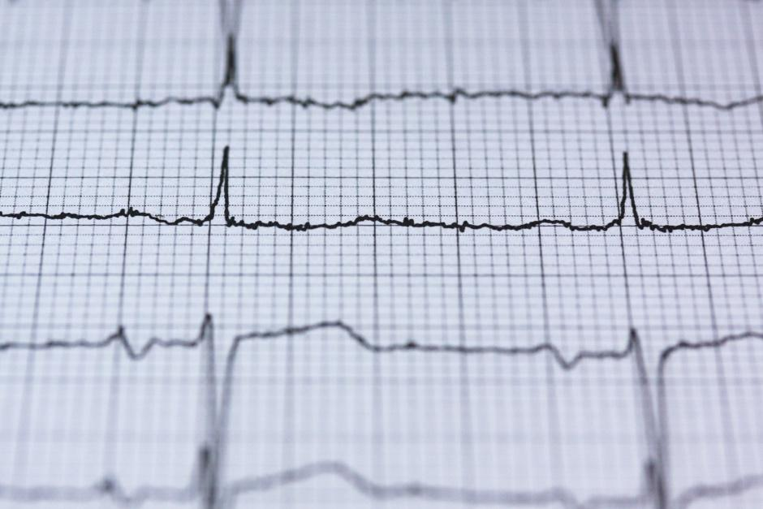

Redirection: https://www.hug.ch/cardiologie/rythmologie-et-electrophysiologie

* “Acute heart failure unit”

Image:



Redirection:

Acute heart failure unit

secretary: Ms. Brugger: +41 (0) 22 37 29 565

nurses: Mrs ARTIGE: +41 79 55 34 717

doctors: Dr P. Meyer CC, Dr A. Testuz, Dr N. Poku

The Acute Heart Failure Unit takes care of patients with weak heart function and supports these patients with innovative treatment modalities. The HUG team has all the means at its disposal, from pharmacotherapy to heart transplantation.

* “Stimulation unit”

Image:

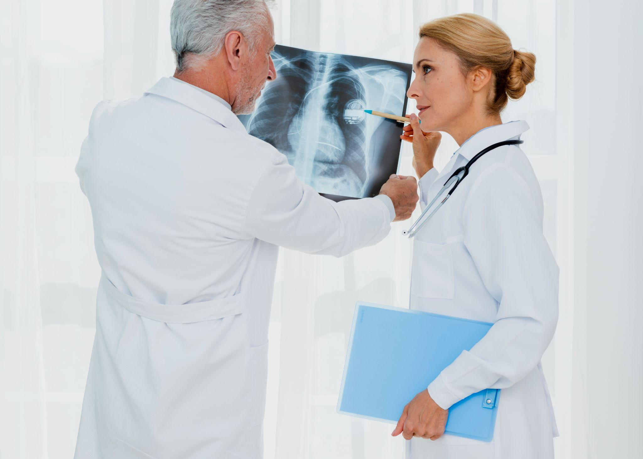

Redirection:

Cardiac stimulation unit

secretary : Ms Béatrice GARAIX 022 37 27 210

doctors : Pr H. Burri, Dr E Bakelants

The Pacemaker Unit takes care of patients with pacemakers and cardiac defibrillators. We are a reference center for difficult cases in particular (extraction of probes, stimulation of the His bundle and others). Prof. H. Burri is an international expert with an important role in the Swiss and European cardiological society.

[esc365.escardio.org/Person/4016-prof-burri-haran](http://esc365.escardio.org/Person/4016-prof-burri-haran)

* “Therapeutic education”

Image:



Redirection:

Therapeutic education activity

secretary Ms. Zellweger: + 41 (0) 22 37 27 214

nurses

Ms. A. Bevand: +41 (0) 79 55 34 065

Mrs. E. Guillermet: +41 (0) 79 55 35 508

doctor Dr F. Sittarame

The Cardiology Department of the HUG has set up a therapeutic patient education team (PET) with the support of the GECOR foundation. Their activities concern patients attending two poles: Preventive Cardiology and Secondary Prevention. Dr Frédéric Sittarame, specializing in therapeutic education, supported at 50% by the GECOR foundation, coordinates and leads the PET activities of secondary prevention and cardiovascular rehabilitation programs which combine technical learning, theoretical knowledge, cultural and artistic activities. The latter component is the subject of a MEG-HUG partnership agreement which aims to implement art and culture as an essential complement to supporting patients in their care.



* “Congenital Heart Disease Unit”

Image:



Redirection:

Congenital heart disease activity

Secretary: Ms Brugger: +41 (0) 22 37 29 565

Nurses: Mme ARTIGE: +41 79 55 34 717

Doctors: Dr J. Bouchardy, Dr C. Blanche

Any patient with a cardiac birth defect requires follow-up that is offered to patients. This follow-up includes ultrasound imaging and cardiac MRI.

* “Cardio-oncology Activity”

Image:

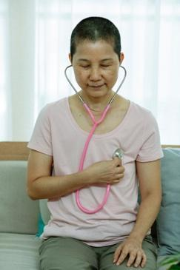

Redirection:

Cardio-oncology activity

Secretary: Ms Brugger: +41 (0) 22 37 29 565

Doctor: Dr N. Poku

We advise and treat any patient with a vascular or cardiac risk or abnormality in connection with an oncological treatment.

1. Put title “Our doctors” → Same than previously mentioned



1. Button: “Contact us” with redirection to contact form

**B4. Annual reports**



Heart transplant → “Annual reports”, text:  **“Our Cardiology Department has many specialized units where a wide variety of clinical activities take place.**

**Beyond the figures, the annual report makes it possible to summarize this experience, list the research articles published, share successes and define the common path for excellence.“**

* “Find each year the service main events and achievements in our activity reports.”
* Add this visual:

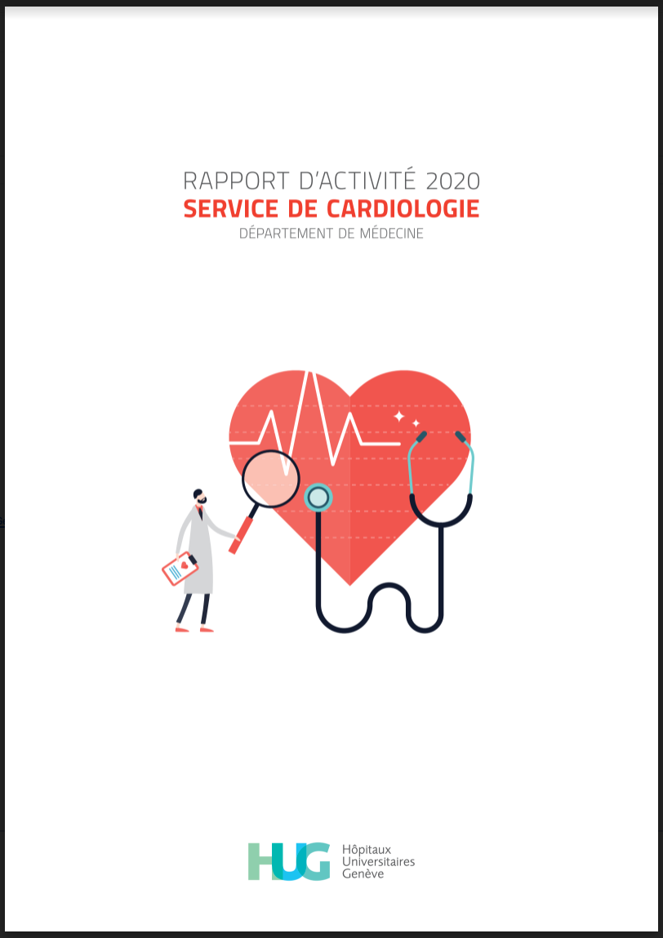

* Add text below:

« ACTIVITY REPORT 2020 - CARDIOLOGY DIVISION  « Year of the Covid-19 health crisis during which we contributed both clinically and scientifically through a vast epidemiological study. We also inaugurated a new room equipped for advanced cardiac imaging (GIBOR) allowing new electrophysiology procedures. We also saw the creation of the stationary cardiovascular rehabilitation clinical unit at Beau-Sejour.  »

* Add button: Discover more → “Download the 2020 report (FR)” link: https://drive.google.com/file/d/1ZrXhLfSKSOJuBUnVC3RIJxX8zXUD0hBB/view?usp=sharing



* Add this image

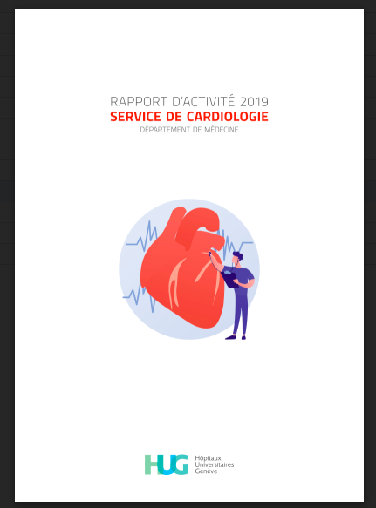

* Add this text:
* «  ACTIVITY REPORT 2019 - CARDIOLOGY DIVISION ”
* « The highlight international event of 2019, was the annual congress of the European Society of Cardiology chaired by Professor Marco Roffi. The latest European lipid treatment recommendations (Lipid guidelines ESC 2019) have been updated following a Geneva study conducted by Prof. François Mach and his team.»
* Add button: Discover more → “Download the 2019 report (FR)” link: https://drive.google.com/file/d/1Upjhy4cGHCEjnltXWQSwsXhJA65u_WIr/view?usp=sharing



* Add this image

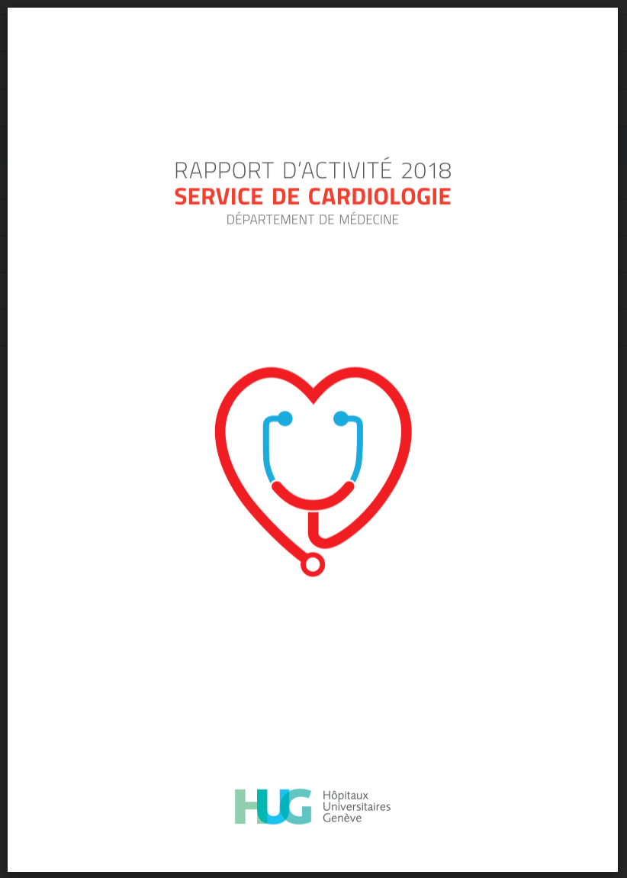

* Add this text:
* «  ACTIVITY REPORT 2018 - CARDIOLOGY DIVISION ”
* «We have inaugurated the coronary care unit (Juillard-53). Research activities continued to progress as evidenced by the significant increase of scientific publications in international journals.»
* Add button: Discover more → “Download the 2018 report (FR)” link: [RAPPORT D’ACTIVITEì 2018.pdf](https://drive.google.com/file/d/10Bz1S5xEaC88JpOyDOMsHp9RumTP0K7R/view?usp=sharing)



**B5. Doctors directory**



Heart transplant → “Cardiology Division”

Add a search field



* + The word of mouth → “Heads of service”



USE THIS FORMAT: IF NO PICTURE OF THE DOCTOR, THEN PUT GEcor LOGO

KD: need help translating the ranks, prepare a file

* + **Pr François Mach** / Médecin-chef de Service



* + **Pr Marco Roffi** / Médecin-chef de Service suppléant

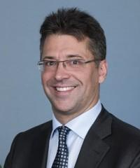

* 
  + The word of mouth → “Echocardiography Unit”
* **CC Müller Hajo** / Médecin-adjoint agrégé, Head of unit

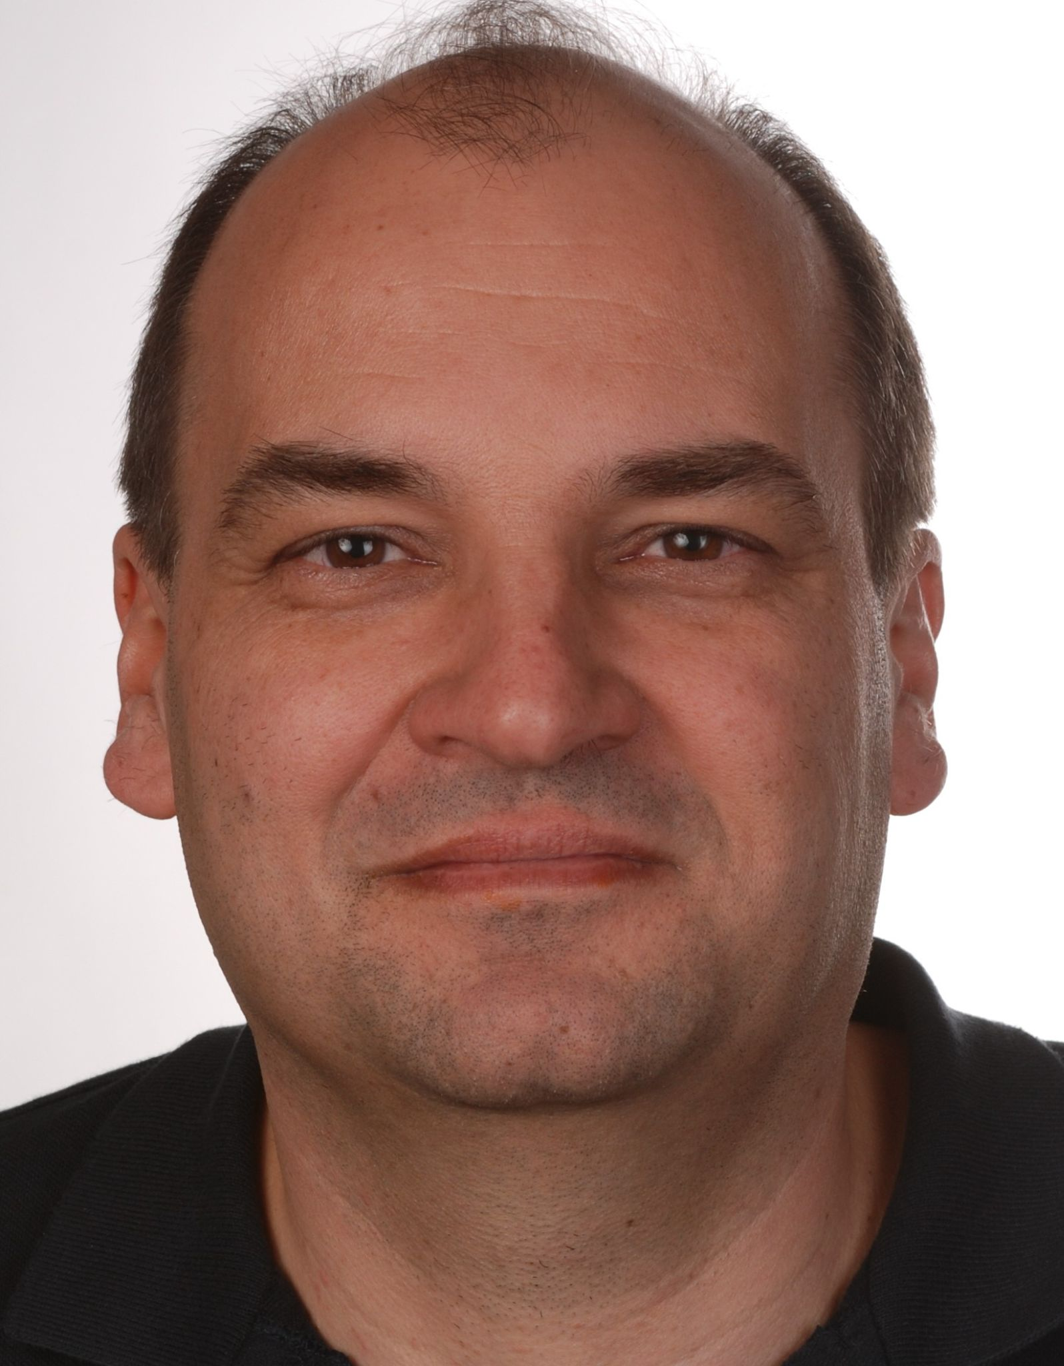

* 
  + The word of mouth → “Electrophysiology Unit”
  + **Pr Dipen Shah** / Médecin-adjoint agrégé, Responsable d’unité

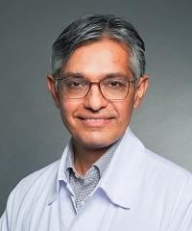

* + **Pr Haran Burri /** Médecin-adjoint agrégé

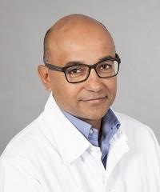

* + **CC Mehdi Namdar /** Médecin-adjoint agrégé

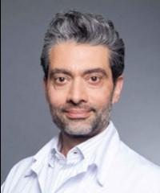

* 
  + The word of mouth → “Acute heart failure and rehabilitation units”
  + **CC Philippe Meyer** /Médecin-adjoint agrégé, Responsable d’unité

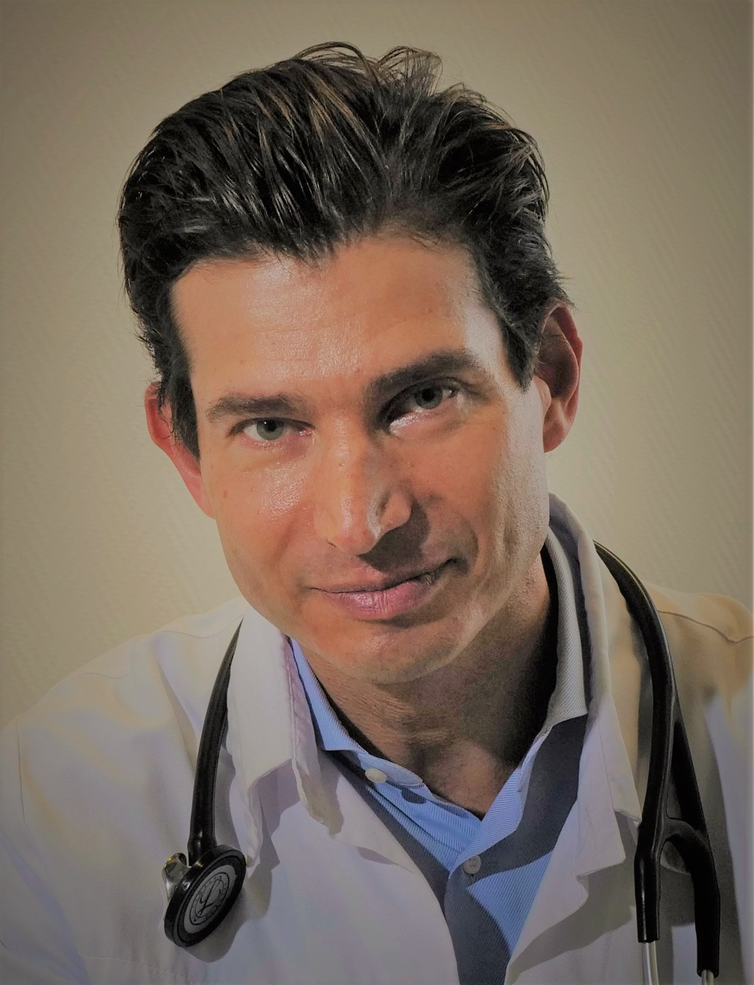



* The word of mouth → “interventional cardiology”
* **Pr Marco Roffi /** Médecin-adjoint agrégé, Responsable d’unité



* **PD Dr Juan F Iglesias /** Médecin-adjoint agrégé
* juan-f-iglesias-760b1aa2
* @JuanFIglesias1

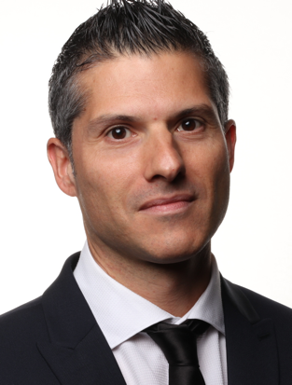

* **Pr Stéphane Noble /** Médecin-adjoint agrégé
* 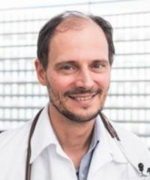



* The word of mouth → “Molecular cardiology unit”
* **CC René Nkoulou /** Médecin-adjoint agrégé, Responsable d’unité





* The word of mouth → “structural cardiology unit”
* **Pr Stéphane Noble** / Médecin-adjoint agrégé, Responsable d’unité



* **Pr Marco Roffi /** Médecin-adjoint agrégé



* **PD Juan F Iglesias /** Médecin-adjoint agrégé
* juan-f-iglesias-760b1aa2
* @JuanFIglesias1





* The word of mouth → “Cardiac stimulation unit”
* **Pr Haran Burri /** Médecin-adjoint agrégé, Responsable d’unité
* @HaranBurri





* The word of mouth → “Cardiac MRI activity”
* **PD David Carballo /** Médecin-adjoint agrégé

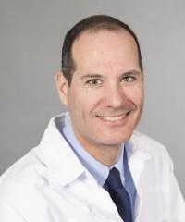



* The word of mouth → “Cardio-gynecology activity”
* **Dr Agathe Py /** Chef de clinique

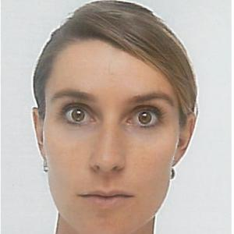



* The word of mouth → “Cardio-oncology activity”
* **Dr Nana Poku /** Chef de clinique

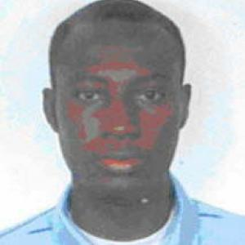



* The word of mouth → “Congenital Heart Disease Unit”
* **PD Judith Bouchardy** / Médecin-adjointe agrégée

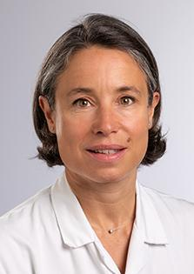



* The word of mouth → “Cardiology activity at « Trois-Chêne » hospital”
* **Pr Georg Ehret** / Médecin-adjoint agrégé
* georg-b-ehret-4b965635
* @georgehret

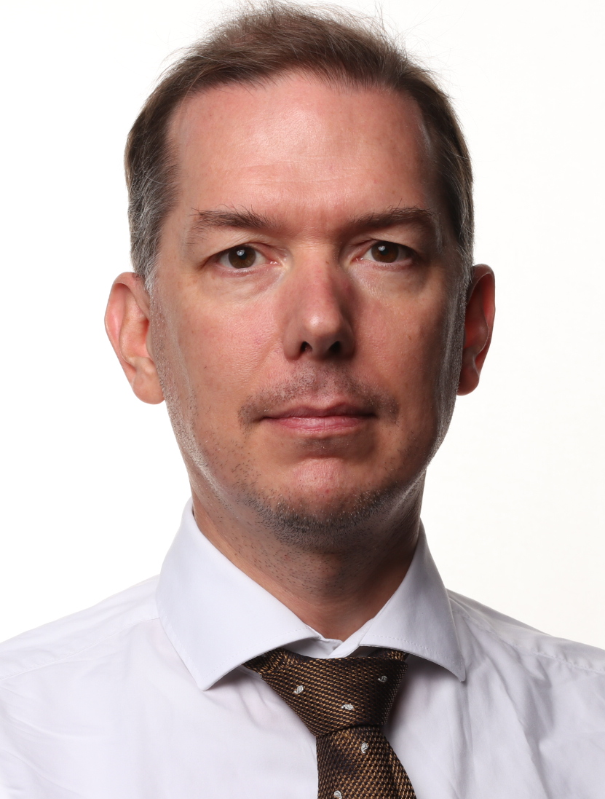



* The word of mouth → “Preventive cardiology activity”
* **Pr Georg Ehret** / Médecin-adjoint agrégé
* georg-b-ehret-4b965635
* @georgehret





* The word of mouth → “Heart transplantation and cardiac assistance sector”
* **CC Philippe Meyer** /Médecin-adjoint agrégé, Responsable d’unité





* The word of mouth → “Biomedical cardiology sector”
* **Mr Gaetano Barcellona**

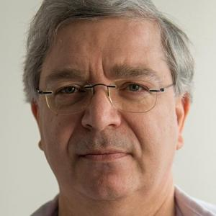



* The word of mouth → “Cardiovascular biology sector”
* **PD Dre Kapka Miteva**

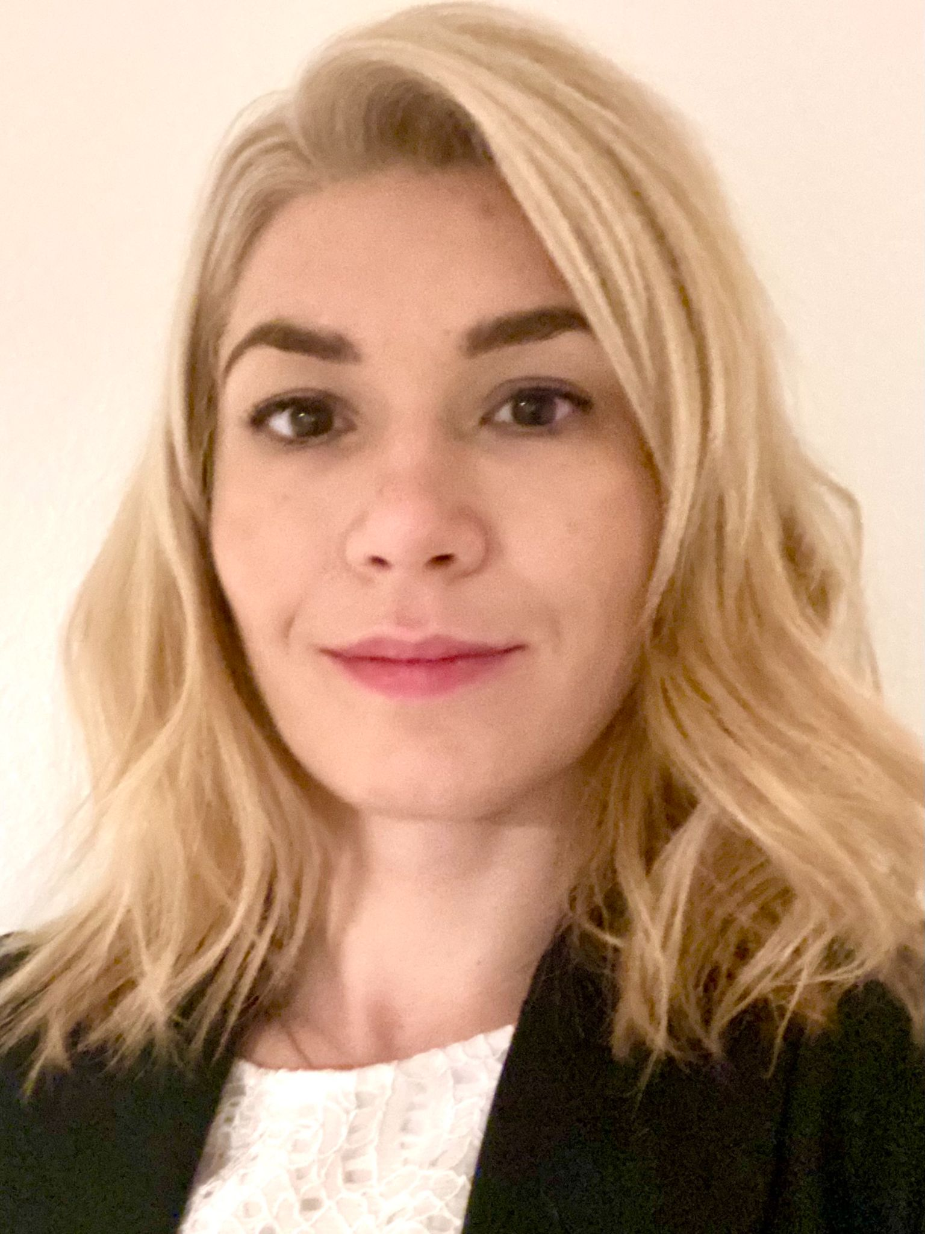

**Linkedin**

[**linkedin.com/in/kapka-miteva-34346b44**](https://www.linkedin.com/in/kapka-miteva-34346b44)

**PubMed Link**

[**https://pubmed.ncbi.nlm.nih.gov/?term=Kapka+Miteva&sort=date**](https://pubmed.ncbi.nlm.nih.gov/?term=Kapka+Miteva&sort=date)

**OrcID**

[**https://orcid.org/0000-0002-6722-8400**](https://orcid.org/0000-0002-6722-8400)



* The word of mouth → “Intermediate medical care”
* **PD David Carballo /** Médecin-adjoint agrégé
* 
* 
* The word of mouth → “Chefs de clinique ”
* **Dr Dionysios Adamopoulos**

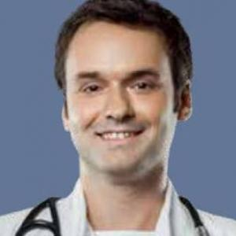

* **Dre Elise Bakelants**
* **Dre Sophie Degrauwe**
* sophie-degrauwe-54ab20156
* **Dr Georgios Giannakopoulos**

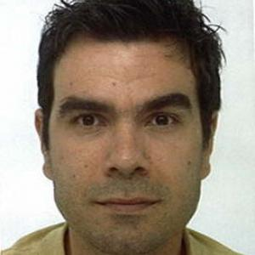

* **Dre Sarah Mauler-Wittwer**

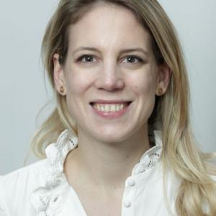

* **Dre Nathalie Nieto**
* **Dr Nana Poku**



* **Dre Aghate Py**



* **Dre Elena Tessitore**
* elena-tessitore-259b771a



* 
* The word of mouth → “Interns”
* **Dre Hania Bernard-Burgan**

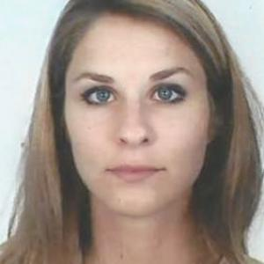

* **Dre Eleonore Campiche**
* **Dr Andrea Carcaterra**

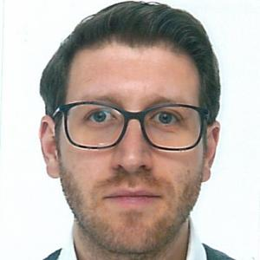

* **Dr Quentin Châtelain**
* **Dr Aurélien Daux**
* **Dr Axel Friedli**
* **Dre Daniela Georgescu Lachenal**

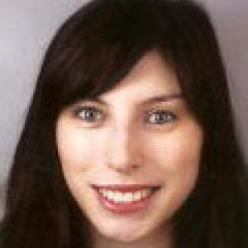

* **Dr Thierry Grandjean**

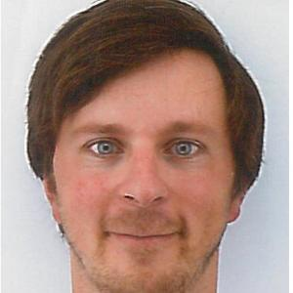

* **Dre Marie-Eva Laurencet**
* **Dre Aki Mizuno**

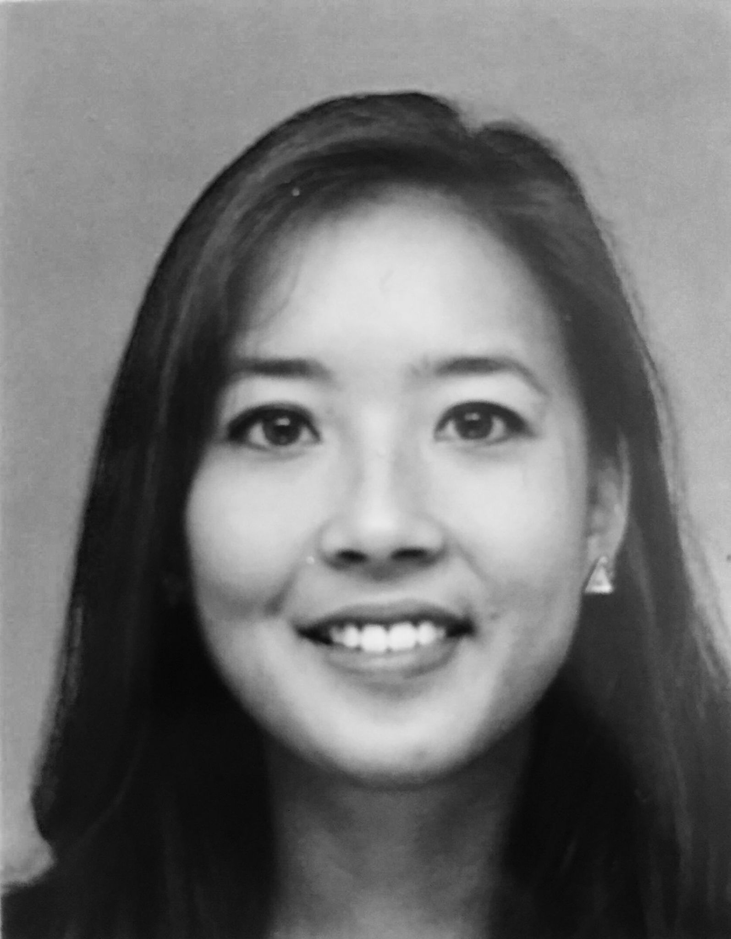

* **Dr Betim Redzepi**

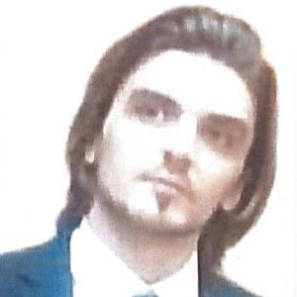

* **Dre Marie Assouline-Reinmann**

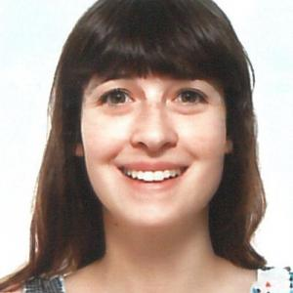

* **Dr Florian Stierlin**
* 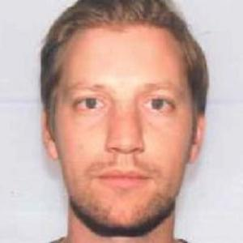
* **Dr Valérian Valiton**
* valerian-valiton-9a6a971b6

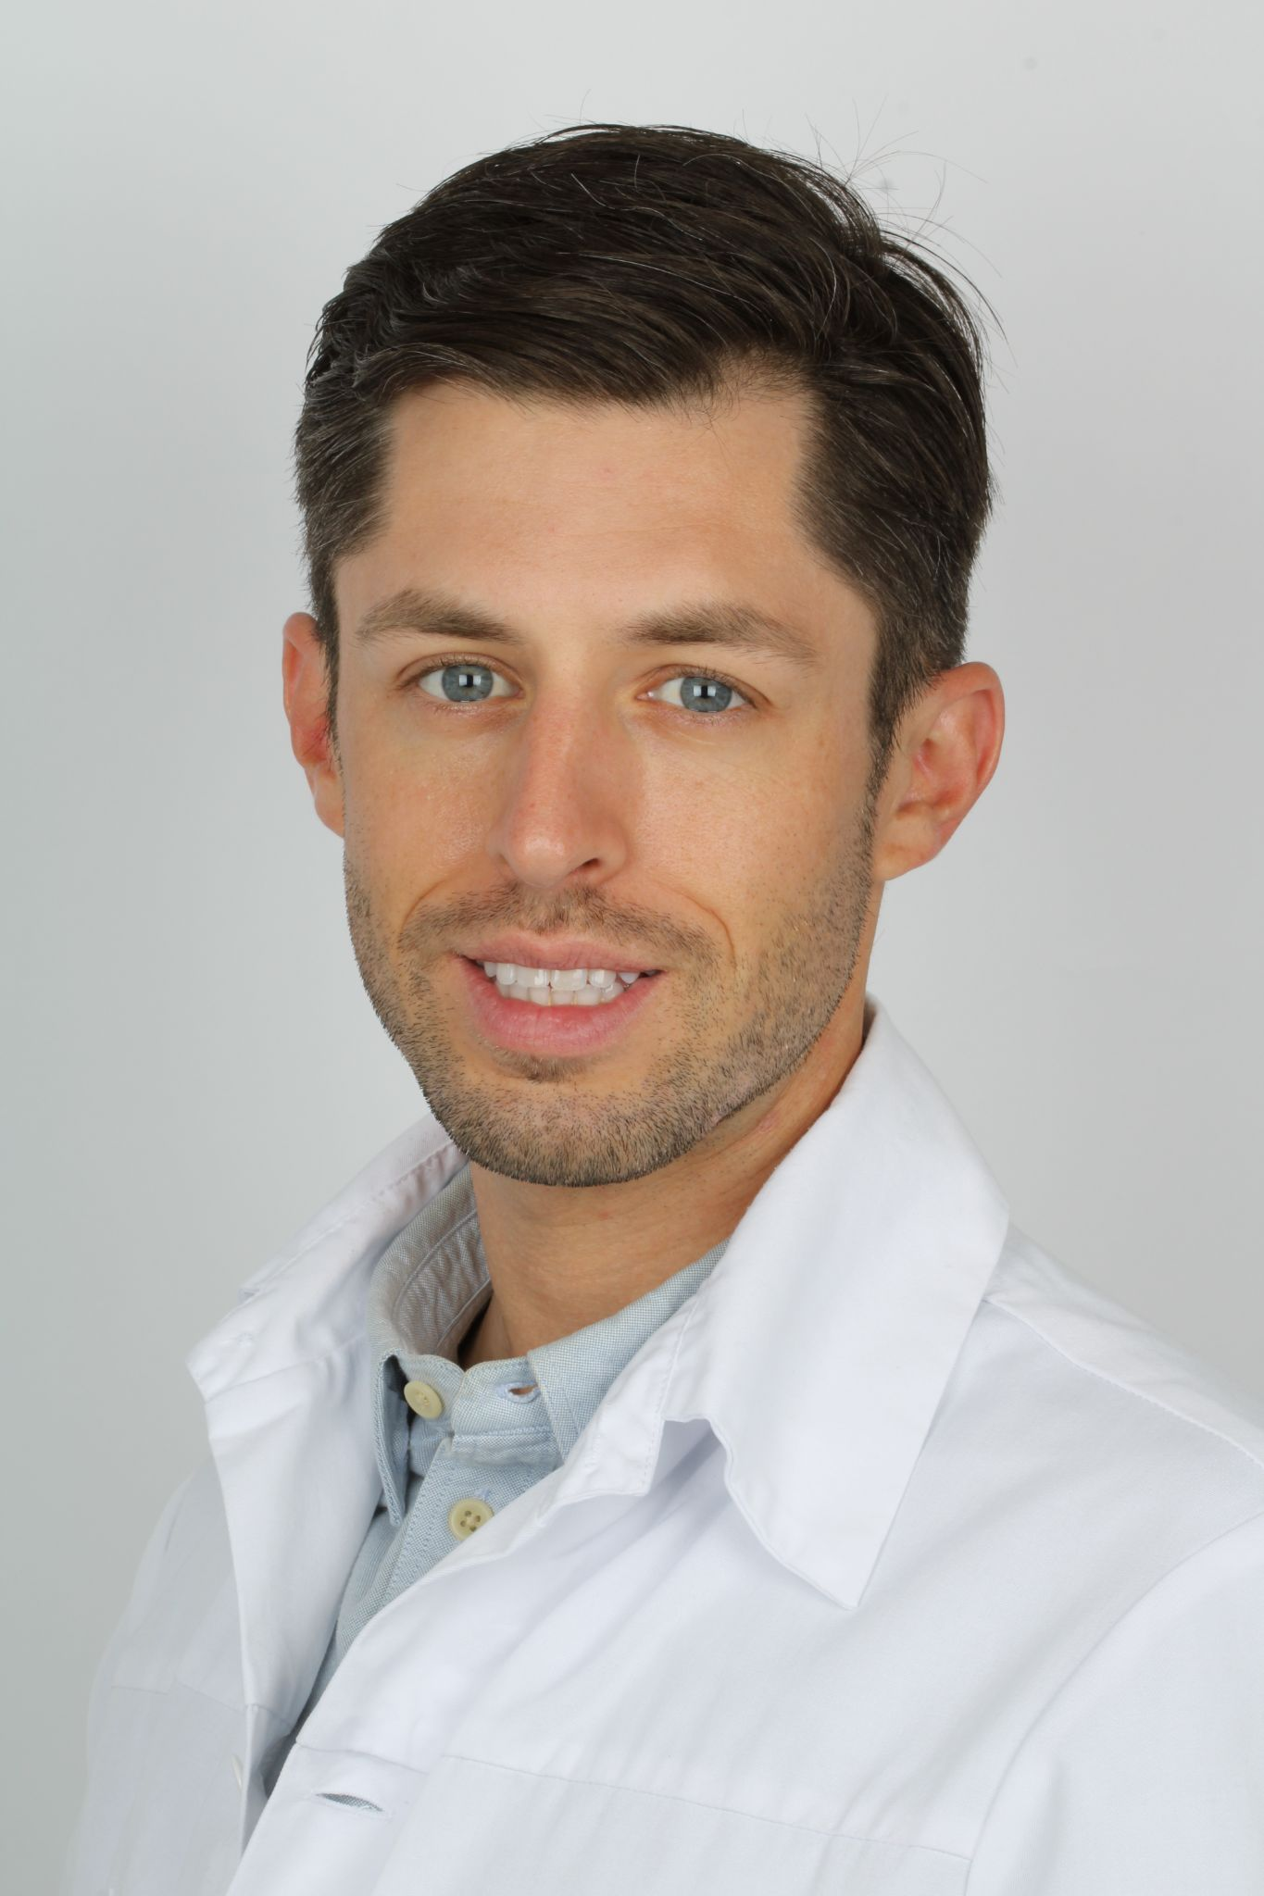



* The word of mouth → “Médecins associés”
* **Dr Cédric Vuille**

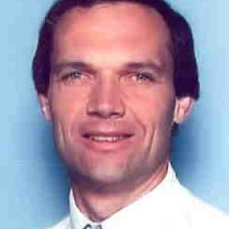

* **Dre Coralie Blanche**
* **Dre Caroline Frangos-Noble**

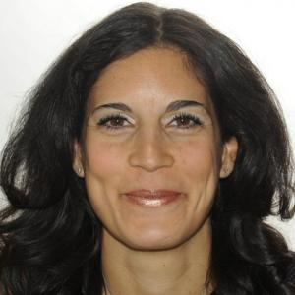

* **Dr Stéphane Mock**

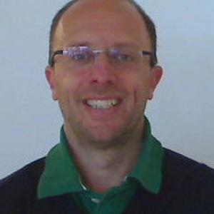



* The word of mouth → “Doctors abroad”
* **Dr Nils Perrin** (Fellow in interventional cardiology at Montreal cardiology institute (CA) )
* nils-perrin-4414ab201



* The word of mouth → “Cardiology bed unit”
* Dr. Gencer

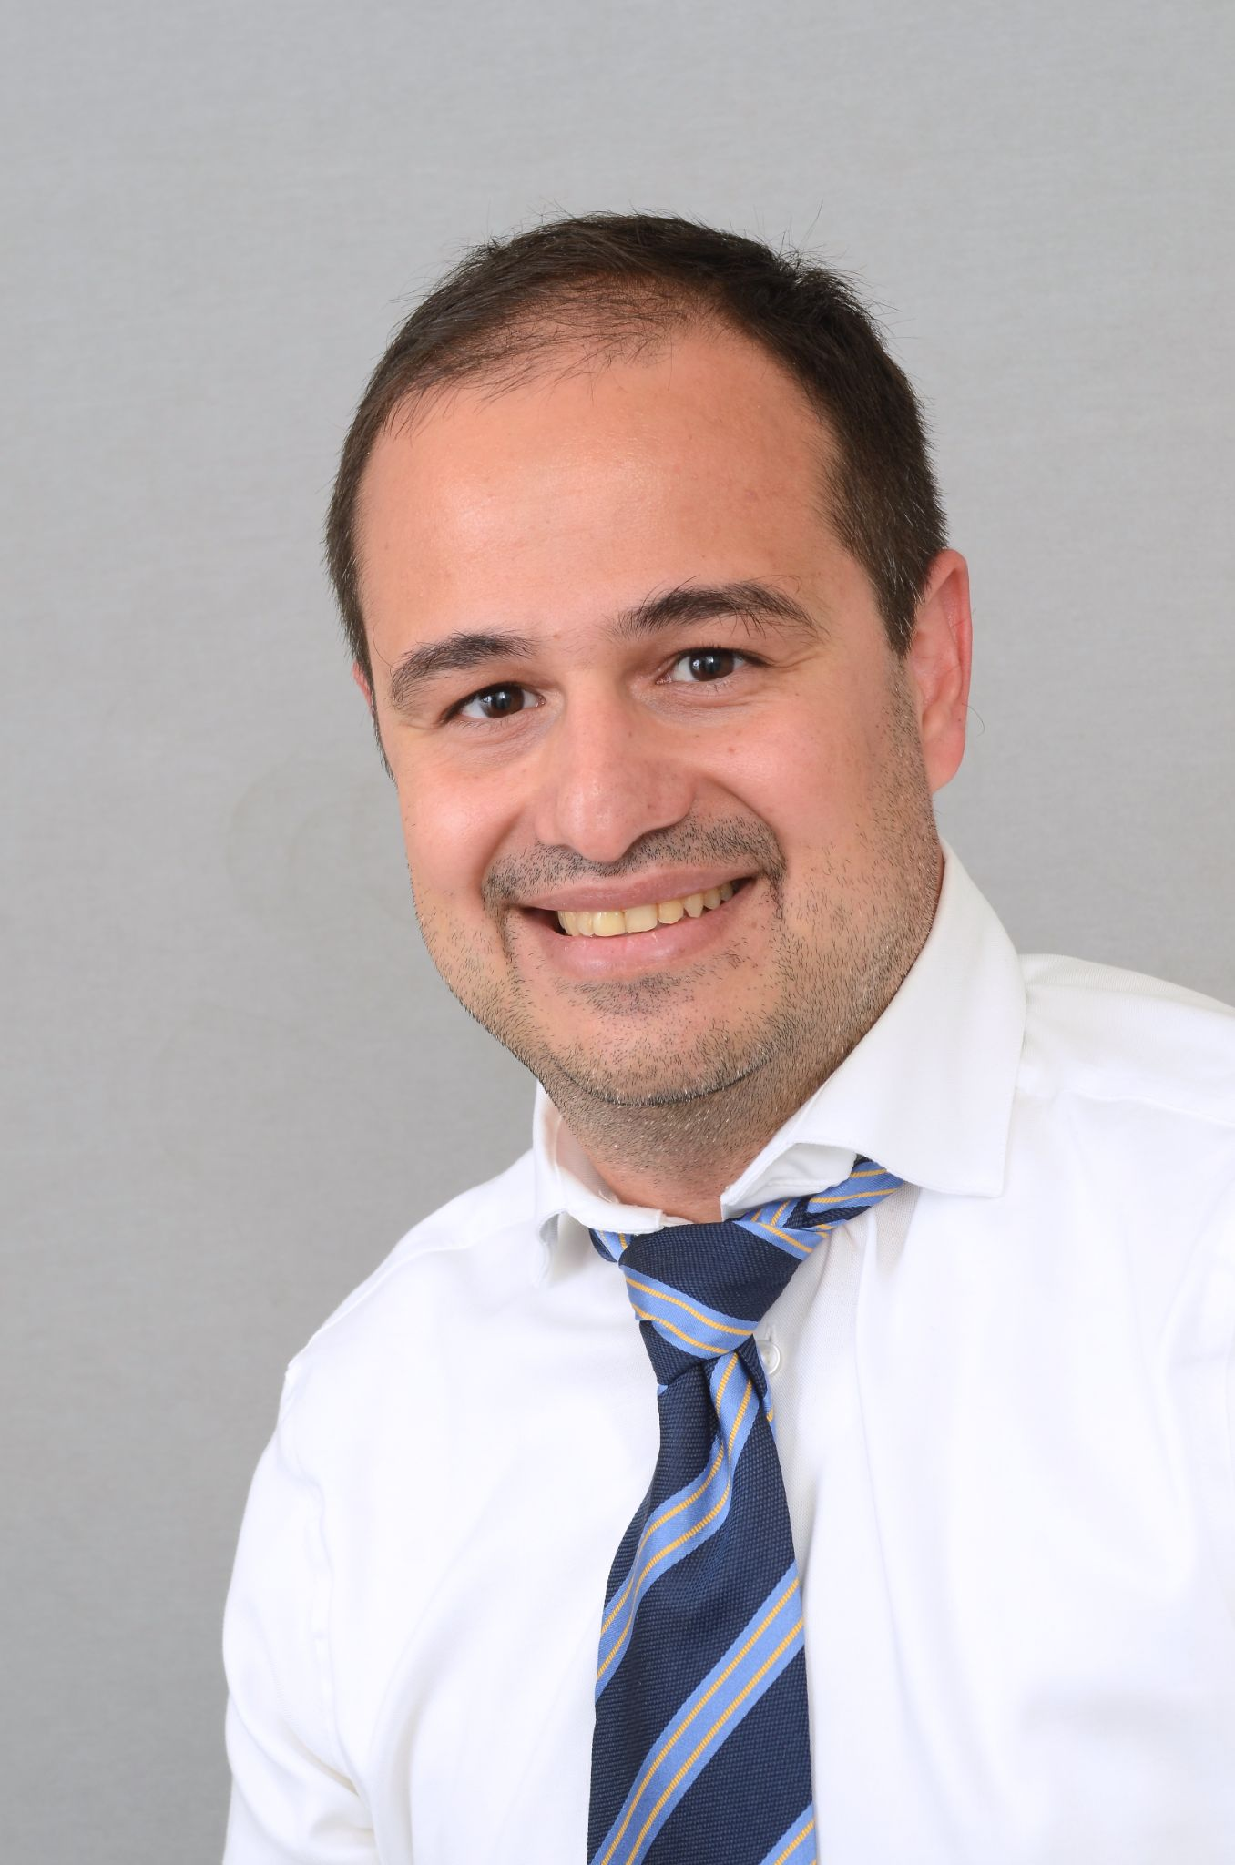

**C. Patients**

Mockup: https://cardiologygeneva.viewmysitenow.com/concept/02/patients.html



Heart transplant → “Patients”

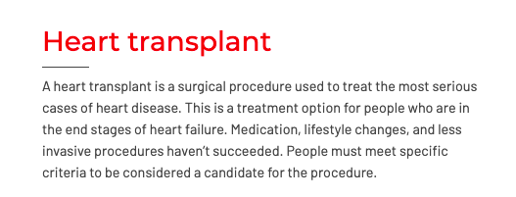

* Heart transplant → “Typical patients”
* Text: « Depending on symptoms and age, a large portion of our patients will identify with one of the following four typical profiles." :

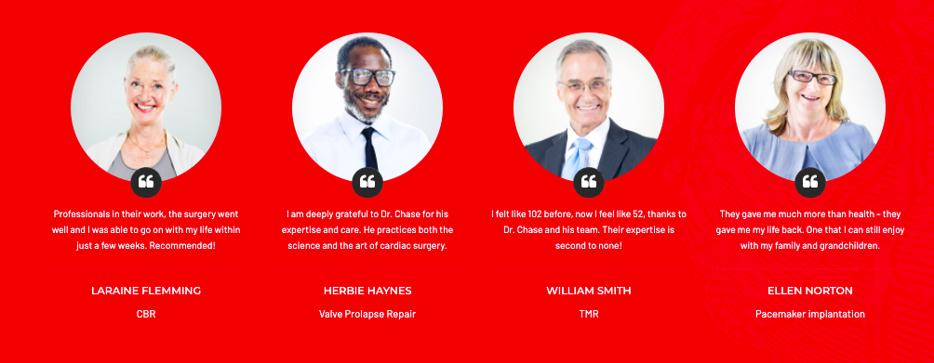

* Lauraine Flemming → “Marcel - coronary heart disease”
* Image:

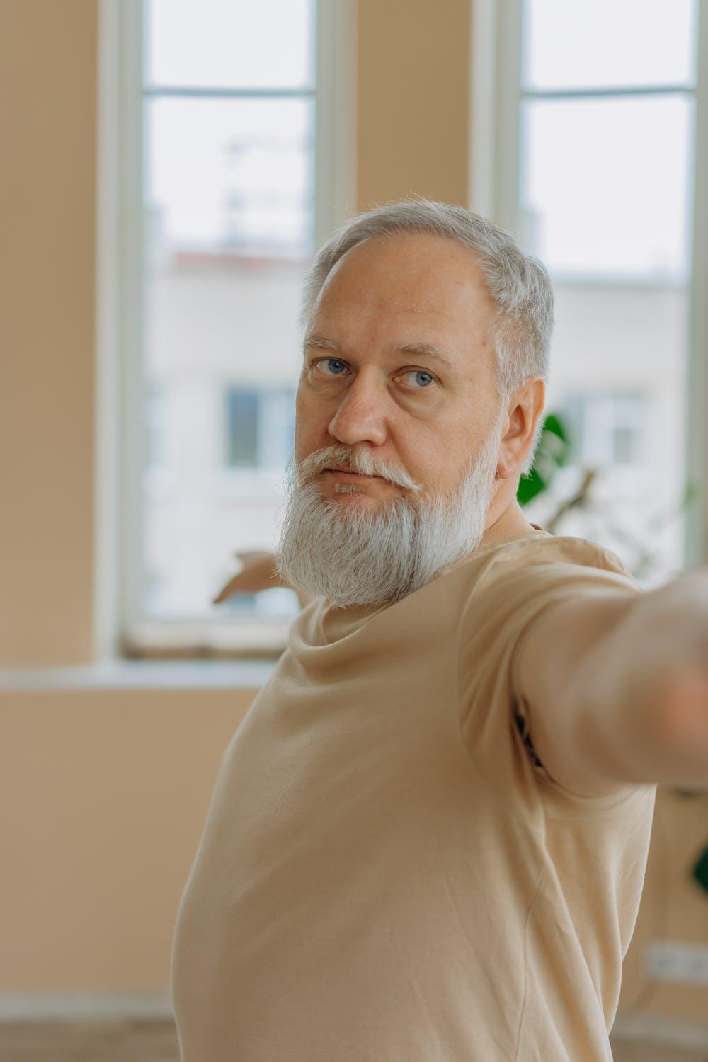

* Herbie Haynes → “Ottilia - Valvular heart disease”
* Image:

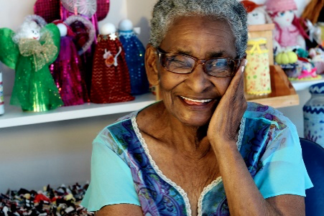

* William Smith → “Anna - Cardiac arrhythmia”
* Image:

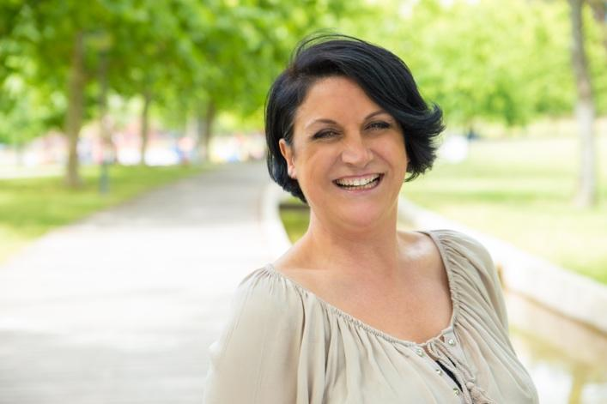

* Ellen Norton → “Peter - Prevention”
* Image:



* Add one → “Sandrine - heart defect from birth”
* Image:



ADD BUTTON “More information” BELOW WITH REDIRECTION TO PAGE “Typical patients”

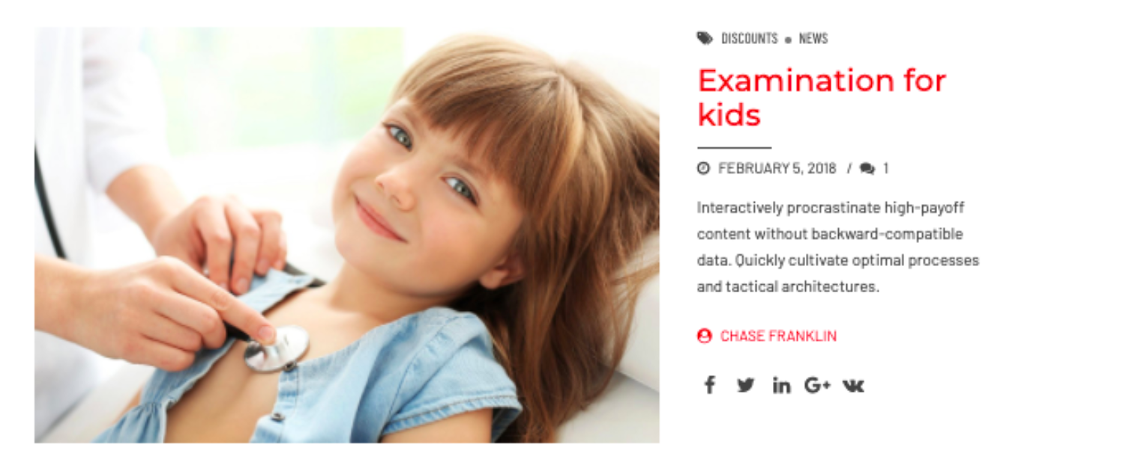

* Image:

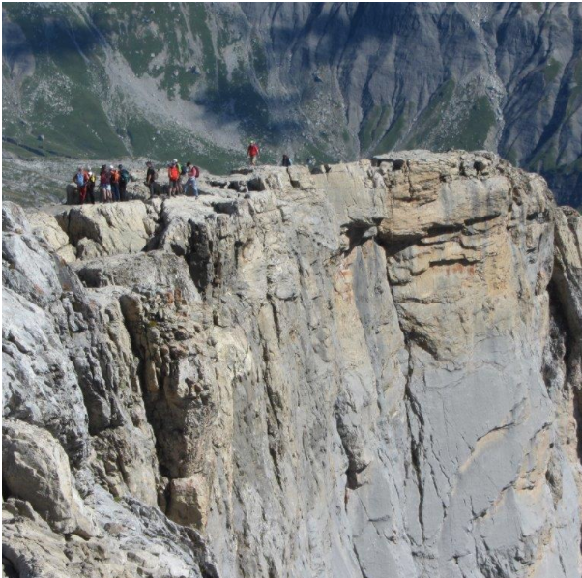

* Title: Examination for kids → “Reaching new heights after a heart attack”
* Text: “Promote rehabilitation through physical exercise of patients with cardiovascular disorders”
* Add button: “Discover our patients projects” → Link to page “Patients projects”

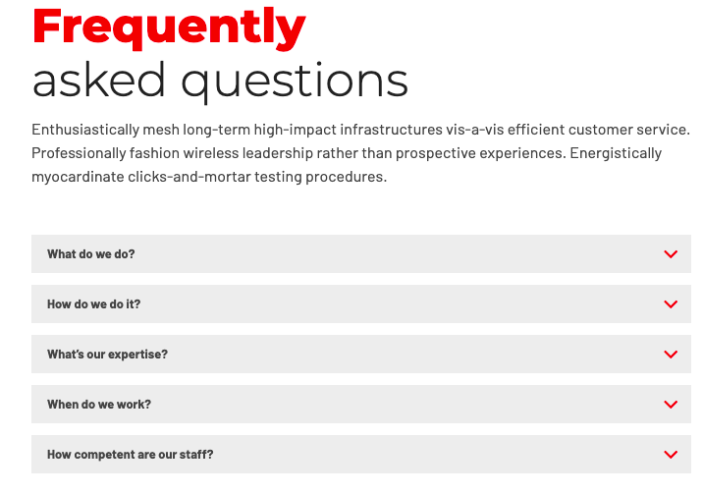

* Frequently asked questions → “Questions fréquentes” - Add text:

1. “[What are the main cardiac diseases ?](https://youtu.be/q2LeTvHM824)”

→ Drop down

Image

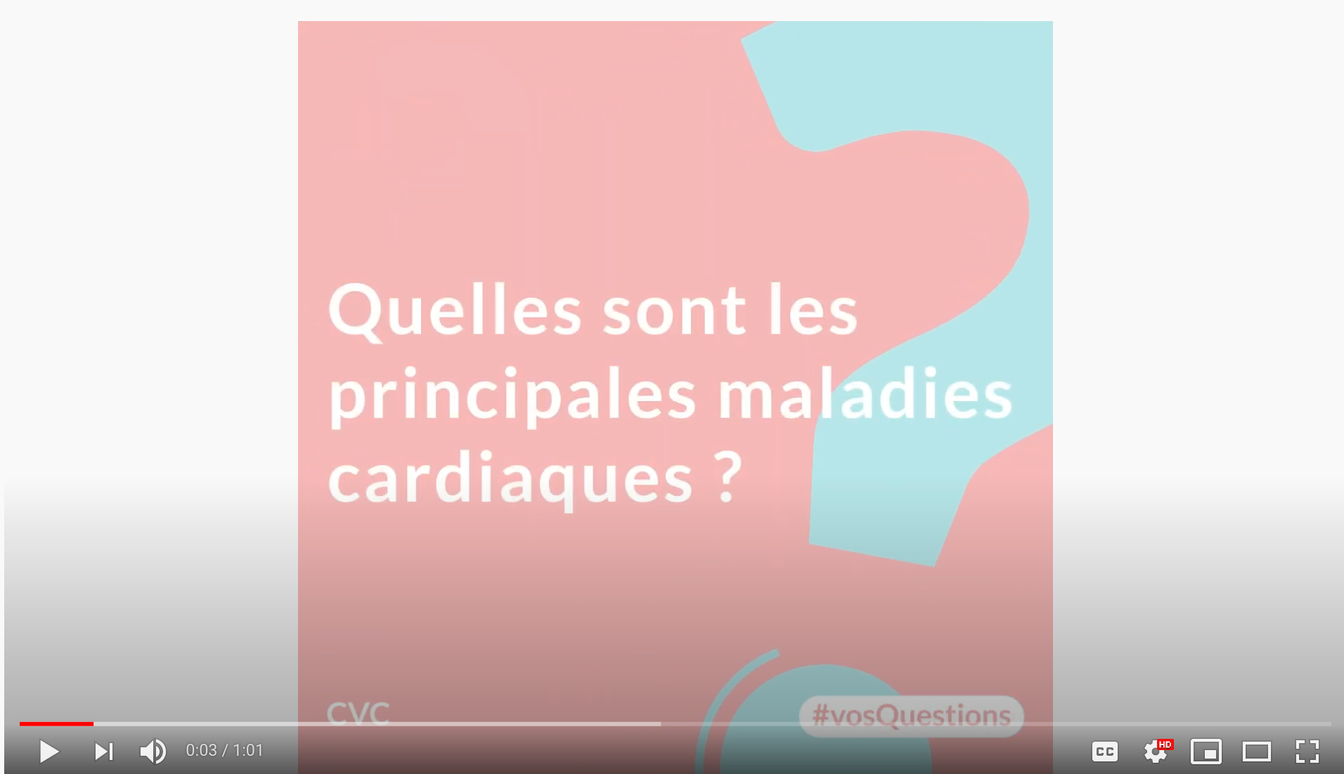

Link: https://www.youtube.com/watch?v=q2LeTvHM824

1. “ [How to know if you have a heart problem ?](https://youtu.be/tWphCBowbYQ)”

→ Drop down

Image

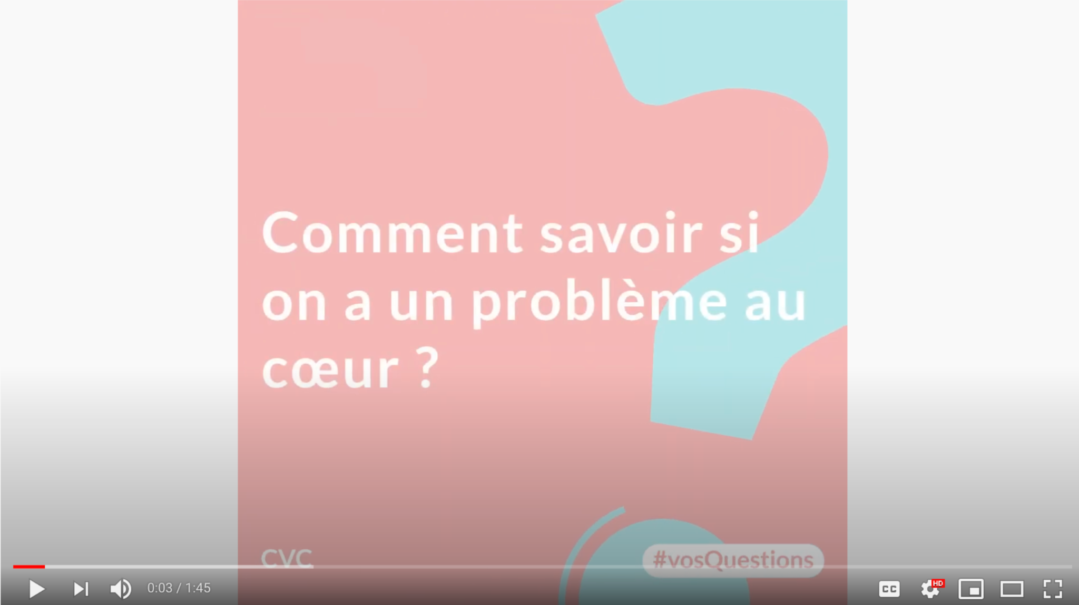

Link: https://www.youtube.com/watch?v=tWphCBowbYQ

1. “ [What are the warning signs of a heart attack?](https://youtu.be/qRmbKxy7iJA)”

→ Drop down

Image

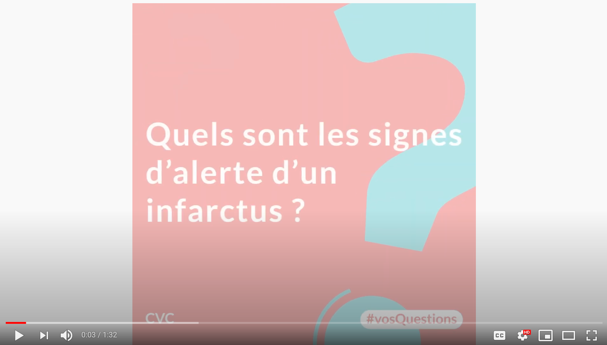

Link: <https://www.youtube.com/watch?v=qRmbKxy7iJA>

Add button “See all questions and answers” → Link to page “FAQ”

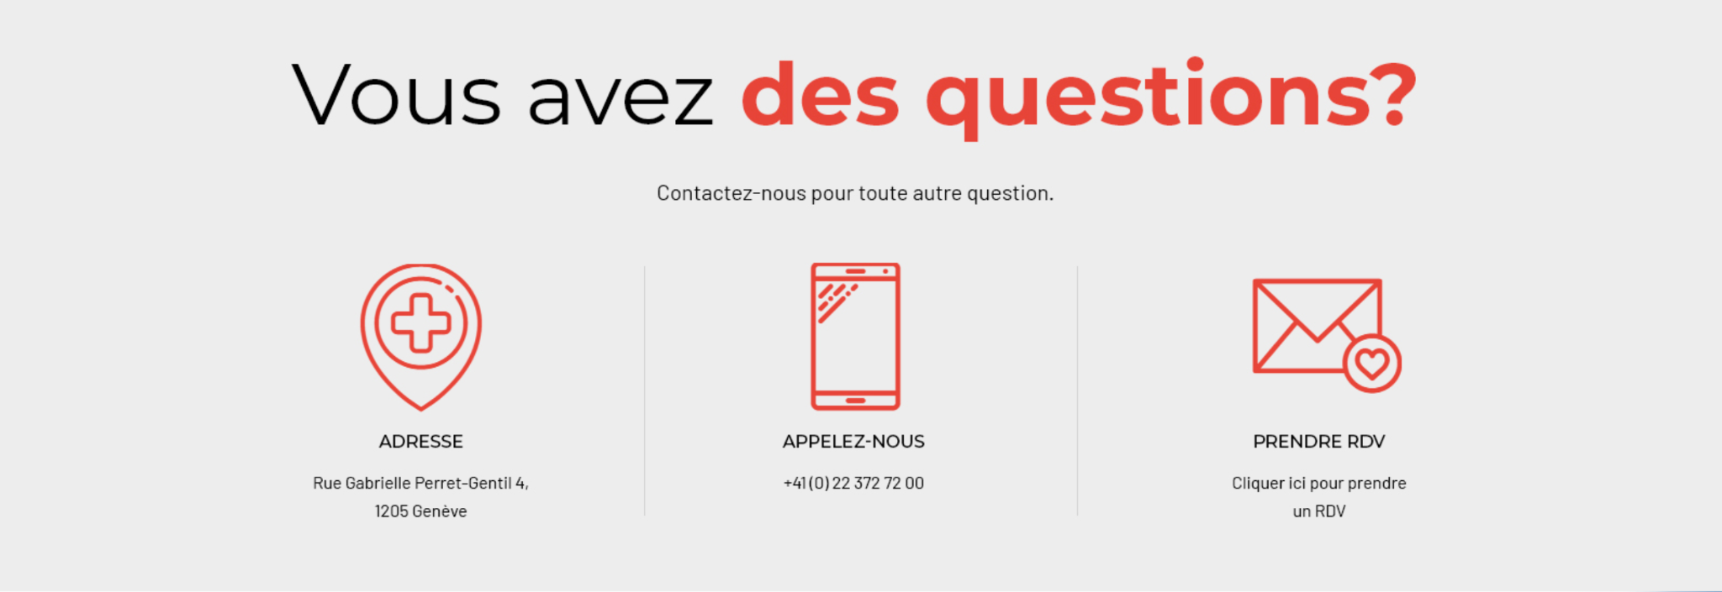

Copy this but instead of “PRENDRE RDV” put “CONTACT-US” which redirects to contact form

**C1. Patients typiques**

Mockup: https://cardiologygeneva.viewmysitenow.com/concept/02/patients-typical.html



Heart transplant → “Typical patients”

b.

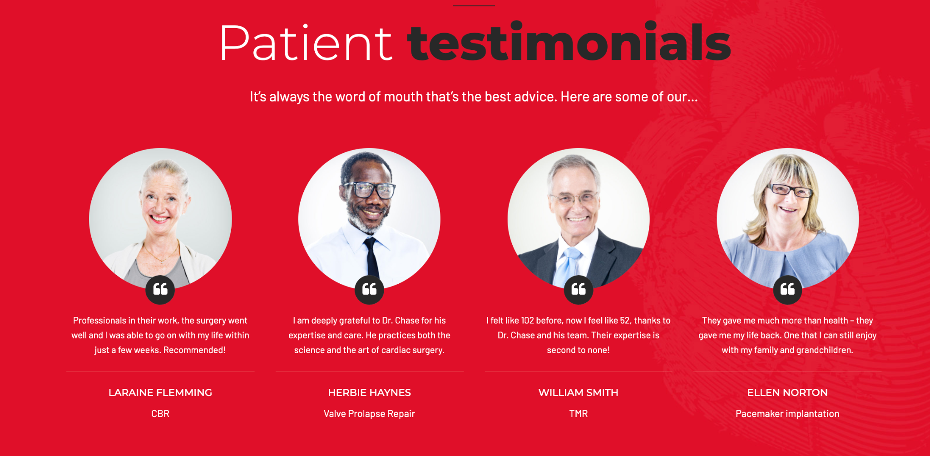

Patient testimonials → “Choose your profile”

Text: “In order to guide you, we have established 5 typical patient profiles. Do you identify with one of them? Click for answers to any questions you may have and the units and doctors recommended for you.”

c.

* Lauraine Flemming →

Marcel - coronary heart disease

60 years old and more

 «Marcel suffers from coronary heart disease. He knows his diagnosis and comes for a check-up or an innovative treatment.»

* Image:



* Herbie Haynes →

Ottilia - la valvular heart disease

80 years old and more

« Ottilia suffers from a valve pathology, she seeks an individualized and close approach. She is moving towards procedures like mitraclip »

* Image:



* William Smith →

Anna - Cardiac arrhythmia

40 to 70 years old

« Anna has cardiac arrhythmia, she is feeling the symptoms and wants to know her diagnosis and available treatments. »

* Image:

1. 

* Ellen Norton →

Peter - Prevention

30 to 60 years old

« People in Pete’s family have had heart problems, he wonders about his cardiovascular risk.»

* Image:



* Add one →

Sandrine - Sandrine - heart defect from birth

18 to 50 years old

« Sandrine has suffered from a heart defect since birth. This anomaly is most often of genetic origin or developed during pregnancy. She wants to learn about the best possible approaches.»

* Image:



**C1.1 Marcel**

1. Quel persona : Marcel
2. Quel CTA : Contact-us
3. Text : Voir sous modèle
4. Visuel : ?
5. 

a. Chase up close → “Marcel - coronary heart disease”, photo, texte: Age group, history, typical symptoms, goals, typical measures

Age: 60 years and more

Background: Coronary heart disease

Symptoms:

* + - * 1. Chest pain
        2. Thoracic pain
        3. Pain in the heart
        4. Heartache
        5. I feel sick
        6. Trouble breathing

Objective:

* + - * 1. Improve his quality of life
        2. Save his life

Typical measures

* + - * 1. Stent placement
        2. Pacemaker placement
        3. Resynchronization
        4. Heart images
        5. heart echography
        6. heart MRI

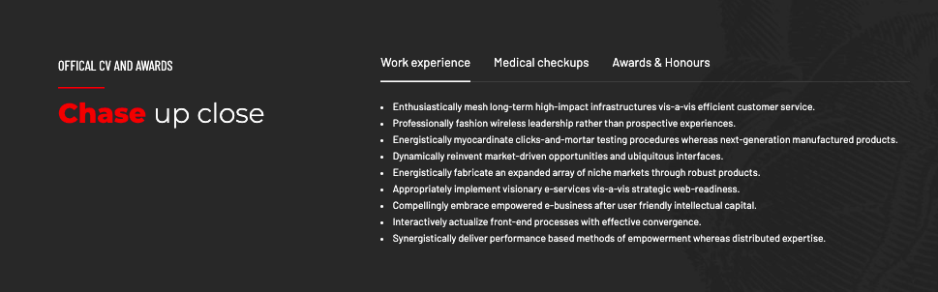

d. “recommended units for you” (recommended units for Marcel)

* + - recommended units for the typical patient
      1. Marcel - coronary heart disease:
         1. - Interventional cardiology
         2. - Echocardiography
         3. - Cardiac MRI
         4. - Nuclear cardiology
         5. - Acute heart failure
         6. - Cardiac Rehabilitation
         7. - Preventive cardiology
         8. - Cardiogeriatrics



e. Meet the Specialist Team → “recommended doctors for you” (recommended doctors for Marcel)



f. Contact form

1. 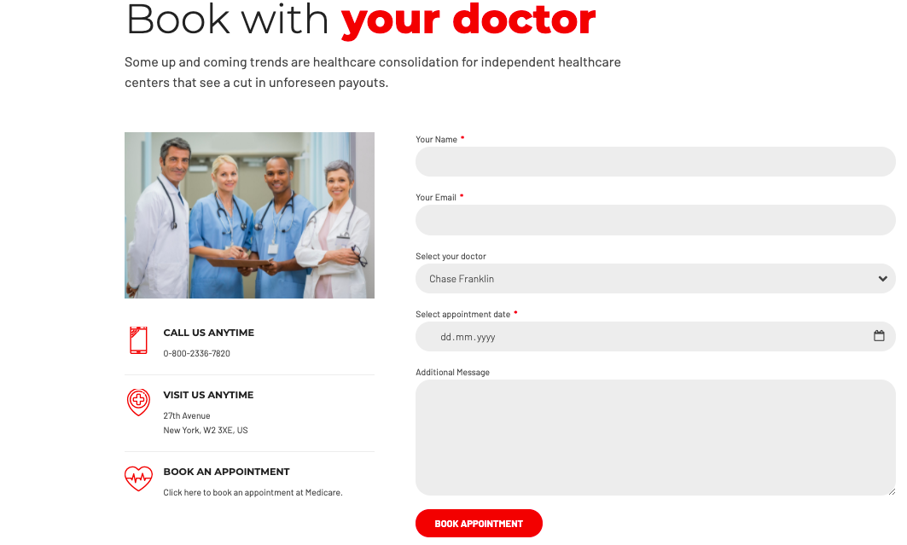

**C1.2 Ottilia**

1. Quel persona : Otto
2. Quel CTA : Contact us
3. Text : Voir sous modèle
4. Visuel :
5. 
6. a. Chase up close → “Ottilia - valvular heart disease”, photo, texte: Age group, history, typical symptoms, goals, typical measures

Ottilia - valvular heart disease

1. age: 80 years and over
2. Background:
   1. Aortic stenosis
   2. mitral regurgitation/failure
3. Symptoms:
   1. Chest pain
   2. Thoracic pain
   3. Pain in the heart
   4. Heartache
   5. I feel sick
   6. Loss of consciousness
   7. Trouble breathing
4. Objective:
   1. Improve her quality of life
   2. Improve her symptoms
   3. Maintain independence
5. typical measures
   1. TAVI
   2. mitra clip



d. “recommended units for you” (recommended units for Ottilia)

Ottilia - valvular heart disease

1. - Echocardiography
2. - Structural cardiology
3. - Cardiogeriatrics



e. Meet the Specialist Team → “Les médecins recommandés pour vous” (recommended units for Ottilia)



f. Contact form



**C1.3 Anna**

Image:



1. a. Chase up close → “Anna - Cardiac arrhythmia”, photo, texte: Age group, history, typical symptoms, goals, typical measures

Anna - Cardiac arrhythmia

1. Age: 40 to 70 years old
2. Background:
   1. First symptoms of cardiac arrhythmia
3. Symptoms:
   1. Heart palpitations
   2. Loss of balance
   3. Irregular heartbeats
   4. Heart that beats fast
   5. Loss of consciousness
4. Objectives:
   1. To know her heart problems
   2. To look for more information, everywhere with a critical look
5. Typical measures:
   1. Palpitations treatment
   2. Control



d. “recommended units for you” (recommended units for Anna)

* 1. Electrophysiology
  2. Cardiac Stimulation
  3. Echocardiography
  4. Cardiac MRI
  5. Acute heart failure
  6. Preventive cardiology



e. Meet the Specialist Team → “recommended doctors for you” (recommended doctors for Anna)



f. Contact form



**C1.4 Peter**

1. Quel persona : Peter
2. Quel CTA : Contact us
3. Text : Voir sous modèle
4. Visuel :
5. 

a. Chase up close → “Peter - prevention”, photo, texte: Age group, history, typical symptoms, goals, typical measures

1. Peter - prevention:
2. Age: 30 to 60 years old
3. Background:
   1. Risk factors for cardiac diseases
4. Symptom:
   1. Someone in his family had some heart problems
   2. He has one or more risk factors (overweight, smoker, hypertension, cholesterol, bad cholesterol, good cholesterol, triglycerides, lipoprotein (a), etc.)
   3. He had a cardiovascular event.
5. Objective:
   1. Decrease cardiovascular risk before or after the event
   2. Be reassured
6. Typical measures:
   1. Cardiovascular treatment
   2. Control



d. “Les unités recommandées pour vous” (recommended units for Peter)

1. Peter - prevention:
   1. Preventive cardiology
   2. Echocardiography
   3. Nuclear cardiology



e. Meet the Specialist Team → “Les médecins recommandés pour vous” (recommended doctors for Peter)



f. Contact form



**C1.5 Sandrine**

Image:



a. Chase up close → “Sandrine - heart defect from birth”, photo, texte: Age group, history, typical symptoms, goals, typical measures

Sandrine - heart defect from birth

1. Age: 18-50 years old
2. Background: heart problem since birth
3. Symptoms:
   1. trouble breathing
   2. blue lips
4. Goals:
   1. to live
   2. Improve her symptoms
5. Typical measures
   1. imaging of the heart
   2. prescribing drugs
   3. sometimes surgery



d. “Les unités recommandées pour vous” (recommended units for Sandrine)

1. Congenital heart disease
2. Echocardiography
3. Cardiac MRI



e. Meet the Specialist Team → “Doctors recommended for you” (recommended doctors for Sandrinel)



f. Contact form



**C2. Your symptoms**

* 1. Example: : <https://www.klinikum.uni-heidelberg.de/zentrum-fuer-innere-medizin-medizin-klinik/innere-medizin-iii-kardiologie-angiologie-und-pneumologie/fuer-patienten/ansprechpartner-innen-nach-symptomen>

1. Visual :
2. Usual questions from our patients → “Symptômes”, court texte (example: Which service should you contact?)
3. Chest pain

* Cardiology polyclinic.
* Interventional cardiology.
* Cardiac MRI.
* Nuclear cardiology.
* Sharp chest pain that does not go away may require a call to 144.

1. Thoracic pain

* Cardiology polyclinic.
* Interventional cardiology.
* Cardiac MRI.
* Nuclear cardiology.
* Sharp thoracic pain that does not go away may require a call to 144.

1. Pain in the heart

* Cardiology polyclinic.
* Interventional cardiology.
* Cardiac MRI.
* Nuclear cardiology.
* Sharp pain in the heart that does not go away may require a call to 144.

1. Heartache

* Cardiology policlinic.
* Interventional cardiology.
* Cardiac MRI.
* Nuclear cardiology.
* Sharp heartache that does not go away may require a call to 144.

1. I feel sick

* Cardiology polyclinic.
* Interventional cardiology.
* Cardiac MRI.
* Nuclear cardiology.
* Sharp chest pain that does not go away may require a call to 144.

1. Trouble breathing

* Heart failure.
* Cardiology polyclinic.
* Structural cardiology
* Interventional cardiology
* Echocardiography
* Cardiac MRI.

1. Loss of consciousness

* Electrophysiology.
* Cardiac stimulation.
* Echocardiography.
* Structural cardiology

1. Heart palpitations

* Electrophysiology.
* Cardiac stimulation.
* Echocardiography

1. Loss of balance

* Electrophysiology.
* Cardiac stimulation.
* Preventive cardiology (hypotension).

1. Cardiac arrhythmia

* Electrophysiology.
* Stimulation.
* Echocardiography.

1. Heart that beats fast

* Electrophysiology.
* Echocardiography

1. Have people with heart attacks in the family

* Preventive cardiology

1. Have had a cardiovascular event

* Cardiac rehabilitation
* Echocardiography
* Policlinic

1. High blood pressure, high blood pressure.

* Preventive cardiology

1. High cholesterol.

* Preventive cardiology

1. Heart valve problem.

* Echocardiography
* Structural cardiology

1. I need to measure my INR regularly.

* Preventive cardiology

1. I have a heart defect.

* Congenital heart disease
* Echocardiography
* Cardiac MRI

1. I have a heart transplant.

* Heart failure
* Echocardiography
* Cardiac MRI

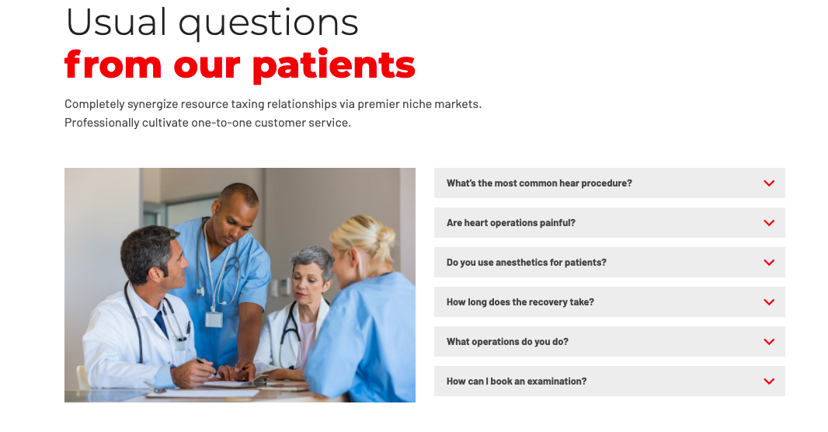

1. Contact form



**C3. Patients projects**

[**https://www.fondationhug.org/search/site/sigaud**](https://www.fondationhug.org/search/site/sigaud)

**Philippe Sigaud, instigator of these great projects, asks that it be stipulated that they are supported and sponsored by the HUG Private Foundation**



* Image:



* Title: Examination for kids → “Reaching new heights after a heart attack”
* Text: “Promote rehabilitation through physical exercise of patients with cardiovascular disorders”
* Add button: “See more” → Link to <https://www.fondationhug.org/atteindre_sommets>



* Image:

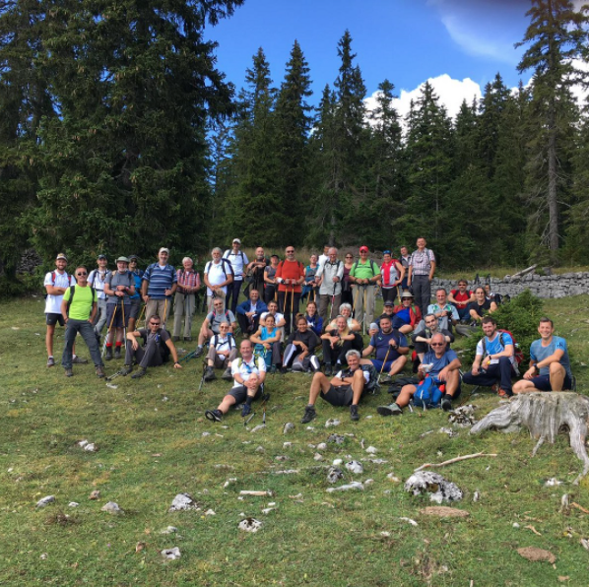

* Title: Examination for kids → “Out and about”
* Text: “3-day walk on the Crêtes du Jura for patients with heart problems.”
* Add button: “See more” → Link to https://www.fondationhug.org/par_monts_par_vaud



* mage:

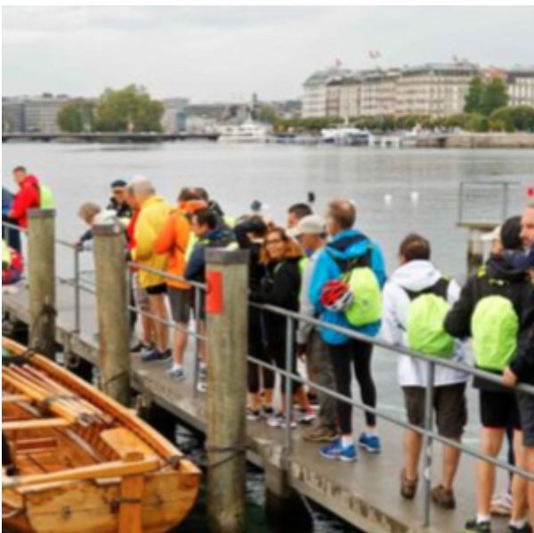

* Title: Examination for kids → “TRIATHLON PADDLING-CYCLING-WALKING FOR HEART PATIENTS”
* Text: “8 km of rowing, 60 km of cycling and 35 km of walking, this is the challenge achieved on September 5 by patients monitored in cardiology.”
* Add button: “See more” → Link to <https://www.fondationhug.org/news-triathlon%20RPM>



* image:

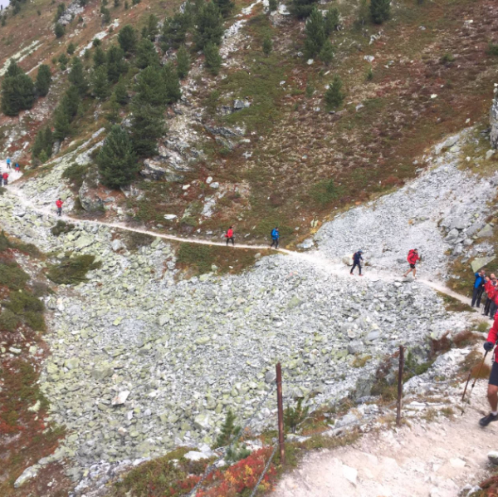

* Title: Examination for kids → “SIERRE-ZINAL AFTER AN INFARCTION”
* Text: “Promote rehabilitation through physical exercise in patients with cardiovascular disorders.”
* Add button: “See more” → Link to https://www.fondationhug.org/Sierre-Zinal



* Image:

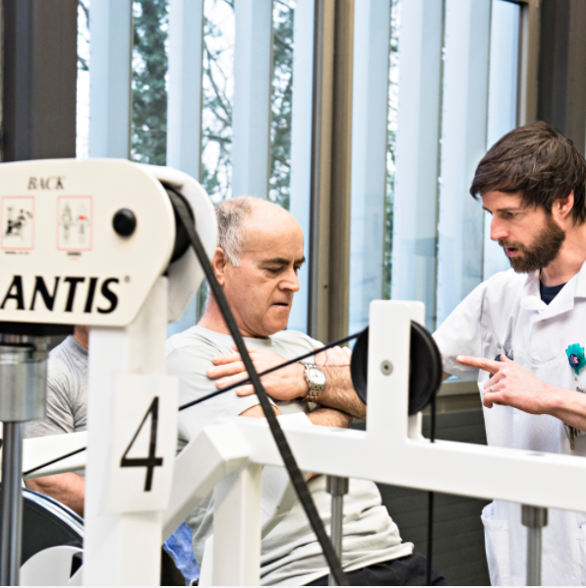

* Title: Examination for kids → “EUREKA IT STARTED!”
* Text: “Post-infarction patients more fit than ever!”
* Add button: “See more” → Link to https://www.fondationhug.org/news_eurecal



* Image:

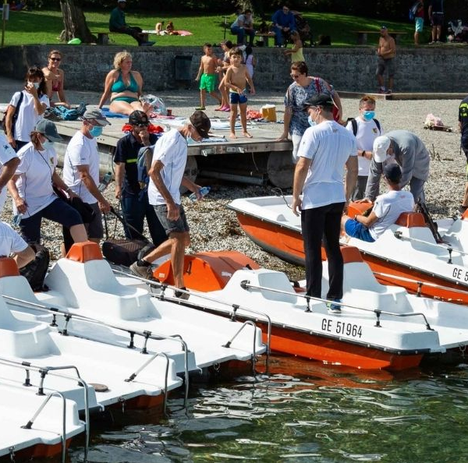

* Title: Examination for kids → “NEW SPORT CHALLENGES FOR PATIENTS WITH HEART ACCIDENT HISTORY”
* Text: “About thirty patients took part in the three-day sports event organized by the Cardiology Department of the HUG”
* Add button: “See more” → Link to https://www.fondationhug.org/news-epreuve-forts



* Image:

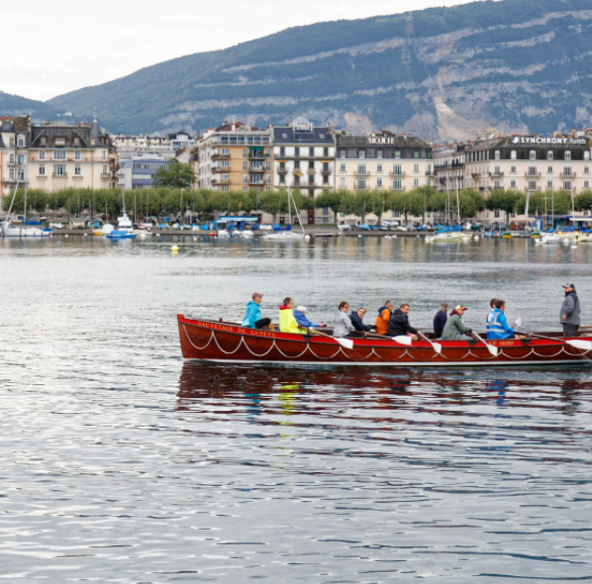

* Title: Examination for kids → “AFTER A INFARCTION, A TRIATHLON AROUND LAKE GENEVA!”
* Text: “Integrate physical activity in patients with heart failure as a daily activity in their new quality of life.”
* Add button: “See more” → Link to https://www.fondationhug.org/apres_infarctus_triathlon_leman



* Image:

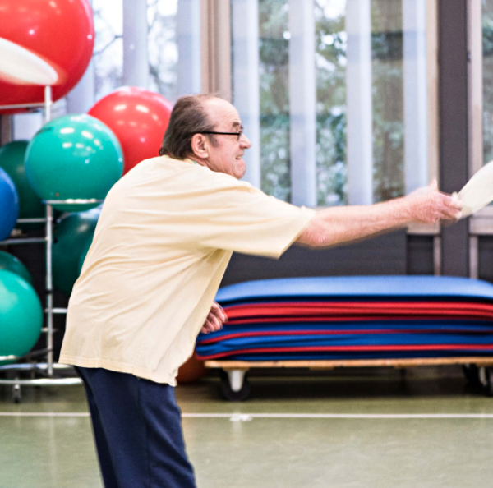

* Title: Examination for kids → “CARDIOVASCULAR REHABILITATION: A LONG-TERM WORK!”
* Text: “Establishment of a professional physical rehabilitation program with supervision by medical staff”
* Add button: “See more” → Link to https://www.fondationhug.org/Readaptation_cardio-vasculaire

**C4. FAQ**



* Frequently asked questions → “Frequently asked questions” - Add text:

1. “[What are the main heart diseases?](https://youtu.be/q2LeTvHM824)”

→ Drop down

Image



Link: https://www.youtube.com/watch?v=q2LeTvHM824

1. “[How do you know if you have a heart problem?](https://youtu.be/tWphCBowbYQ)”

→ Drop down

Image



Link: https://www.youtube.com/watch?v=tWphCBowbYQ

1. ["What are the warning signs of a heart attack?"](https://youtu.be/qRmbKxy7iJA)

→ Drop down

Image



Link: <https://www.youtube.com/watch?v=qRmbKxy7iJA>

1. [“How to deal with heart disease?”](https://youtu.be/qRmbKxy7iJA)

→ Drop down

Image

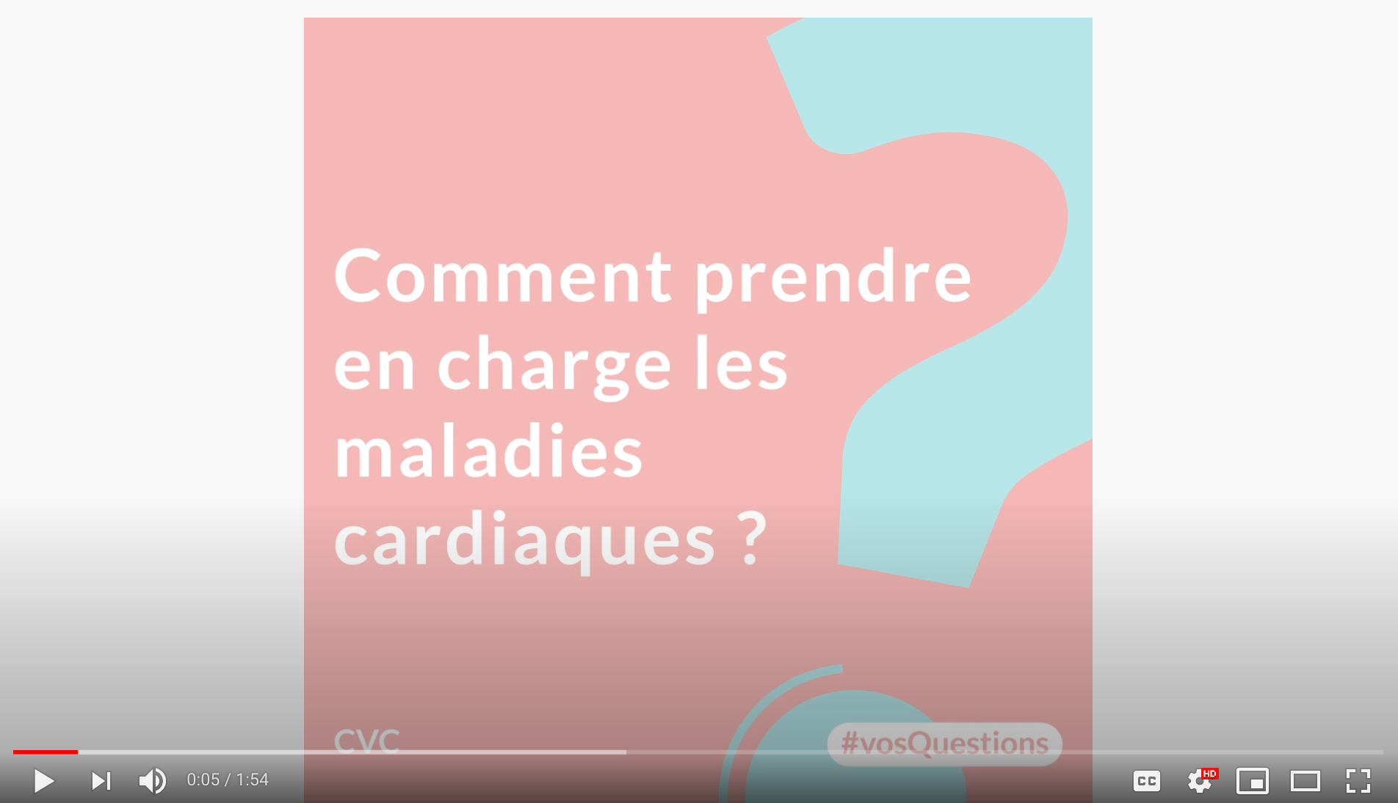

Link: <https://www.youtube.com/watch?v=1fTLpBGVbcg>

1. "Can you have a heart attack more than once?"

→ Drop down

Image

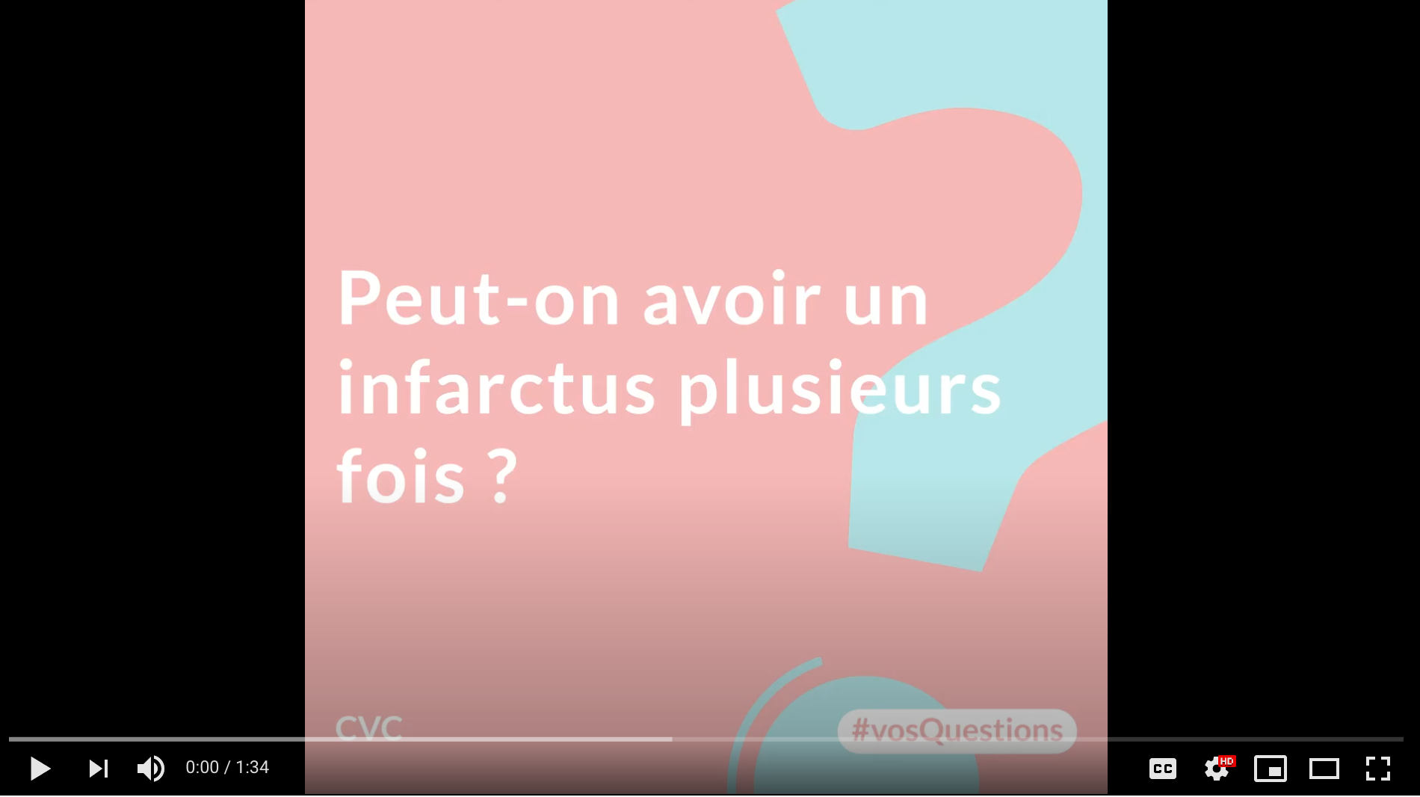

Link: <https://www.youtube.com/watch?v=BjKnAt19iHI>

1. “How to live with heart failure? ”

→ Drop down

Image

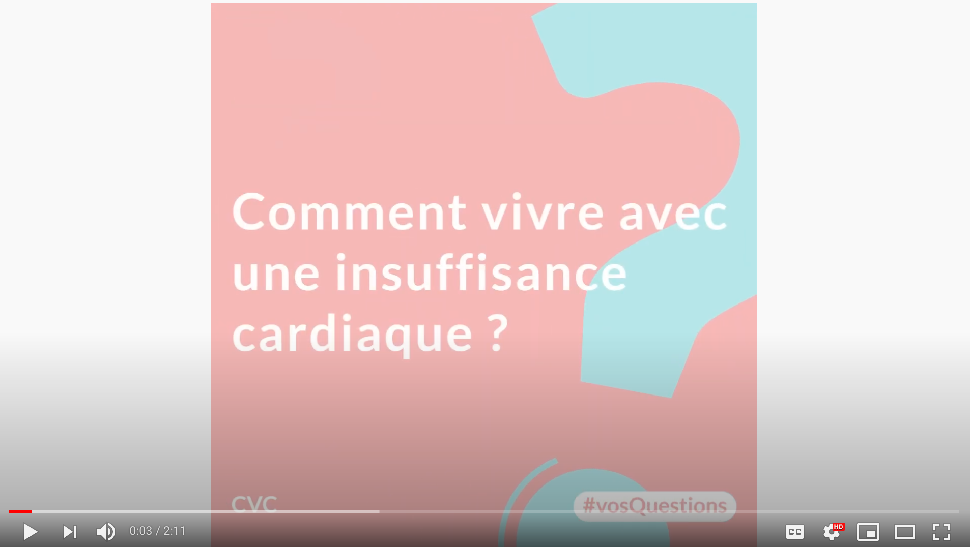

Link: <https://www.youtube.com/watch?v=vFptwpR4EnQ>

1. "What is stress ? ”

→ Drop down

Image

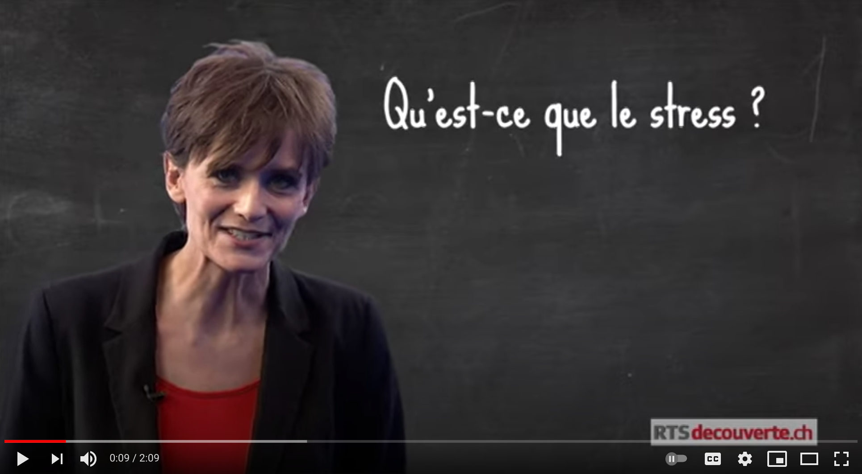

Link: https://www.youtube.com/watch?v=uELFQiSJAwg&list=PLZ0bTMBjdXfH9CggJIjuhpr07nlc_jAyi&index=4&t=18s

1. “What to do with unstable angina or myocardial infarction?”

→ Drop down

Image

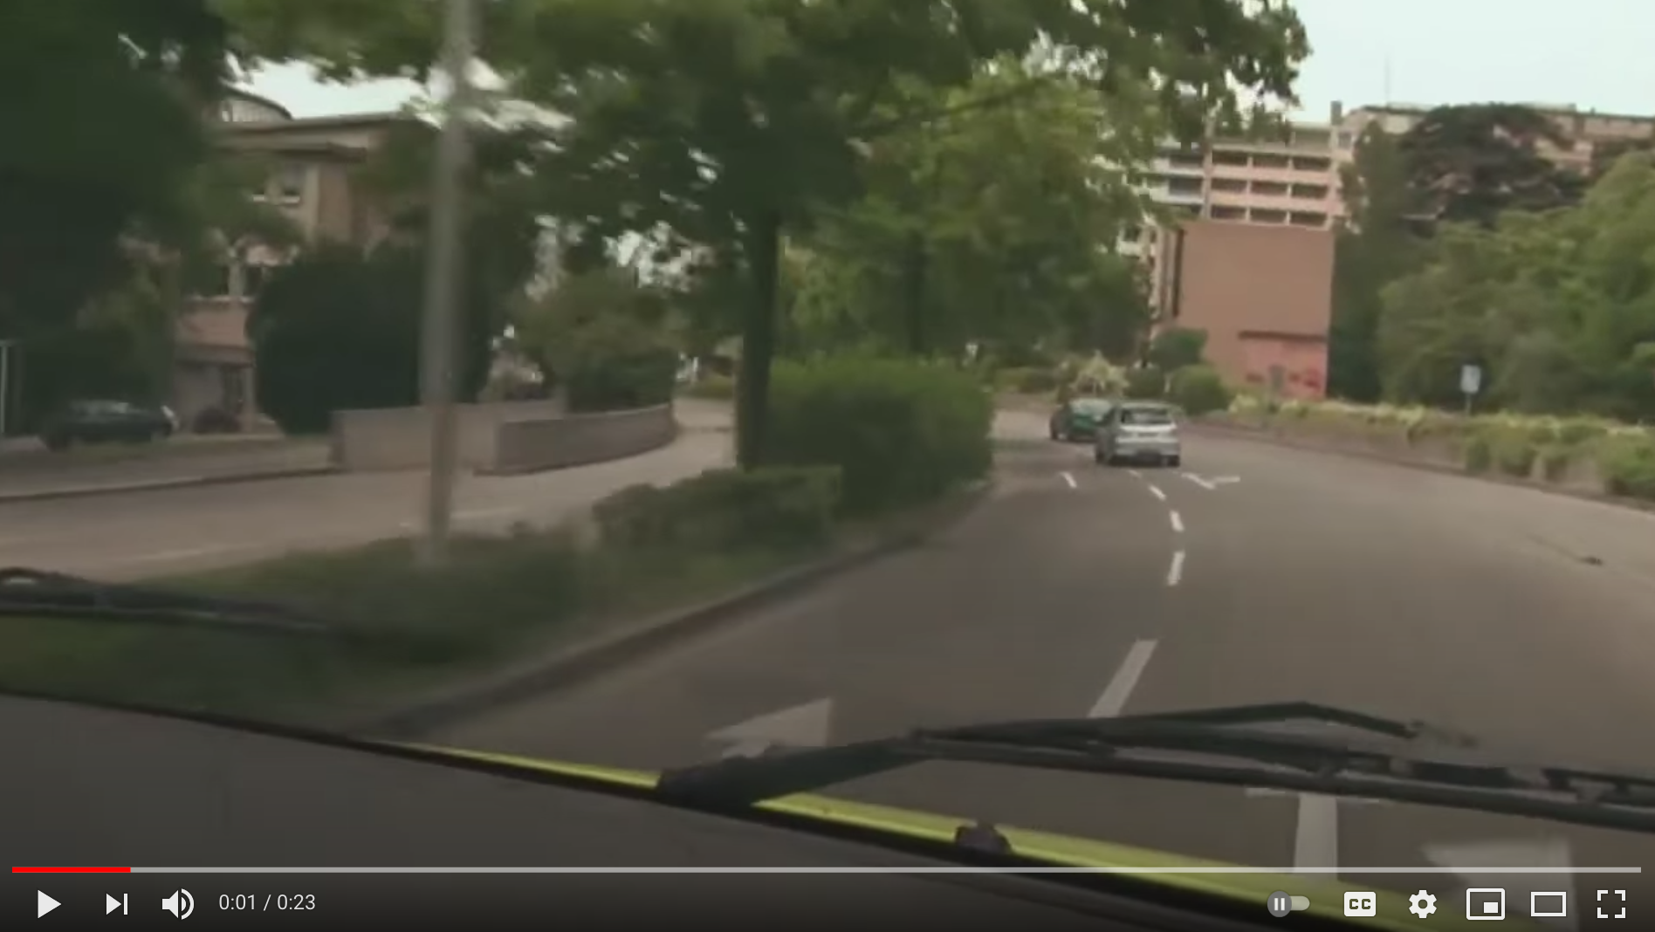

Link: <https://www.youtube.com/watch?v=6k7nzzpdi1o&list=PLZ0bTMBjdXfH9CggJIjuhpr07nlc_jAyi&index=10>

1. “What is interventional cardiology?”

→ Drop down

Image

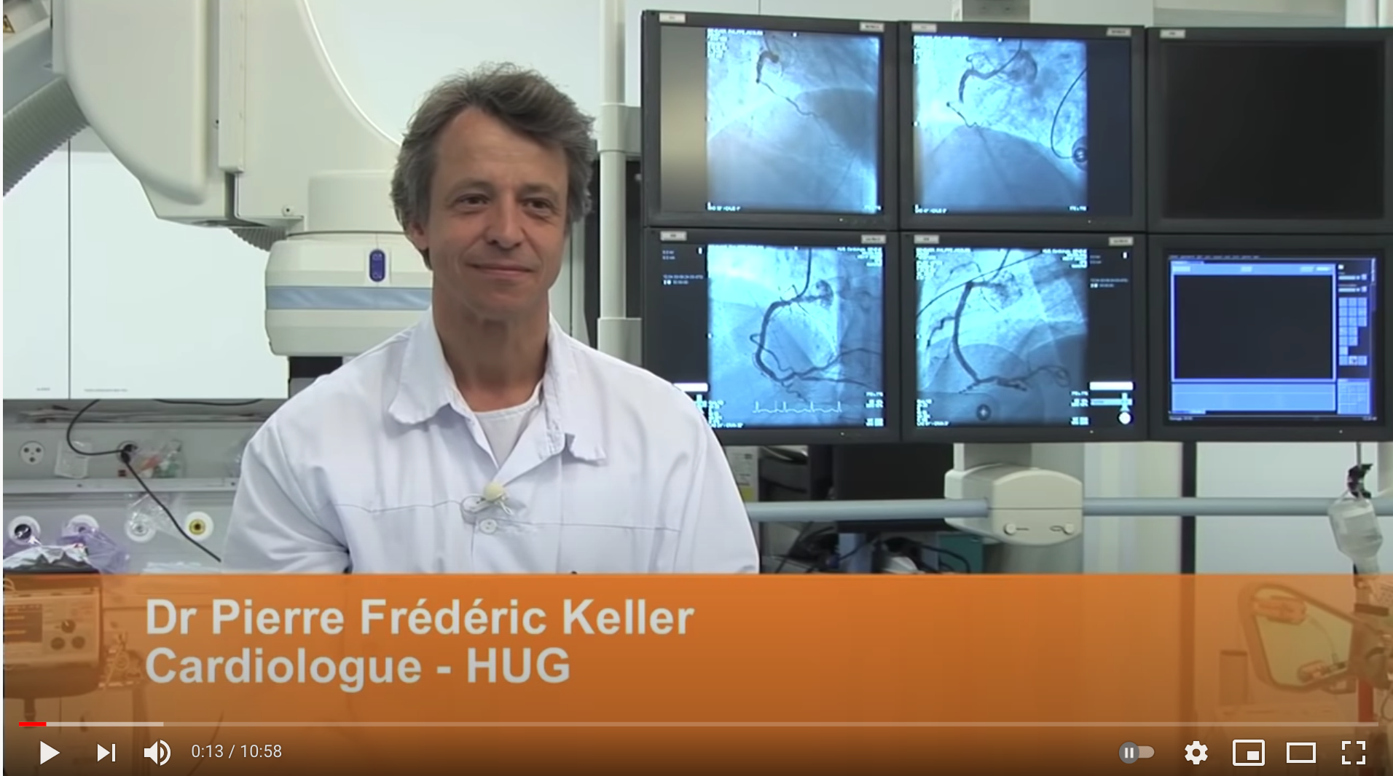

Link: <https://www.youtube.com/watch?v=SJaQe-KN5Yw&list=PLZ0bTMBjdXfH9CggJIjuhpr07nlc_jAyi&index=5&t=1s>

1. “Case Study: Justine’s Heart”

→ Drop down

Image

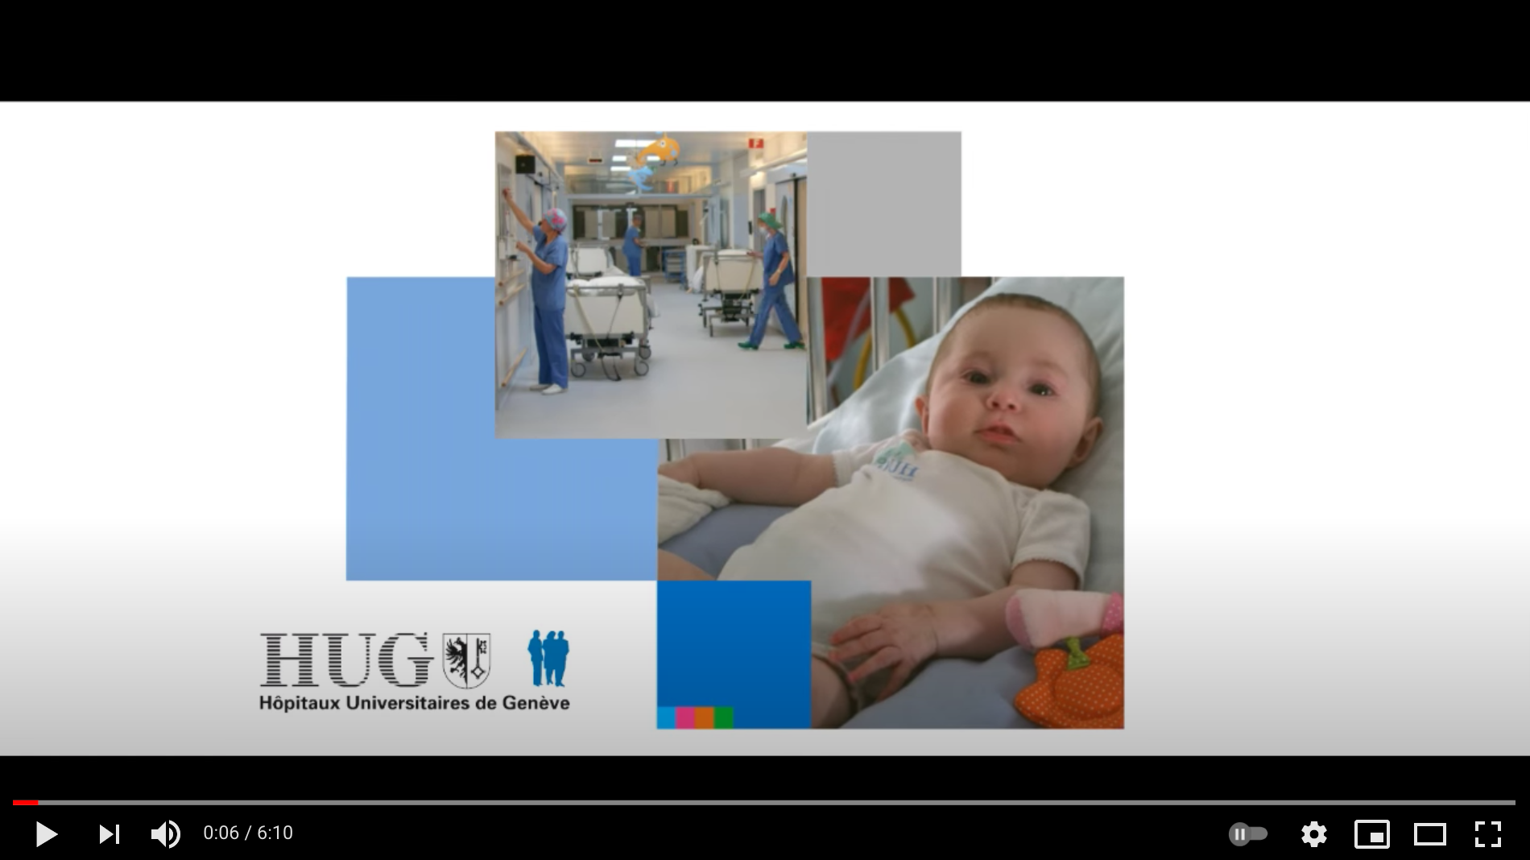

Link: <https://www.youtube.com/watch?v=B5m84nIUT6s&list=PLZ0bTMBjdXfH9CggJIjuhpr07nlc_jAyi&index=8>

1. “What is coronary angioplasty?”

→ Drop down

Image

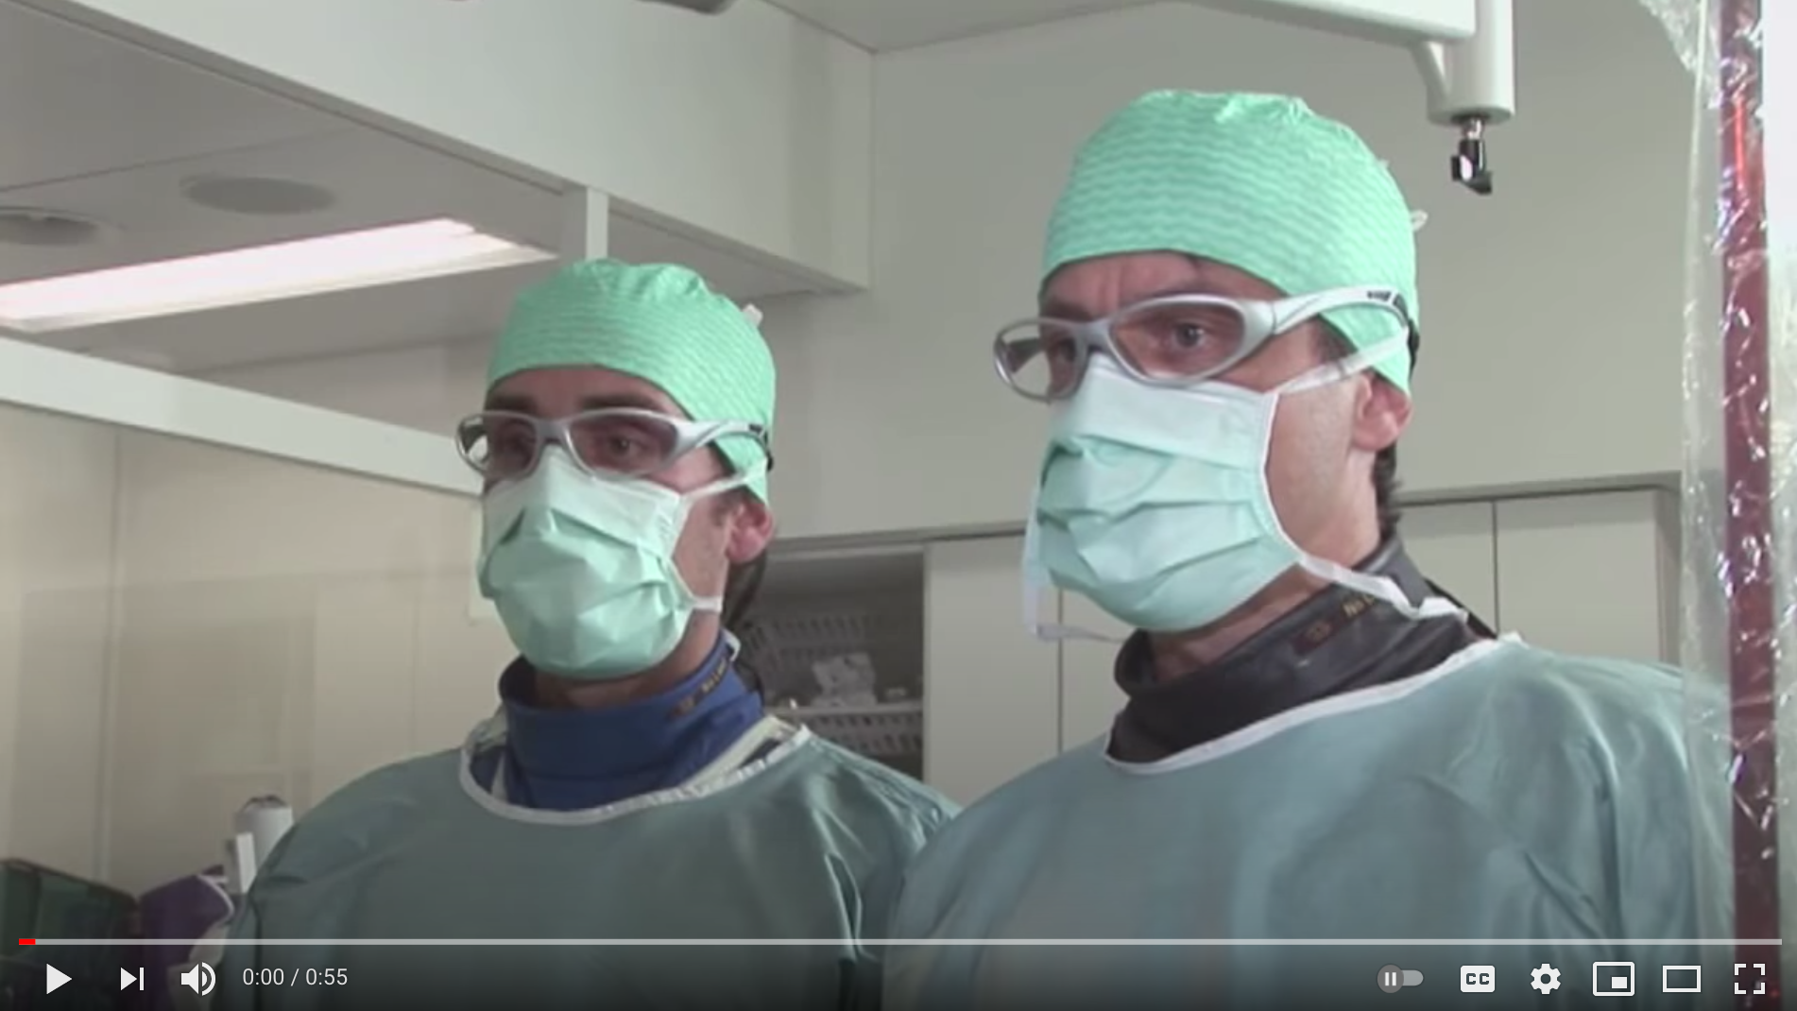

Link: https://www.youtube.com/watch?v=v59xXDsAAdE&list=PLZ0bTMBjdXfH9CggJIjuhpr07nlc_jAyi&index=11

1. “What is the CPR TestLung?”

→ Drop down

Image

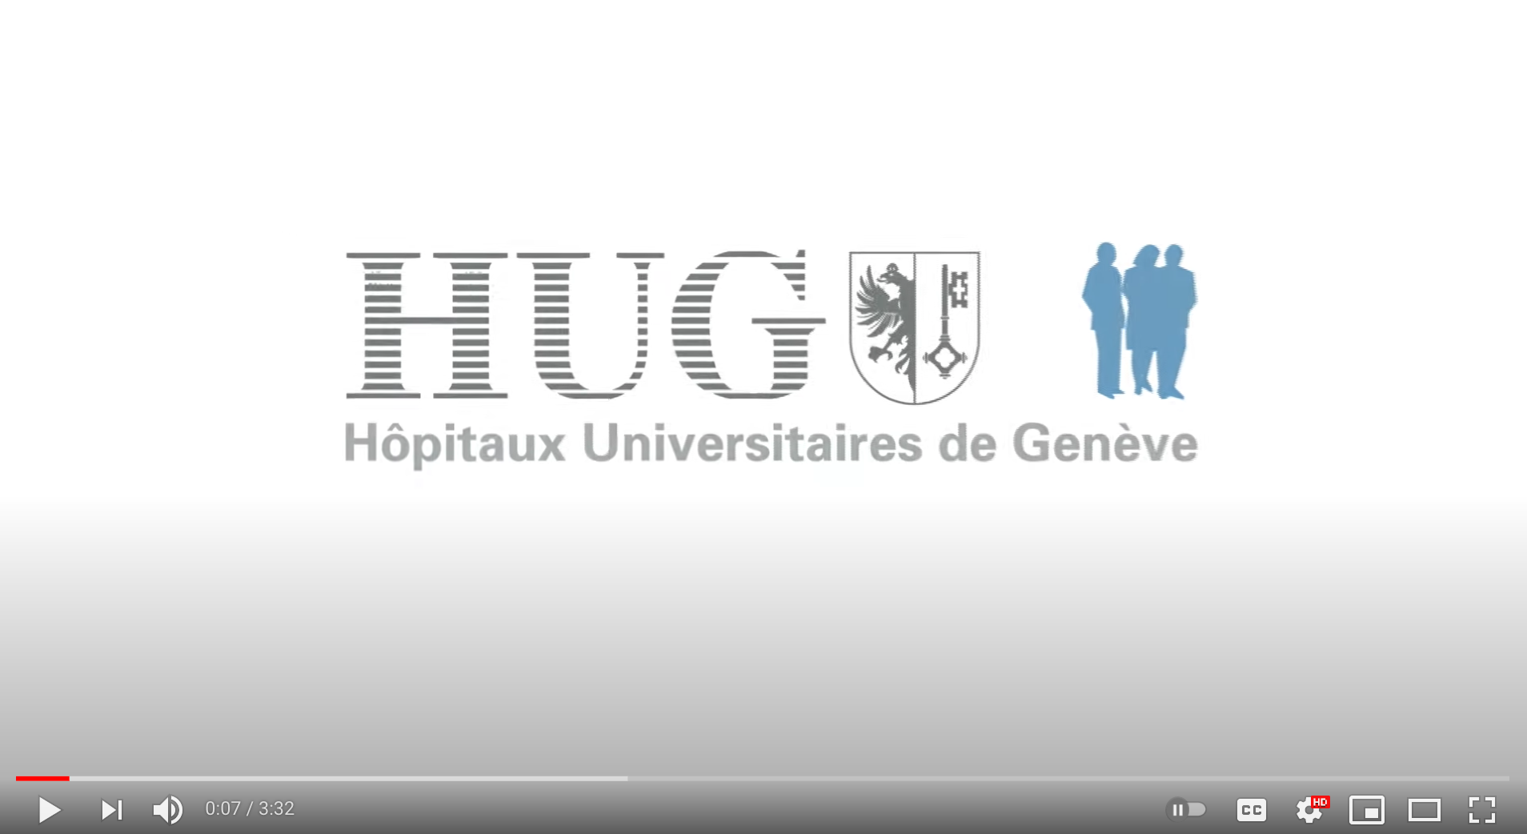

Link: https://www.youtube.com/watch?v=NFsHDrT6QAQ&t=1s&list=PLZ0bTMBjdXfH9CggJIjuhpr07nlc_jAyi&index=8

1. “What is the role of the heart and how does it work?”

→ Drop down

Image

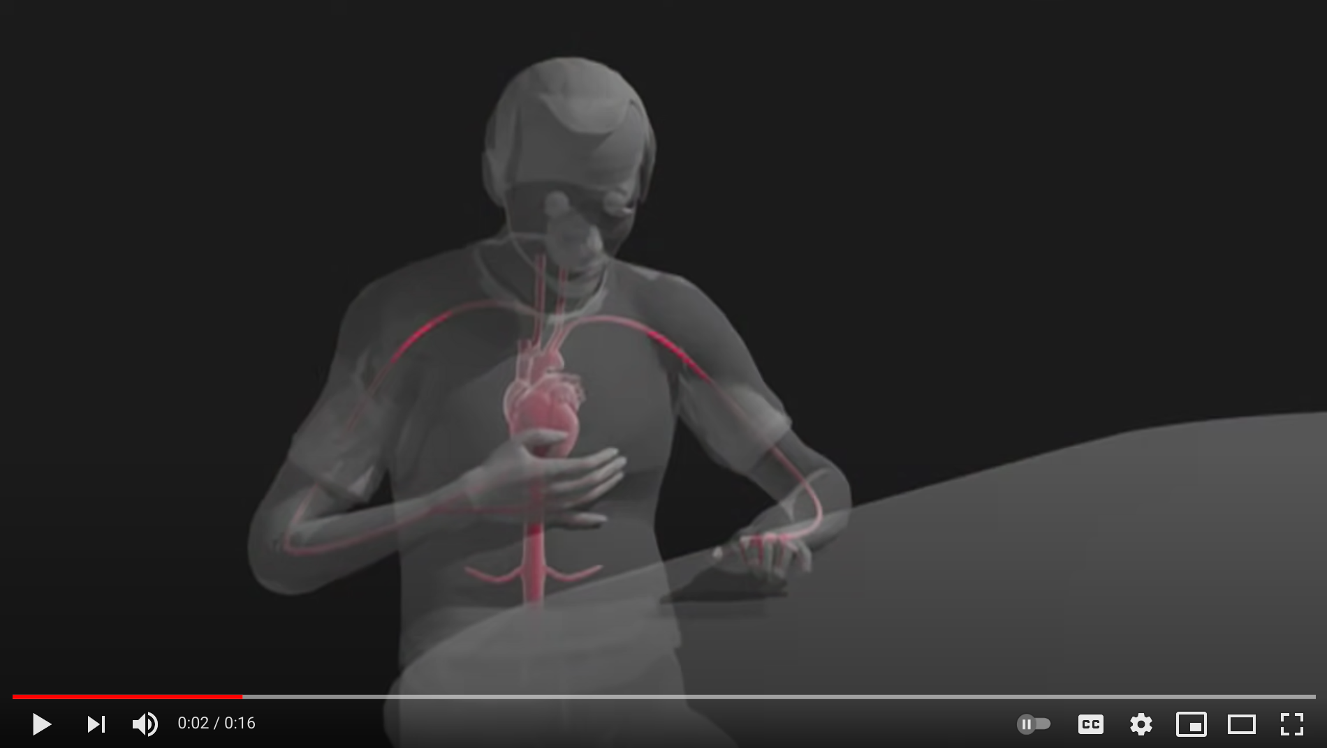

Link: <https://www.youtube.com/watch?v=3ijbJvHKG2M&list=PLZ0bTMBjdXfH9CggJIjuhpr07nlc_jAyi&index=12>

1. “How does a stress test work after a coronary angiography”

→ Drop down

Image

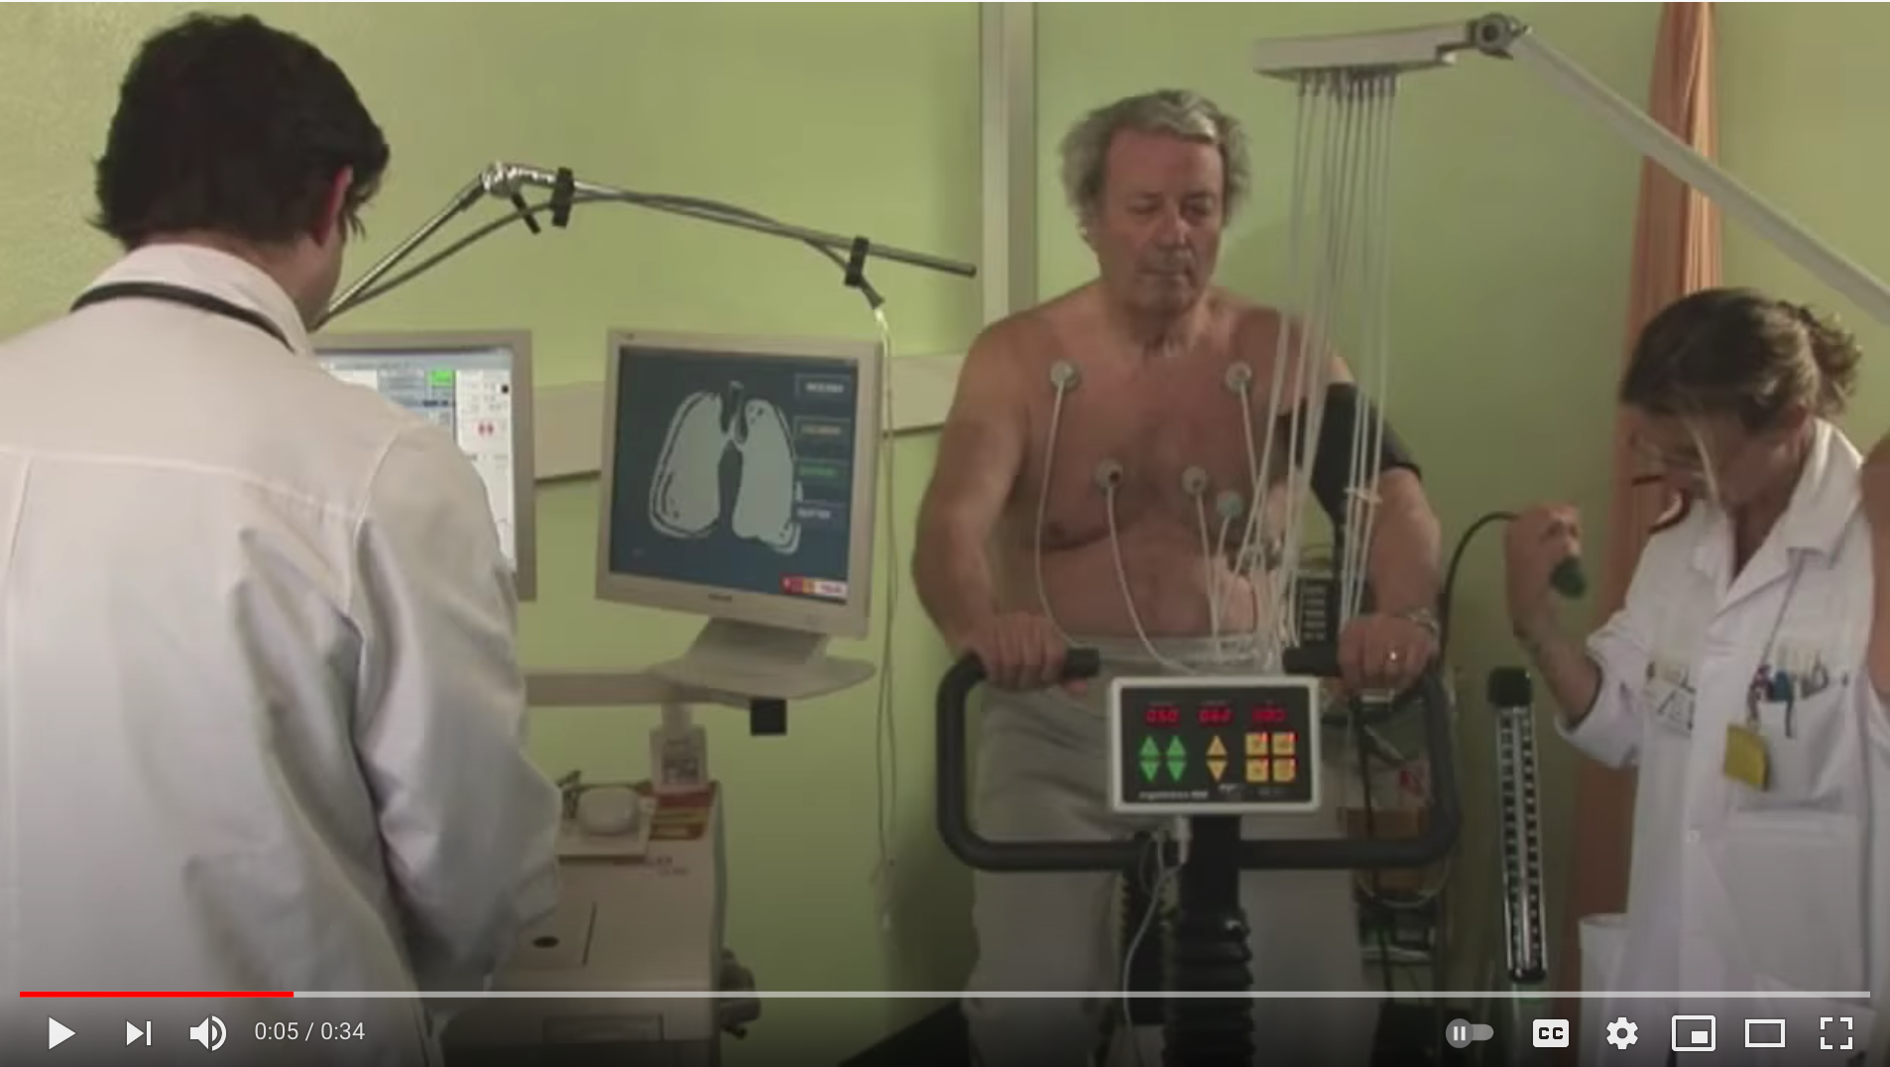

Link: <https://www.youtube.com/watch?v=qqachzNBDBs&list=PLZ0bTMBjdXfH9CggJIjuhpr07nlc_jAyi&index=13>

1. “What are antiplatelet drugs?”

→ Drop down

Image

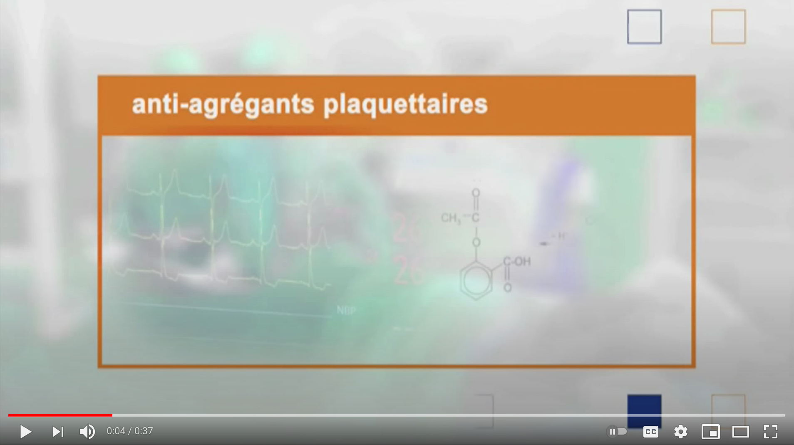

Link: https://www.youtube.com/watch?v=crkW1qH1S3Q&list=PLZ0bTMBjdXfH9CggJIjuhpr07nlc_jAyi&index=14

1. "What are beta blockers?"

→ Drop down

Image

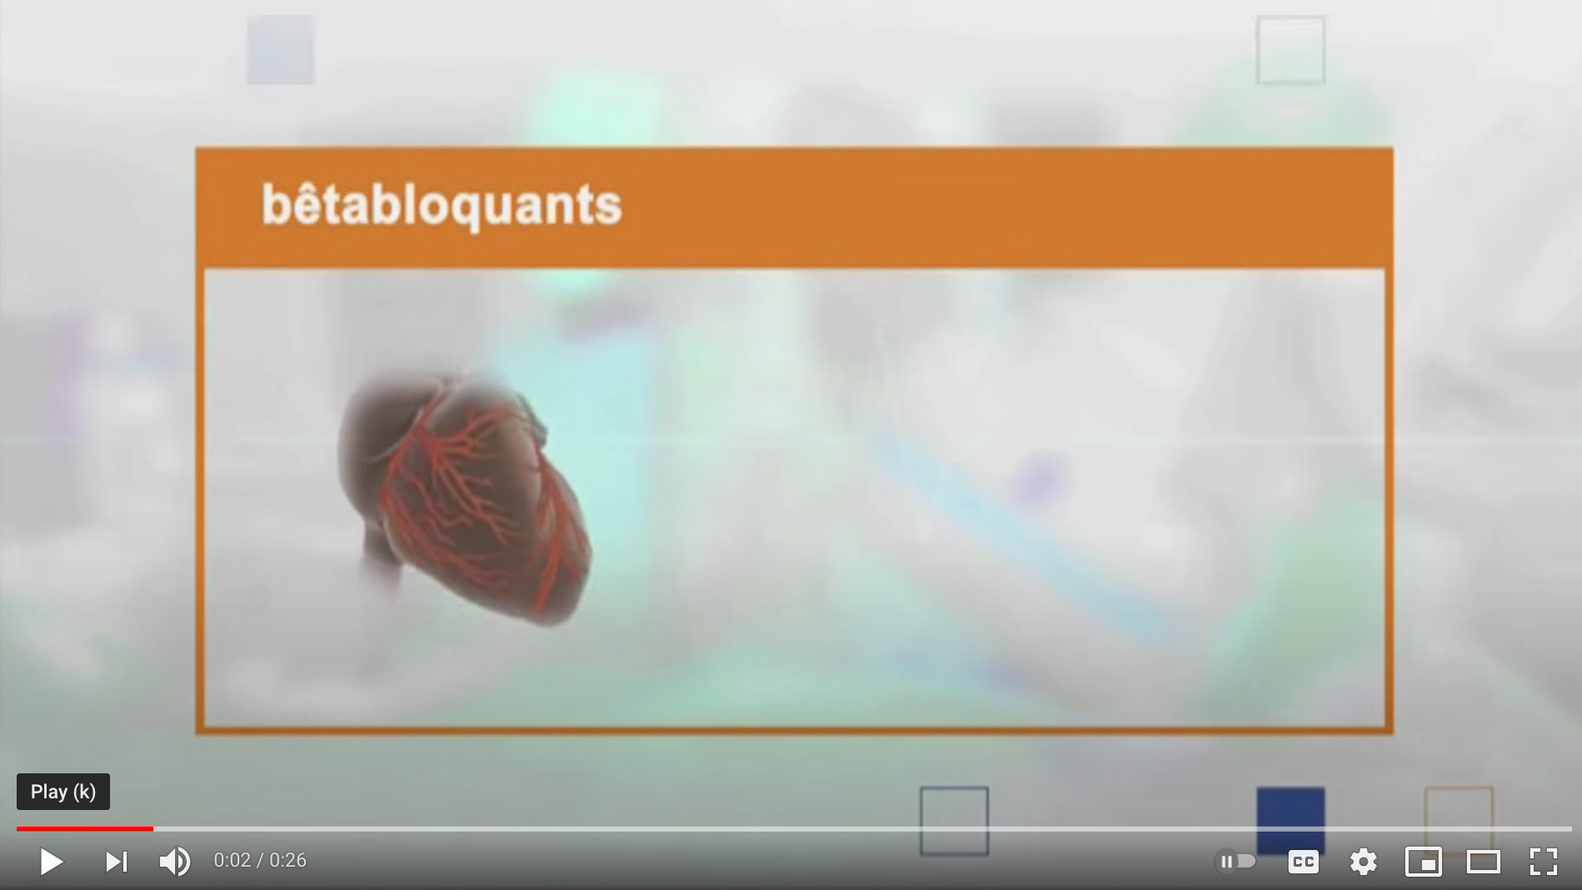

Link: https://www.youtube.com/watch?v=hulX76dUtB0&list=PLZ0bTMBjdXfH9CggJIjuhpr07nlc_jAyi&index=15

1. "What is coronary angiography?"

→ Drop down

Image

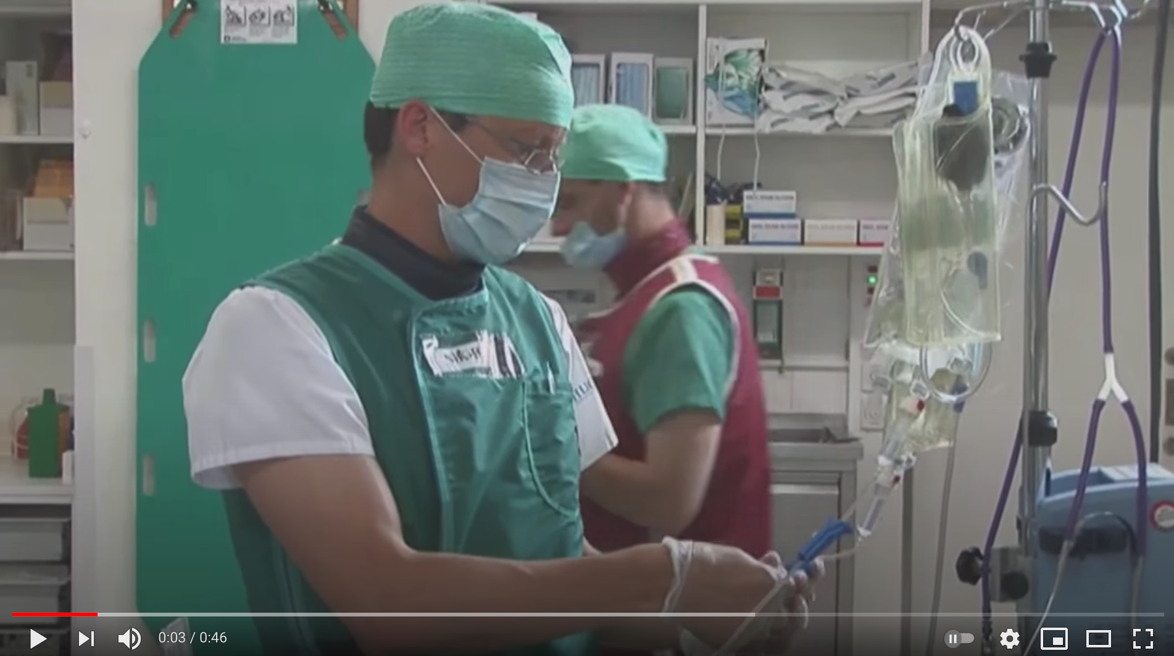

Link: <https://www.youtube.com/watch?v=JCYmVtf_Bi8&list=PLZ0bTMBjdXfH9CggJIjuhpr07nlc_jAyi&index=16>

1. "What is the role of angiotensin converting enzyme (ACE) inhibitors? What are the side effects?"

→ Drop down

Image

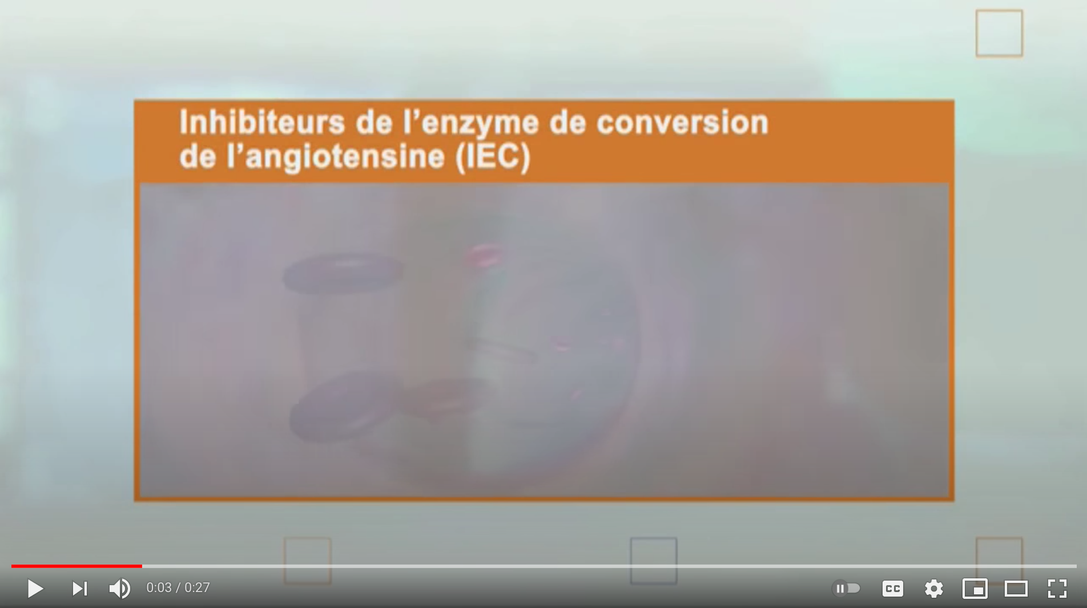

Link: https://www.youtube.com/watch?v=17iWdozHAl0&list=PLZ0bTMBjdXfH9CggJIjuhpr07nlc_jAyi&index=17

1. "Cardiac surgery: At the heart of the heart"

→ Drop down

Image

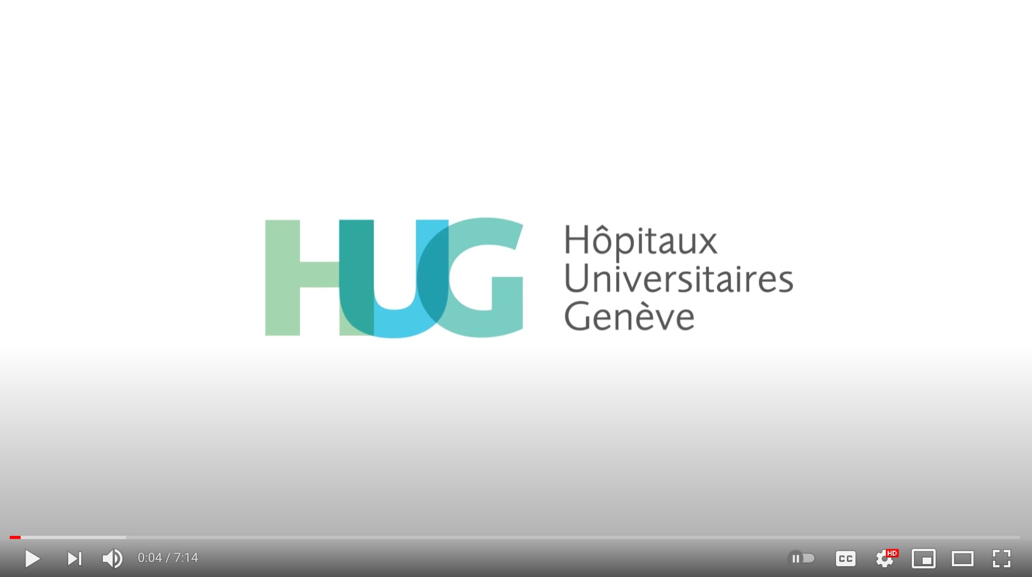

Link: https://www.youtube.com/watch?v=gQf5e5_88Sk&list=PLZ0bTMBjdXfH9CggJIjuhpr07nlc_jAyi&index=19

1. “With a light heart around the lake”

→ Drop down

Image

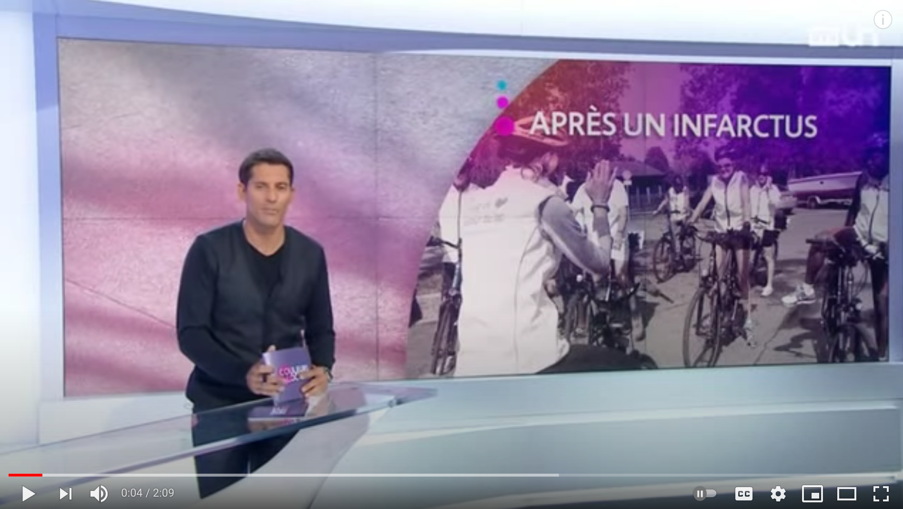

Link: <https://www.youtube.com/watch?v=CqlHXsyU0ZY&list=PLZ0bTMBjdXfH9CggJIjuhpr07nlc_jAyi&index=21>

1. "How is the initial medical management of a myocardial infarction going?"

→ Drop down

Image

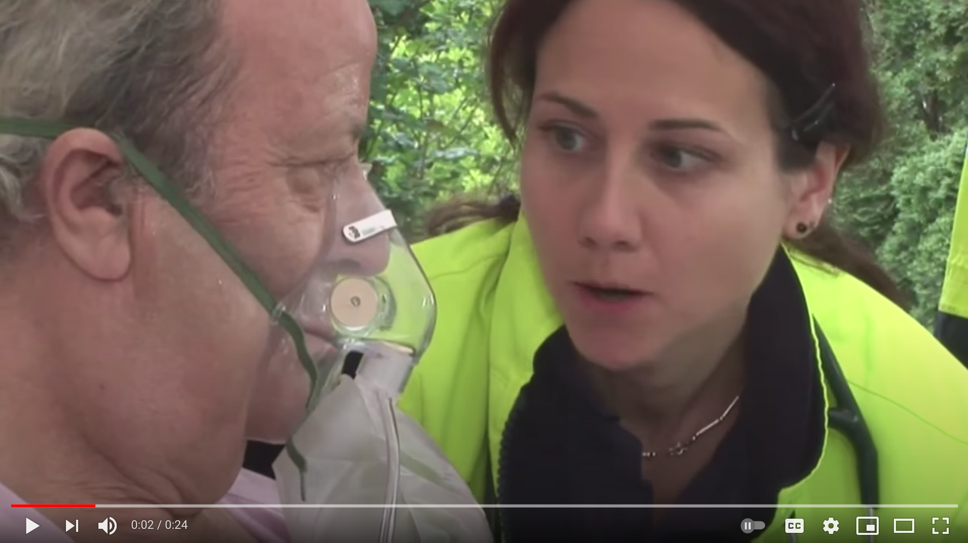

Link: https://www.youtube.com/watch?v=_s4MGecriuE&list=PLZ0bTMBjdXfH9CggJIjuhpr07nlc_jAyi&index=21

1. Contact form

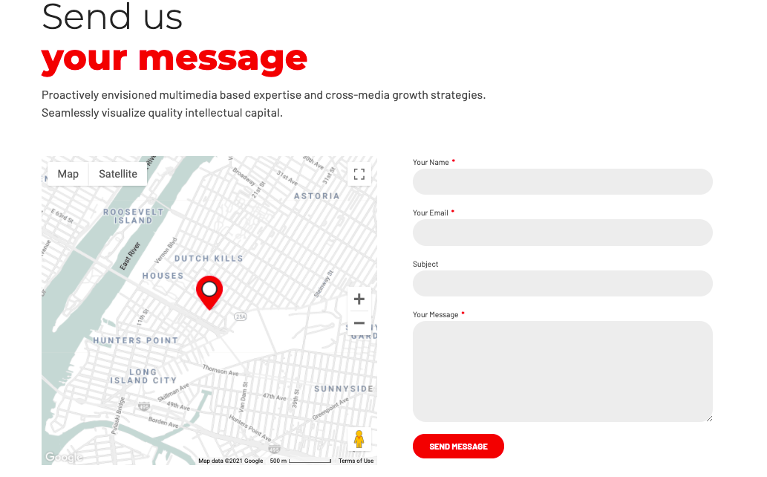

**C5. Doctors directory**

SAME THAN B5

**D. Training**

Mockup: https://cardiologygeneva.viewmysitenow.com/concept/02/formation.html



* Heart transplant → “Training”



* Heart transplant → “Post-graduate training”
* Text:
* Intended for future specialists in cardiology. Therefore particularly important for ensuring academic continuation and guaranteeing high-quality, high-level liberal medicine.

This teaching revolves around the daily activity of the service, presentations and discussions of cases, multidisciplinary conferences, Journal clubs which make it possible to follow the literature and discuss topics related to research, as well as consultations. with senior doctors.

* Add button: “More information”



* Heart transplant → “Continuing education”
* Text:

Organized in the form of symposiums, the continuing training provided by the cardiology service is aimed at all health professionals, including established doctors.

The program includes:

* weekly cardiology symposiums
* the multidisciplinary Thursday symposia, under the aegis of the cardiology, cardiovascular surgery and pediatric cardiology departments.
* the seminars of the Faculty of Medicine
* annual and extraordinary conferences
* Add button: “More information”



Medicare updates → “Les prochains colloques”

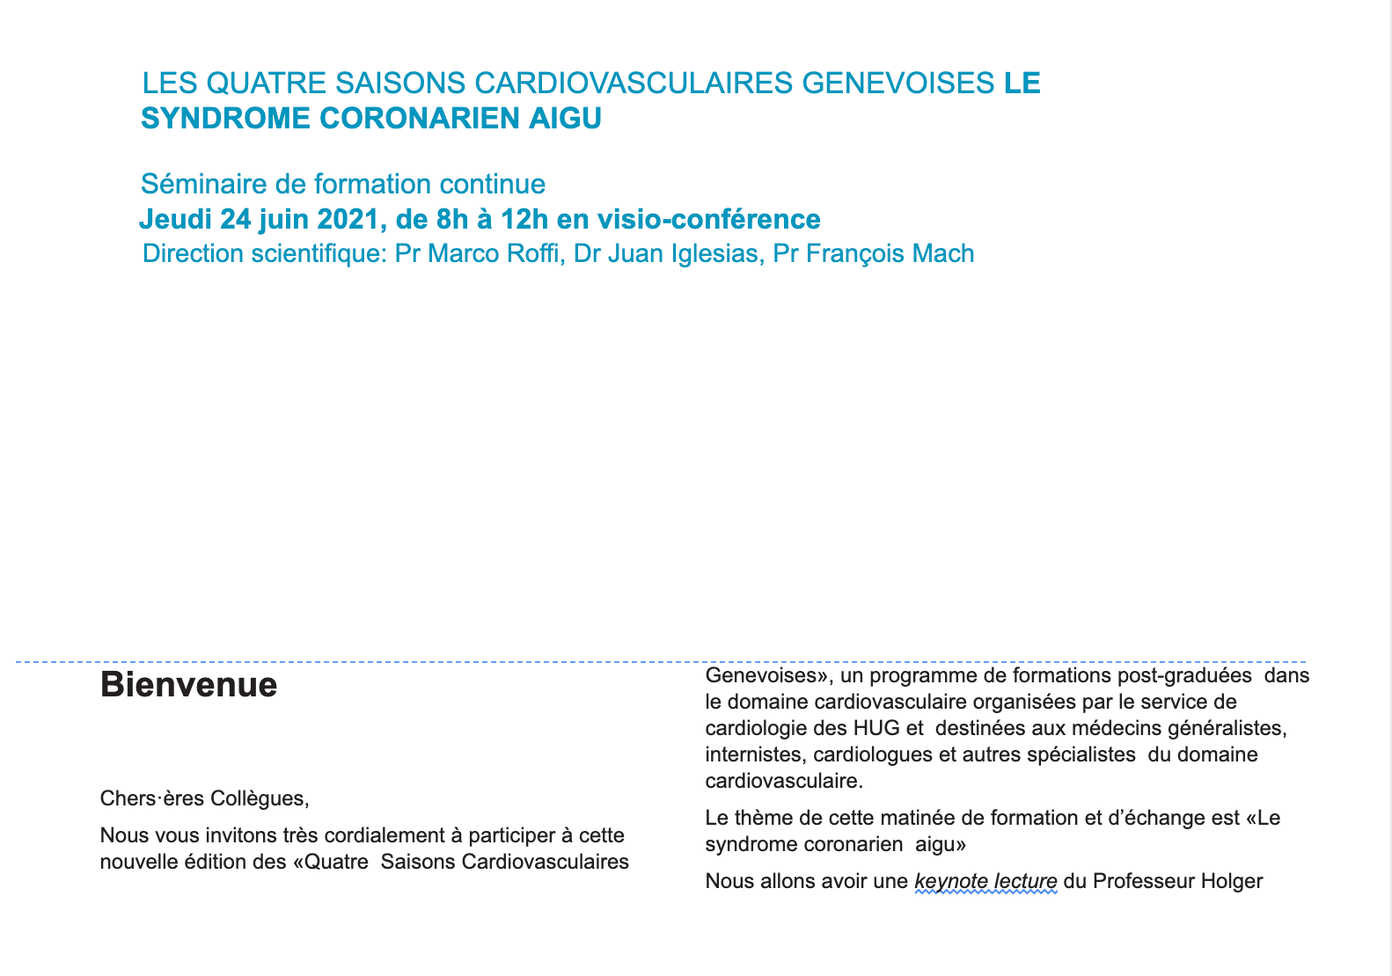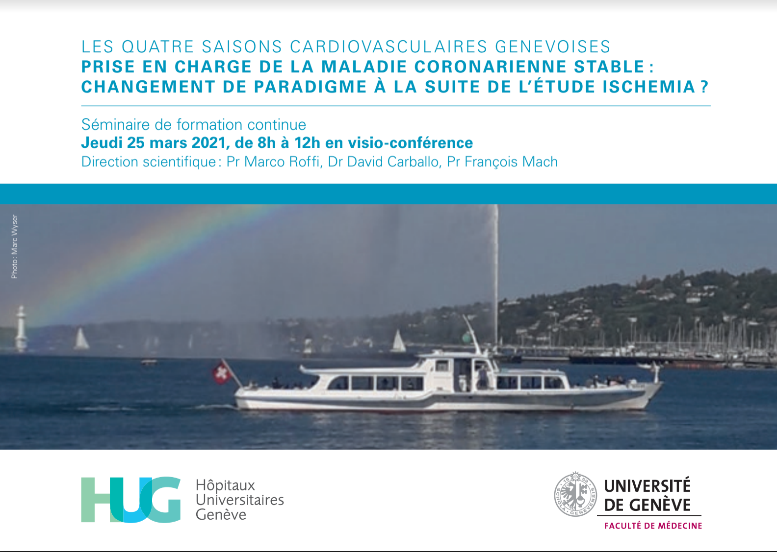

Add button: “see all symposiums” redirecting to page “Symposiums”

**D1. Post graduate training**

Mockup: https://cardiologygeneva.viewmysitenow.com/concept/02/formation-post.htm

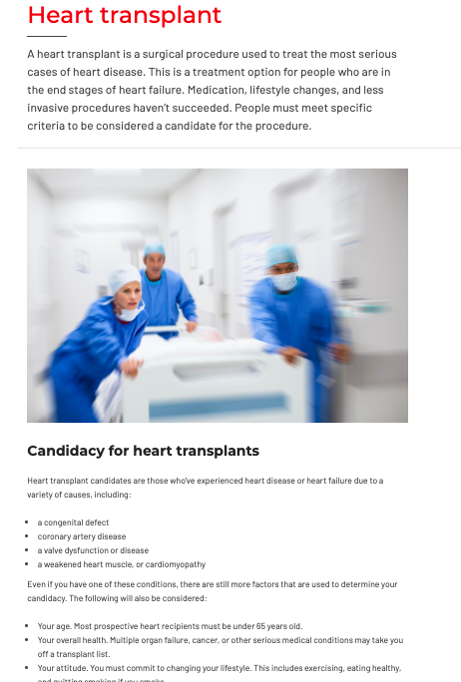

Heart transplant **→ “**Post graduate training**”**

Text: “Intended for future specialists in cardiology. Therefore particularly important for ensuring academic continuation and guaranteeing high-quality, high-level liberal medicine.

This teaching revolves around the daily activity of the service, presentations and discussions of cases, multidisciplinary conferences, Journal clubs which make it possible to follow the literature and discuss topics related to research, as well as consultations. with senior doctors.

The Faculty of Medicine also offers a master of advanced studies in cardiology (MAS cardiology) which is particularly suitable for visiting physicians wishing to deepen their knowledge (90 ECTS credits) “

“MAS - cardiology” redirect to https://www.unige.ch/medecine/en/enseignement/formationpostgrade/masteretudesavancees/masproposes/cardio/

Image:



Candidacy for heart transplant → “Faculty of Medicine”

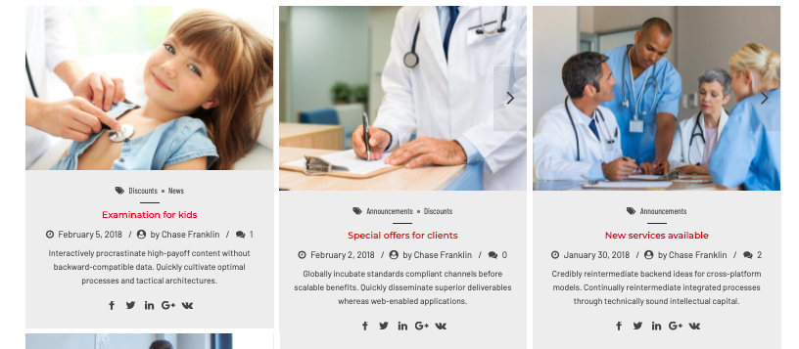

Put header above: “Our next post-graduate symposiums”

Column 1:

Examination for kids → “Preventive cardiology: Arterial Hypertension”

Date → “15th september 2021”

By → “G.Ehret”

Remove image, “Discounts”, “News”, other text, social media logos

Column 2:

Examination for kids → “Pulmonary hypertension: etiology, classification, diagnosis, treatment”

Date → “13th october 2021”

By → “J. Wacker et F. Lador”

Remove image, “Discounts”, “Announcement”, other text, social media logos

Column 3: Cancel

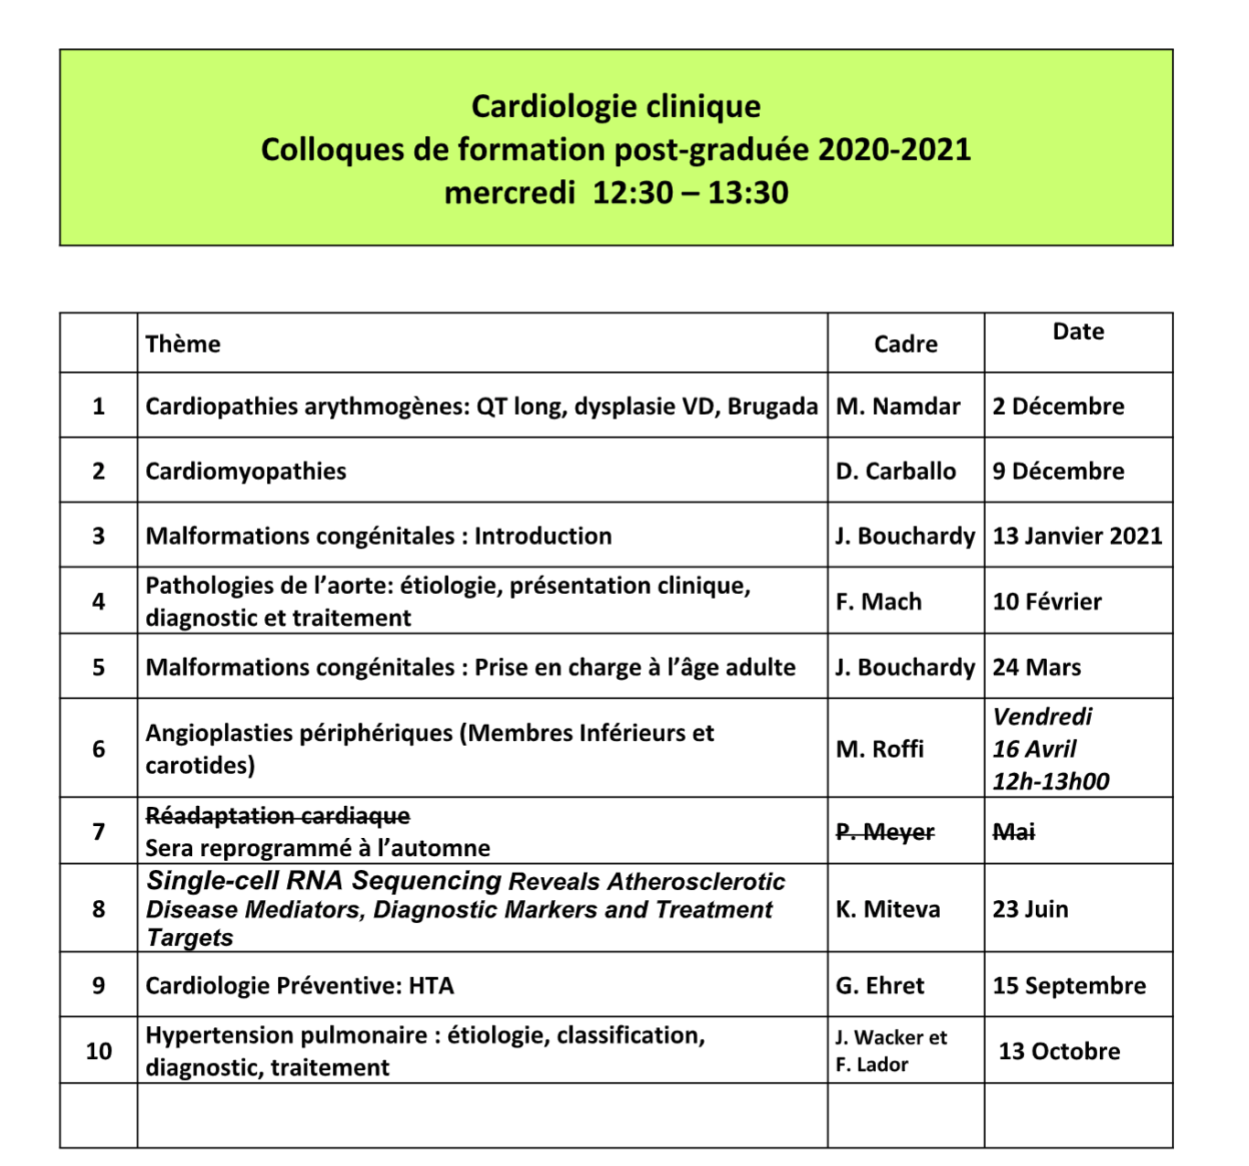

| Clinical Cardiology - Post graduate training Symposiums 2020-2021- Wednesdays 12:30-13:30 | | | |
| --- | --- | --- | --- |
|  | Topic | Presenter | Date |
| 1 | Arrhythmogenic heart disease: Long QT, RV dysplasia, Brugada | N. Namdar | 2nd december 2020 |
| 2 | Cardiomyopathies | D. Caballo | 9th december 2020 |
| 3 | Congenital malformation: Introduction | J. Bouchardy | 13th january 2021 |
| 4 | Pathologies of the aorta: etiology, clinical presentation, diagnosis and treatment | F. Mach | 10th february 2021 |
| 5 | Congenital malformation: Care in adulthood | J. Bouchardy | 24th march 2021 |
| 6 | Peripheral angioplasties (lower limbs and carotids) | M. Roffi | 16th april 2021 |
| 7 | Cardiac rehabilitation -> rescheduled in autumn 2021 | P. Meyer | may->autumn 2021 |
| 8 | Single-cell RNA sequencing reveals atherosclerotic disease mediators, diagnostic markers and treatment targets | K. Miteva | 23rd june 2021 |
| 9 | Preventive cardiology: Arterial hypertension | G. Ehret | 15th september 2021 |
| 10 | Pulmonary hypertension: etiology, classification, diagnosis, treatment | J. Wacker & F. Lador | 13th october 2021 |

**D2. Continuing education**



Heart transplant → “Continuing education”

Text: “Organized in the form of symposiums, the continuing training provided by the cardiology service is aimed at all health professionals, including established doctors.

The program includes:

* weekly cardiology symposiums
* the multidisciplinary Thursday symposia, under the aegis of the cardiology, cardiovascular surgery and pediatric cardiology departments.
* the seminars of the Faculty of Medicine
* annual and extraordinary conferences

Image:





Put header above: “Upcoming continuing education symposiums”

Column 1:

Examination for kids → “Meeting on inter-team collaboration for clinical studies of renal denervation”

Date → “24.08.2021”

By → “Dr Juan Iglesias, Dr Sophie Degrauwe, Laeticia Gallego”

Remove image, “Discounts”, “News”, other text, social media logos

Column 2:

Examination for kids → “Start of the Cardiology conferences on Thursday”

Date → “01.10.2021”

By → “ Dr Elena Tessitore”

Remove image, “Discounts”, “News”, other text, social media logos



Put header above: “Review the slides from past symposiums”

Column 1:

Examination for kids → “Stationary cardiovascular rehabilitation: program in Geneva”

Date → “15.04.2021”

By → “ Dr Elena Tessitore”

Remove image, “Discounts”, “News”, other text, social media logos

* Diapositives : fichier 2021.15.04Réadaptation cardiovasculaire-Tessitore.pdf
* Miniature : 2021.15.04Réadaptation cardiovasculaire-Tessitore.png

Column 2:

Examination for kids → “Cardiology research symposium”

Date → “20.04.2021 ”

By → “ Dr Sandra Handgraaf, Laeticia Gallego ”

Remove image, “Discounts”, “News”, other text, social media logos

* *Miniature : EASECardio_logo.png (à envoyer en annexe, diapos peut être trop privés)*

Column 3:

Examination for kids → “Heart metabolism”

Date → “022.04.2021”

By → “Dr Marc Scheen ”

Remove image, “Discounts”, “News”, other text, social media logos

**Add button: “See more → directing to page “Slides”**

**D2.1 Past symposiums and slides**

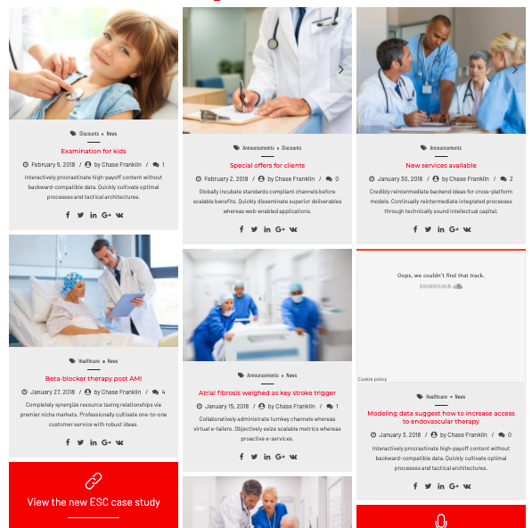

[2021.01-03 Programme des colloques multidisciplinaires du jeudi matin](https://docs.google.com/document/d/1f5U3mnxMwOLWft-Tlw8fG_R5OfFgJUcCcX-Lvb2vPzA/edit?usp=sharing)

[Avril_Juin 2021_ Programme des colloques multidisciplinaires du jeudi ma.._](https://docs.google.com/document/d/1ILukPMOF8dim4KXi4pY65j7KyrAzdRCTWSvGbHHVEJE/edit?usp=sharing)

[FINALE - 4saisons_Programme_Juin2021_web](https://docs.google.com/document/d/1-g6aJpOUiVOHDmy9pTk9DWXgzGrwlpgtWaJ1tPT47xI/edit?usp=sharing)

[APSO 19.10 20_.pptx](https://docs.google.com/presentation/d/1Rt-51I0SqPGzRhVK_WBHkPdMc0zU1Pel/edit?usp=sharing&ouid=102198289177715758089&rtpof=true&sd=true)

[Maladie coronarienne et sport.pptx](https://docs.google.com/presentation/d/197PgyYcqnOr9NoRB_RrWvux3mN_UnDRX/edit?usp=sharing&ouid=102198289177715758089&rtpof=true&sd=true)

[2021.06.17HTA, nouveautés en 2021- Pr Pechère.pdf](https://drive.google.com/file/d/19MyPNr_7TS1FfAKfkeFz9U7aImY9XNqU/view?usp=sharing)

[2021.05.27 LDL-Cholestérol-Mach.pdf](https://drive.google.com/file/d/1Cb2BZALhd9T37Jzm4B6AZRypRhAnYDwm/view?usp=sharing)

[2021.15.04Réadaptation cardiovasculaire-Tessitore.pdf](https://drive.google.com/file/d/13u57XtqxuGz4Wefysk_0T61EloaF59SE/view?usp=sharing)

[2021.20.05-Le pontage coronarien à coeur battant versus CEC-Cikirilkcioglu (1).pdf](https://drive.google.com/file/d/1RU1azX9EpUSdNhnRtq3js5XPiyjk4nb2/view?usp=sharing)

Section 1 :

Examination for kids → “Stationary cardiovascular rehabilitation: program in Geneva”

Date → “15.04.2021”

By → “ Dr Elena Tessitore”

Remove image, “Discounts”, “News”, other text, social media logos

* Diapositives : fichier 2021.15.04Réadaptation cardiovasculaire-Tessitore.pdf
* Miniature : 2021.15.04Réadaptation cardiovasculaire-Tessitore.png

Section 2:

Examination for kids → “Cardiology research symposium”

Date → “20.04.2021 ”

By → “ Dr Sandra Handgraaf, Laeticia Gallego ”

Remove image, “Discounts”, “News”, other text, social media logos

* *Miniature : EASECardio_logo.png (à envoyer en annexe, diapos peut être trop privés)*

Section 3:

Examination for kids → “Heart metabolism”

Date → “022.04.2021”

By → “Dr Marc Scheen ”

Remove image, “Discounts”, “News”, other text, social media logos

Section 4:

Examination for kids → “Artificial intelligence in cardiology: like CRP in coronary artery disease? ”

Date → “29.04.2021”

By → “Prof C. Lovis and Dr M.Namdar ”

Remove image, “Discounts”, “News”, other text, social media logos

Section 5:

Examination for kids → “Selection of interns for post-graduate training: evidence and tools”

Date → “06.05.2021 ”

By → “Dr Nadja Bajwa Médecin adjointe in charge of post graduate training”

Remove image, “Discounts”, “News”, other text, social media logos

20.05.2021 **On-Pump vs Off-Pump Coronary Artery Bypass Grafting** *Dr Mustafa Cikirikcioglu ( CHIR CV - HUG)*

* Diapositives : fichier 2021.20.05-Le pontage coronarien à coeur battant versus CEC-Cikirilkcioglu.pdf
* Miniature : 2021.20.05-Le pontage coronarien à coeur battant versus CEC-Cikirilkcioglu.png

27.05.2021 **LDL-cholesterol, the silence age** *Prof François Mach*

* Diapositives : fichier 2021.05.27 LDL-Cholestérol-Mach.pdf
* Miniature : 2021.05.27 LDL-Cholestérol-Mach.png

03.06.2021 **Advances in Cancer Therapies: The Role of the Cardiologist** *Dr. Laure Thouvenin, Dr Nita Usdin, Dr N. Poku*

17.06.2021 **Hypertension: news in 2021** *Prof Antoinette Pechère*

24.06.2021 - **4 seasons "Acute coronary syndrome" « 2020 NSTE-ACS Guidelines »** *Prof Roffi/Prof Mach*

**E. Research**

Mockup: https://cardiologygeneva.viewmysitenow.com/concept/02/research.html





* Examination for kids → “Clinical studies”:

Text: “Find all of our clinical studies”

Add button: “See all of our clinical studies”

Image:



Remove everything else

* Special offers for clients → “Fundamental studies”
* Text: “Find all of our fundamental studies”
* Add button: “See all of fundamental studies”
* Image:



* Remove everything else
* New services available → “Publications”
* Text: “Find all our publications”
* Add button: “See all publications”
* Image:

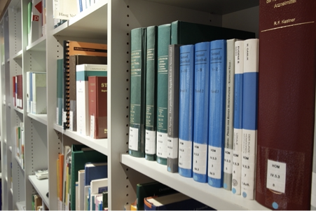

* Remove everything else

1. 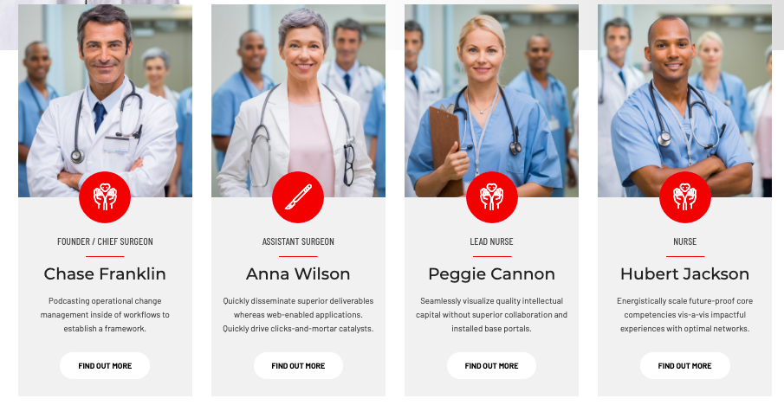

Put a header above: “The researchers”

Column 1:

Image:



Text:

PD Dr Juan F. Iglesias MD, FESC, FACC

Médecin Adjoint agrégé

Interventional cardiology unit

Cardiology division

Linkedin button

Twitter button

Column 2:

Image:



Text:

Pr Georg Ehret

Preventive cardiology, respondent in cardio-geriatrics

Cardiology service activities at Trois-Chêne hospital

Linkedin button

Twitter button

Column 3:

Image:

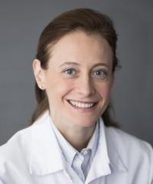

Text:

Dre Elena Tessitore

Cheffe de Clinique

Cardio-geriatrics

Cardiology service activities at Trois-Chêne hospital

Column 4:

Image:

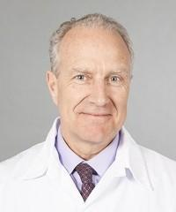

Text:

Pr François Mach

Médecin-head of service

Cardiology

Add button below: “See all researchers”

**E1. Clinical studies**

Mockup: https://cardiologygeneva.viewmysitenow.com/concept/02/clinical-study.html

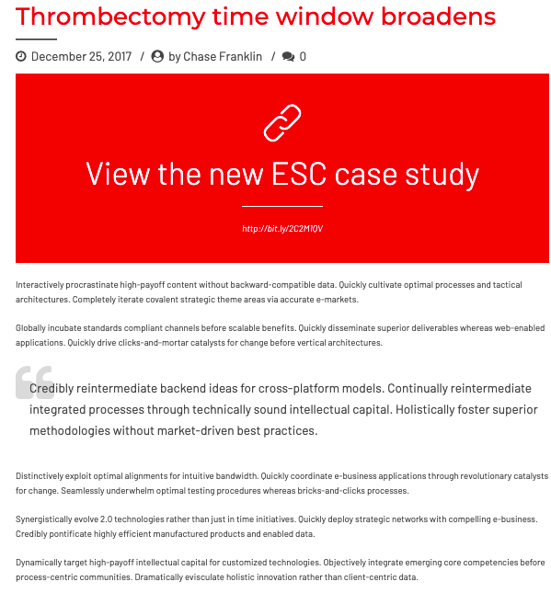

* Thrombectomy time window broadens → “Elips”
* Remove date, writer, comment icon
* View the new ESC case study → “Consult the study”
* Text: «
* Active sites in Switzerland: Geneva-HUG, Lausanne-CHUV, Zurich, Bern
* Study duration : 8 years
* Start 2009, End : 2018
* Property/Sponsor: HUG

Information program aimed at improving prevention and the chances of recurrence for any patient hospitalized following an acute coronary syndrome and evaluating its impact through a study.»

Add this logo:





* Thrombectomy time window broadens → “Horizon”
* Remove date, writer, comment icon
* View the new ESC case study → “Consult the study”
* Text:
* “Active sites in Switzerland: HUG, CHUV, Inselspital, Basel, Liestal
* Study duration : ~ 3 years
* Start in Geneva : september 2020
* Property: Novartis Pharmaceuticals

Clinical trial to assess the impact of lowering Lp (a) on major cardiovascular events in patients with a history of cardiovascular disease.»

Add this logo:





* Thrombectomy time window broadens → “Clever ACS”
* Remove date, writer, comment icon
* View the new ESC case study → “Consult the study”
* Text:
* “Active sites in Switzerland: Geneva-HUG, Bern-HUB, Lugano-Cardiocentro-Ticino, Zurich-HUZ
* Start : january 2015
* End : september 2021
* Property: Zurich University, Swiss National Science Foundation, Novartis Pharmaceuticals

Study on the short-term efficacy (5 days) of everolimus (Votubia on the Swiss market) on the size of the infarction, the scarring of the left ventricle and the inflammation compared to placebo in patients hospitalized with a myocardial infarction.»

Add this logo:



**E2. Fundamental studies**

**Title 1 :**

Follicular regulatory helper T cells control the response of regulatory B cells to a high-cholesterol diet

**By:**

Dr Miteva, Pr Mach

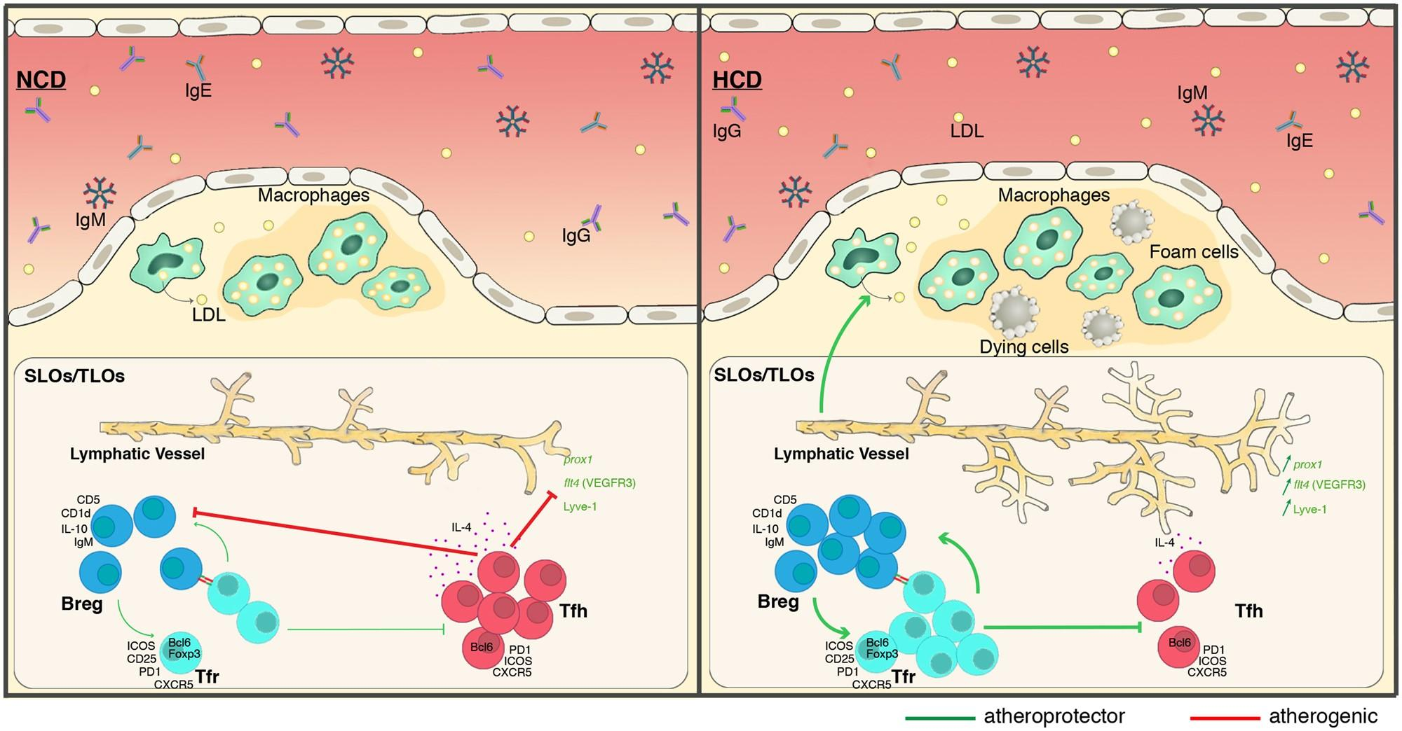

**Infos :**

**Status :** Finished on 19th april 2020, published 1st of March 2021

**Journal :** *Cardiovasc Res*, Volume 117, Issue 3, Pages 743–755

**Autors :** Fabienne Burger †,  Kapka Miteva,  Daniela Baptista,  Aline Roth,  Rodrigo A Fraga-Silva, Catherine Martel,  Nikolaos Stergiopulos,  François Mach,  Karim J Brandt

**Link to publication :** <https://doi.org/10.1093/cvr/cvaa069>

**Text :**

Our results suggest that Follicular regulatory T cell (TFR) populations play a crucial role in the establishment of atherosclerotic lesions in response to a high cholesterol Diet (HCD).

**Title 2 :**

Monocytes derived ROS triggers NLRP3 Inflammasome Activation in VSMCs and Promotes VSMCs Phenotypic Switch

**By:**

Dr Miteva, Pr Mach

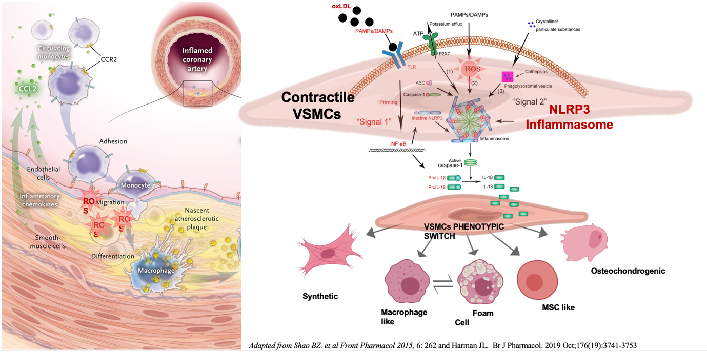

**Text:**

One of our recent finding demonstrates that monocytes which are the first wave of intima invading cells in atherosclerosis invade the intima and produce pro-inflammatory factors as well as reactive oxygen species and which could induce Vascular smooth muscle cells (VSMC).

**Title 3 :**

Single-cell RNA sequencing of CD45+ and CD45- cells derived from Apoe-/- mice on  
 a normal (NCD) or high cholesterol diet (HCD)

**By:**

Dr Miteva, Pr Mach

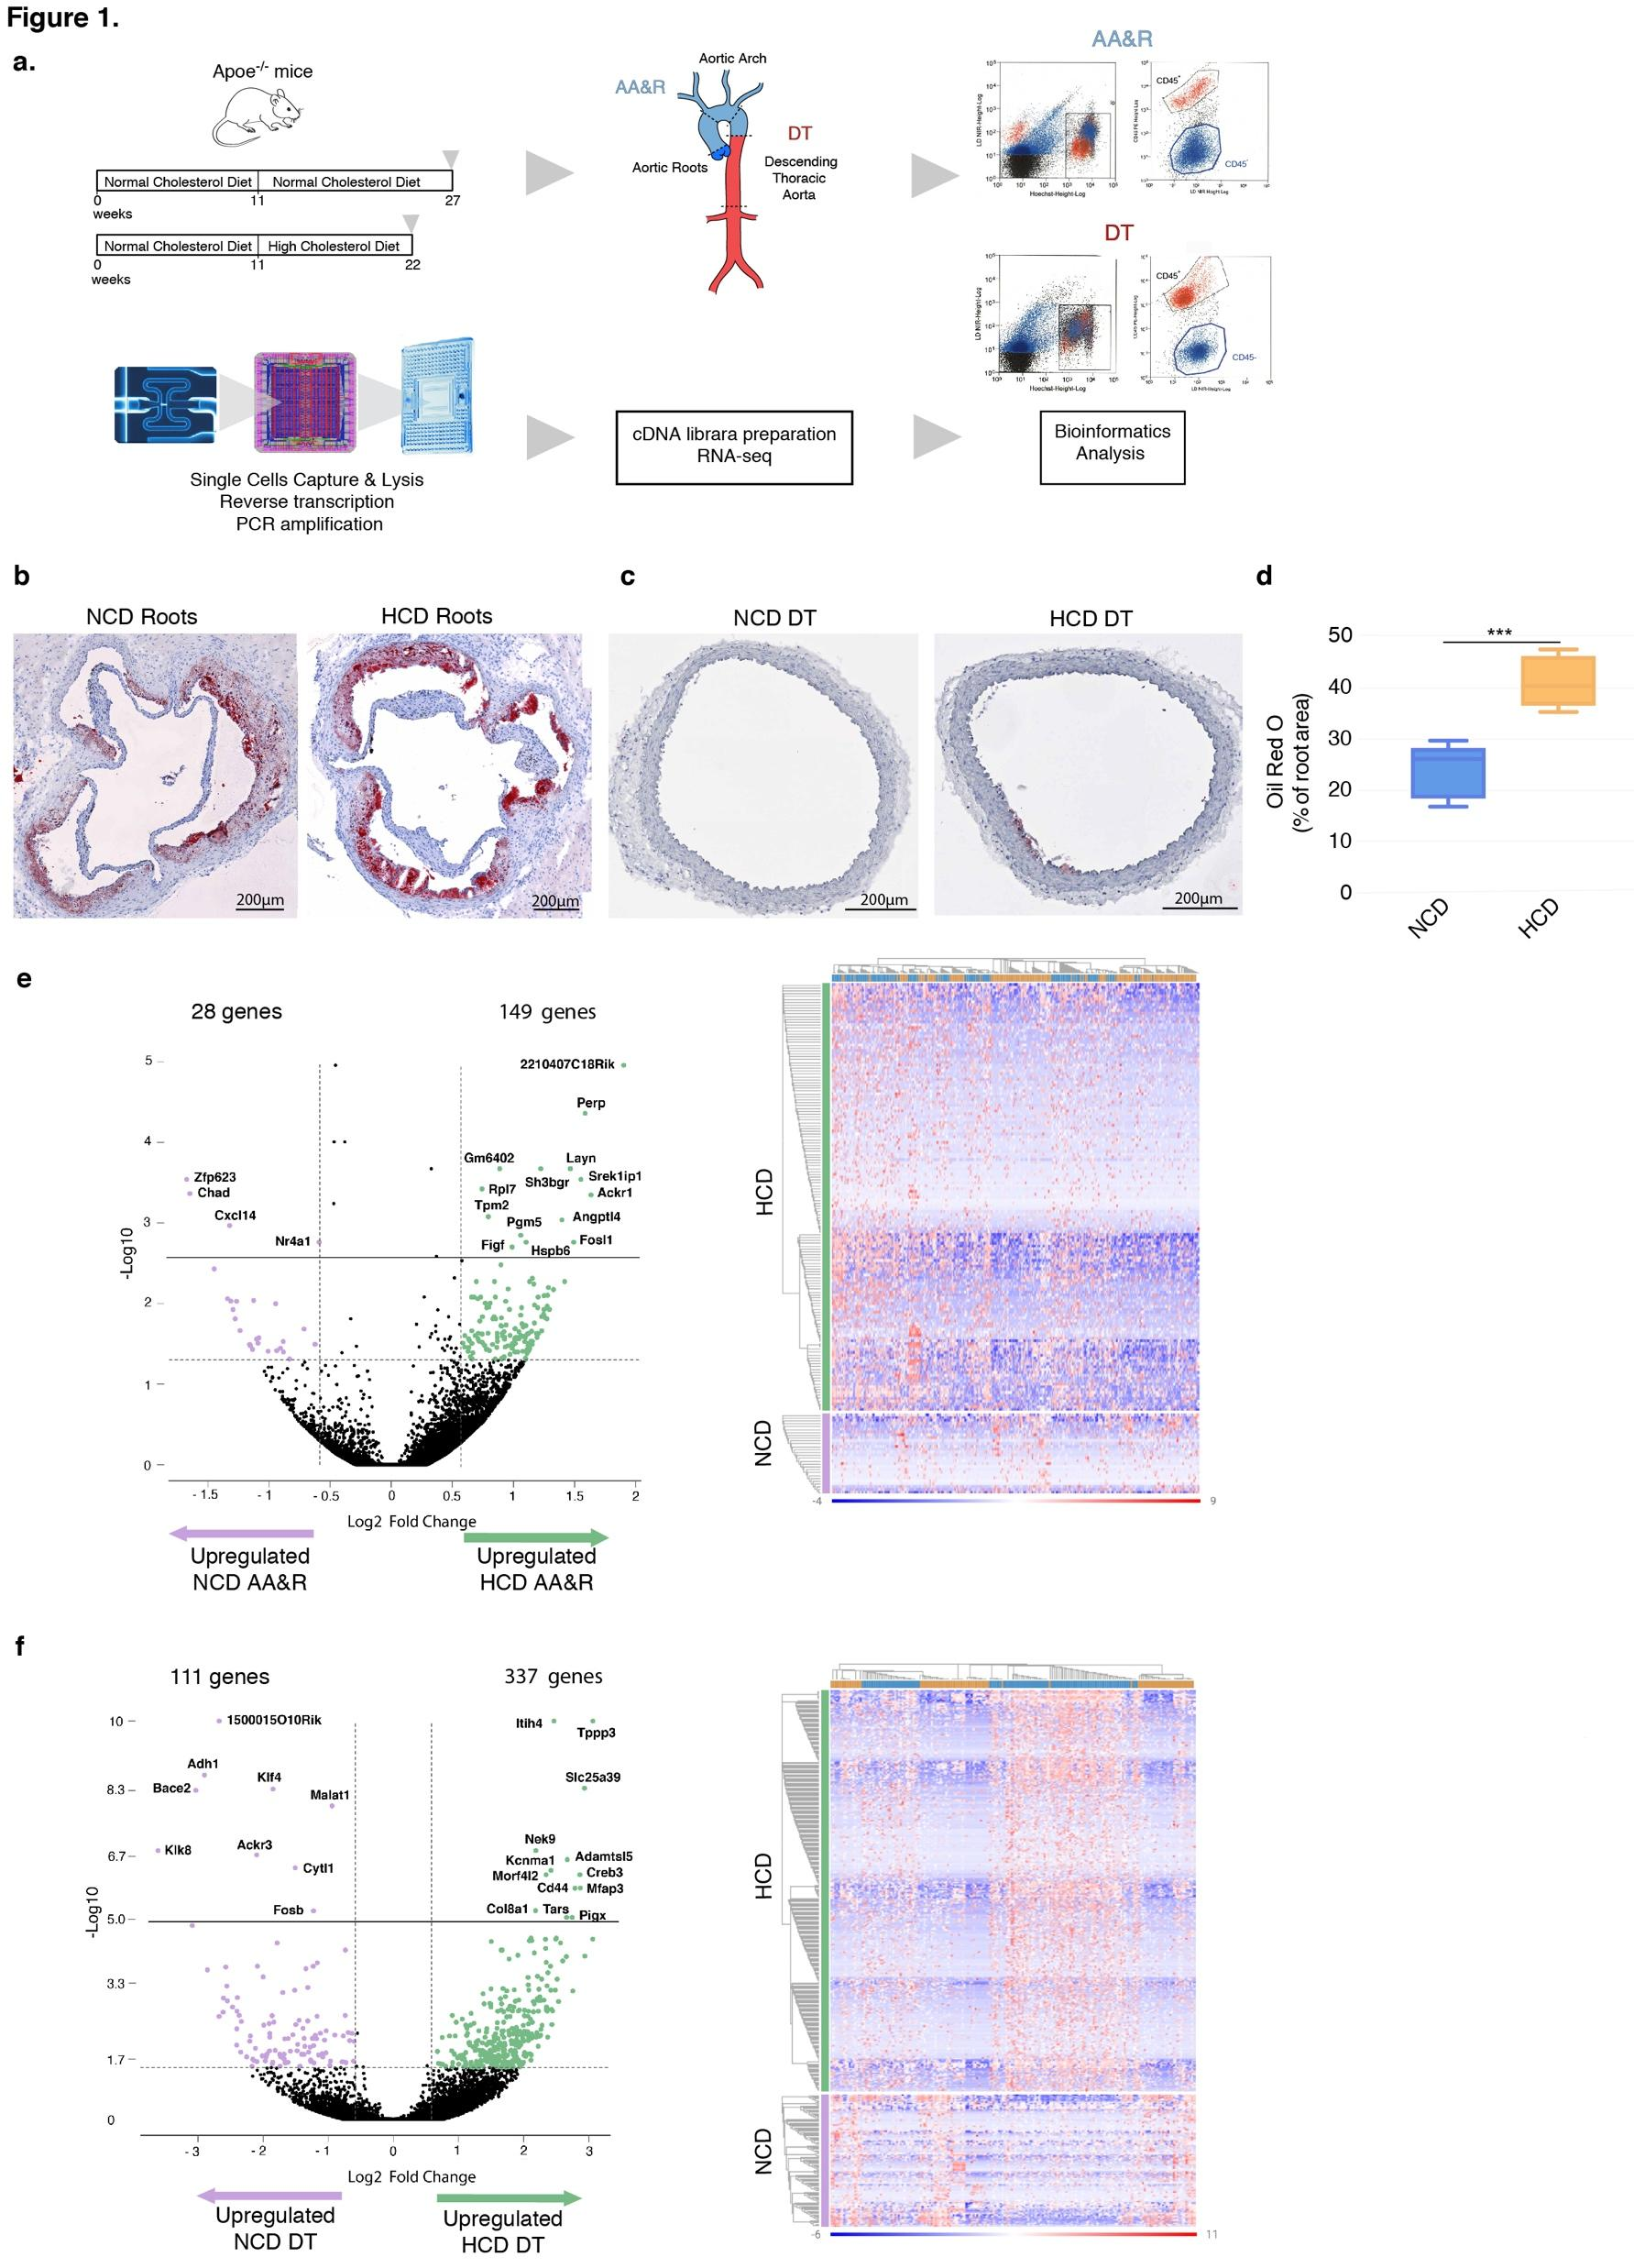

**Text:**

Using single-cell RNA sequencing (scRNAseq), we comprehensively characterized the transcriptomic profile of the phenotypically modulated Vascular smooth muscle cells as well as immune cell populations in atherosclerosis-prone or atherosclerosis-resistant parts of the aorta during atherosclerosis progression.

**Title 4 :**  
Genomic analyses of all known putative familial hypercholesterolemia mutations showcase the value and limitations of public familial hypercholesterolemia mutation databases

**By:**

Pr Ehret, K. Dobretz

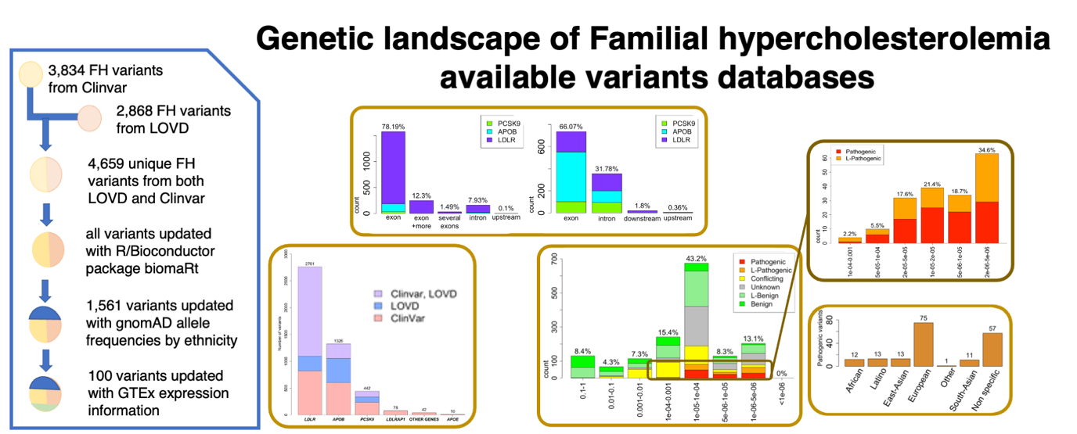

**Text :**

Familial hypercholesterolemia (FH) is one of the most frequent monogenic disorders.

Most cases of FH are due to a mutation in either the *LDLR* gene coding for the LDL receptor or the genes coding for proteins interacting with it, such as *APOB* and *PCSK9*.

We aimed to evaluate all currently known publicly available putative FH variants from the LOVD and ClinVar databases that are frequently considered clinically, using genetic tools and novel genomic datasets:

**Published as abstract to the annual conference of the European Society of Cardiology in 2020**

**Title 5 :**  
Facilitated FH genotyping using a polygenic lipid score.

**By**

Pr Ehret, K. Dobretz

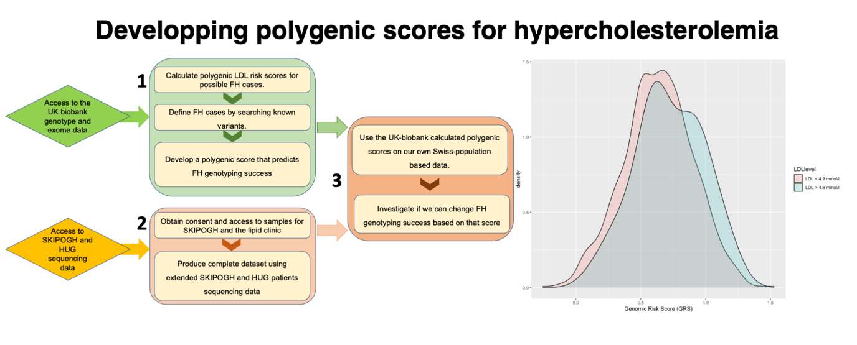

**Text :**

We aim at increasing the yield of sequencing for FH cases by “filtering” using a polygenic LDL score. We wish to evaluate if the knowledge of a polygenic LDL score (computed from data from the UK biobank) would permit cost-effective prioritization of individuals to sequence.

Project supported with fundings from the Swiss Foundation of Cardiology (2021).

1. : ?

**E3. Publications**



[Publications-2020_v2.3.docx](https://docs.google.com/document/d/1HV2hwW4vgkfFErcX5swr3g0Ap6xF4sUZ/edit?usp=sharing&ouid=102198289177715758089&rtpof=true&sd=true)

**E4. Researchers directory**



Heart transplant → “Annuaire des chercheurs”



* + The word of mouth → “Clinical research”



USE THIS FORMAT: IF NO PICTURE OF THE DOCTOR, THEN PUT GEcor LOGO

Anne BEVAND

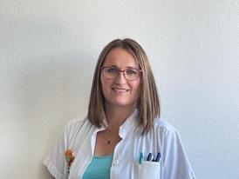

Nurse

Cardiology Division

Laetitia GALLEGO

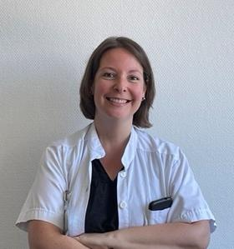

Clinical studies coordinator

Interventional cardiology unit

Cardiology Division

Romane GOTTELAND

Clinical research nurse

Acute heart failure unit

Cardiology Division

Fanny BRAND

Nurse for Congenital cardiopathies

Cardiology Division

LinkedIn: http://linkedin.com/in/fanny-brand-1885471b8

Amandine SABOUREAU

Research assistant

Structural cardiology unit

Cardiology Division

Carinne CALAMARI

medical assistant, research assistant

Cardiology Division

Sandra HANDGRAAF PhD

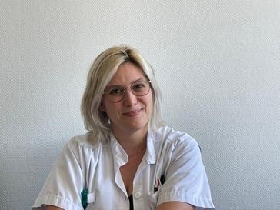

scientific collaborator

Cardiology Division

Kevin DOBRETZ

Research assistant

Preventive Cardiology unit

Cardiology Division

<https://www.linkedin.com/in/kevin-dobretz-9a306430>

Sandrine BRADER

Research nurse

Cardiology Division

Élise GUILLERMET

Nurse

Cardiology Division

Sylvianne BOTTONE

Research nurse

Cardiology Division

Philippe SIGAUD

Nurse - Projects manager

Cardiology Division

Maëlle ACHARD

Research nurse

Cardiology Division

Céline ARTIGUE

Clinical research nurse

Acute heart failure unit

Cardiology Division

Armelle DELORT

Clinical research nurse

Acute heart failure unit

Cardiology Division

**Contact us**

1. Quel persona : Tous
2. Quel CTA : Contactez-nous
3. Text : Voir sous modèle
4. Visuel :
5. Exemple : <https://www.hug.ch/pour-contacter-le-centre-cardiovasculaire>
6. formulaire de contact général?

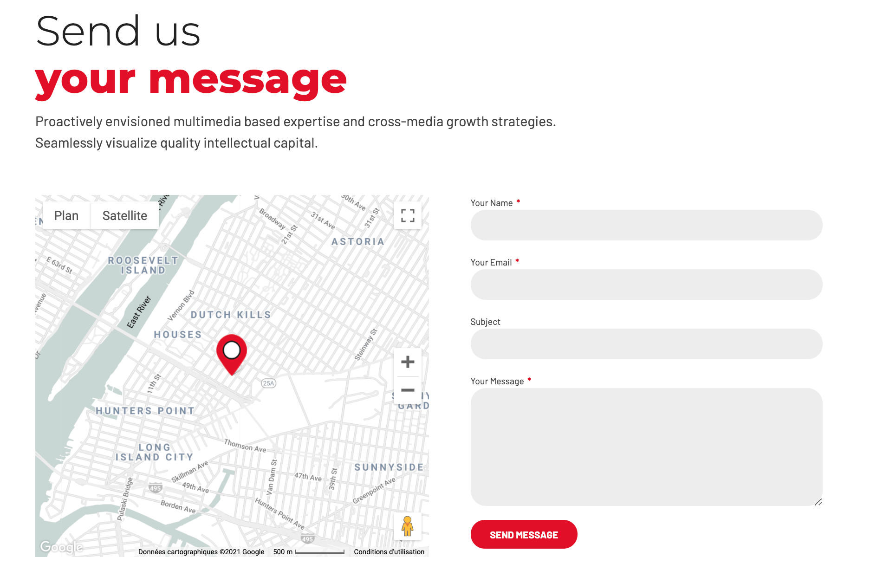

1. Send message → Choose your unit (optional)

# Votre consultation

1. Quel persona : Marcel, Otto, Anna, Peter
2. Quel CTA : Book your consultation
3. Text : Voir sous modèle
4. Visuel : ?
5. Book with your doctor: “Book a consultation” (choice form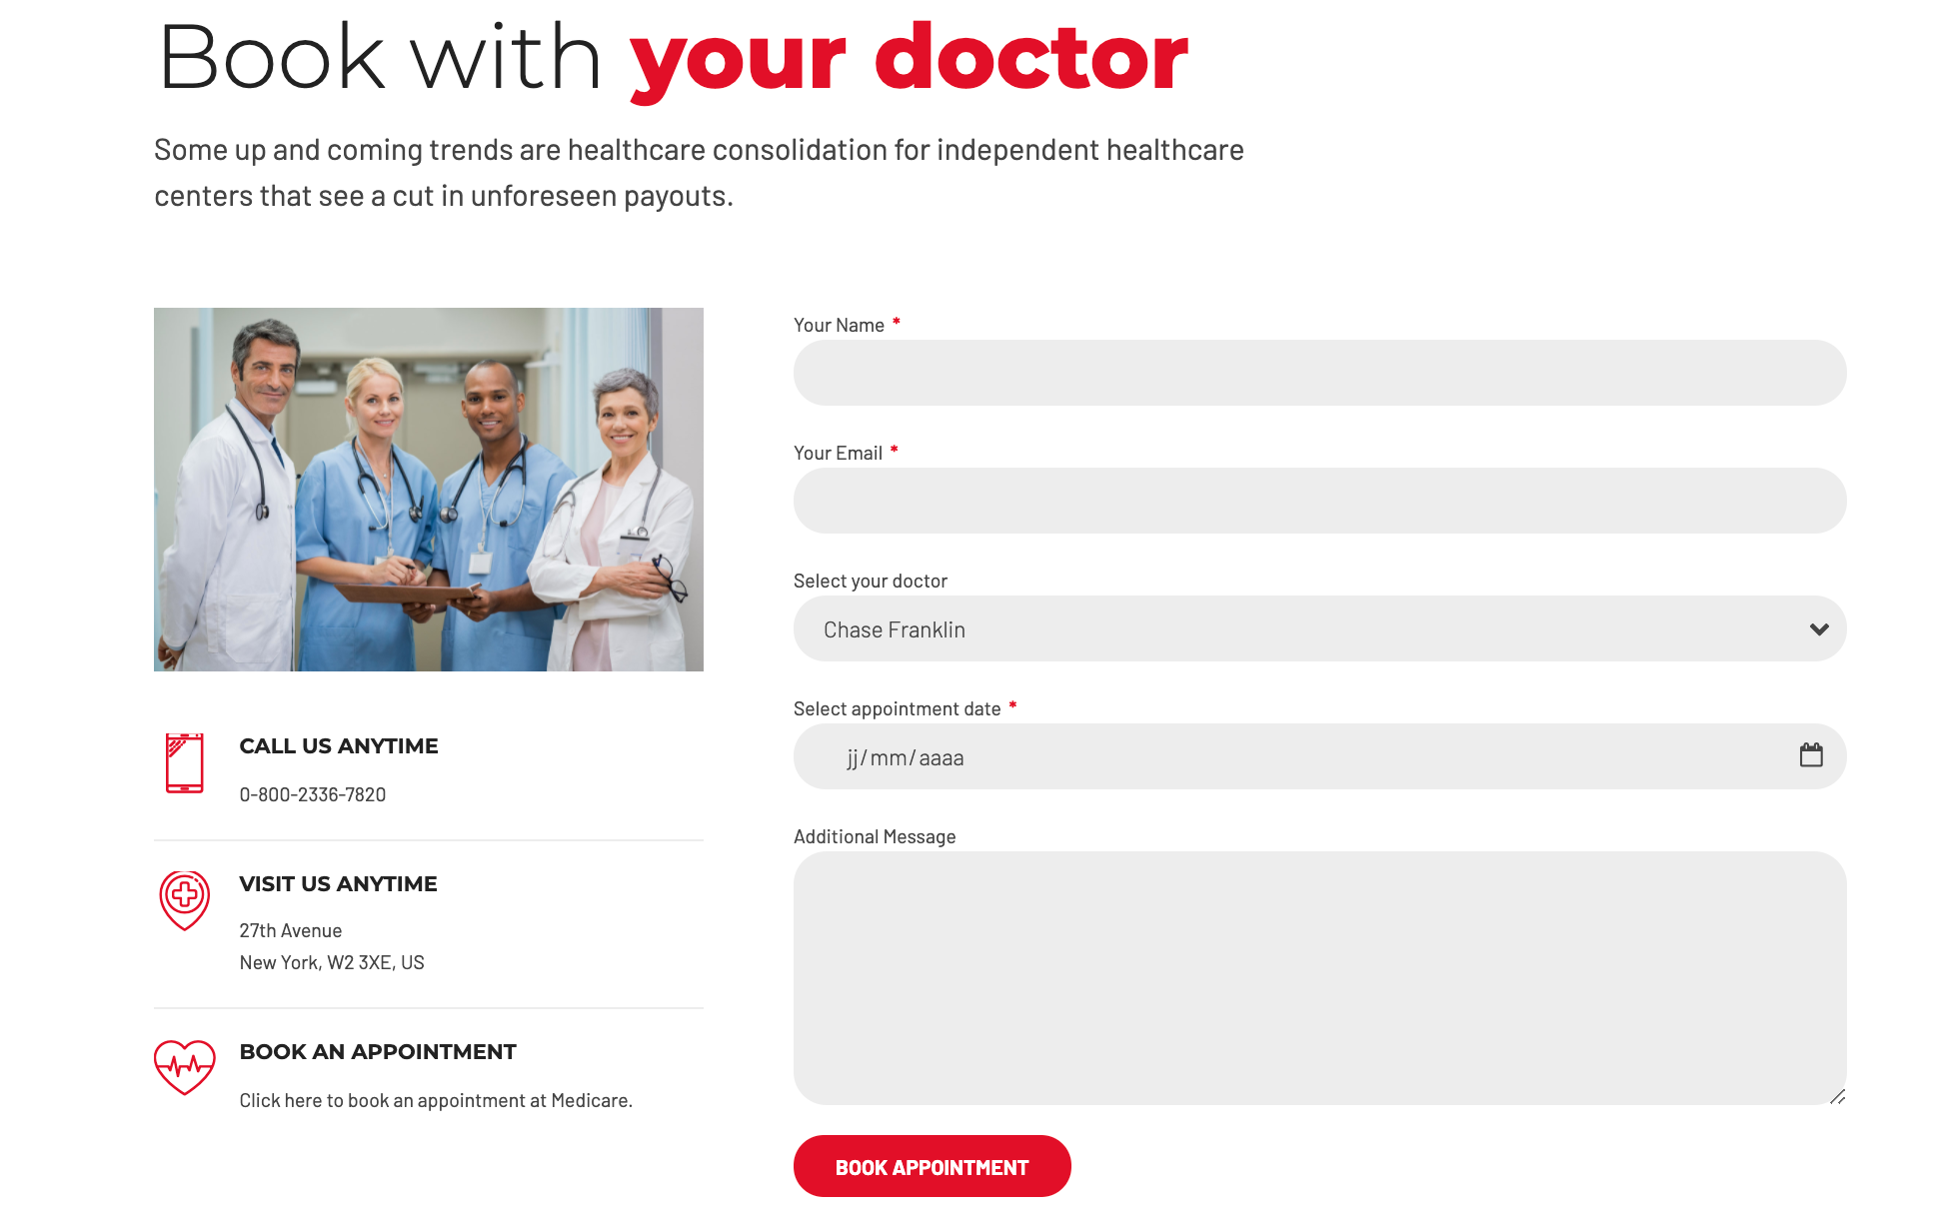



**Services d’urgence**

1. Quel persona : Marcel, Otto, Anna, Peter
2. Quel CTA : Emergencies

Redirection : <https://www.hug.ch/acces-direct-aux-services-urgences-hug>

**Appeler le 144 (composition du numéro automatiquement)**

1. Quel persona : Marcel, Otto, Anna, Peter
2. Quel CTA : Emergencies

Redirection : Phone number

**Faire un don**

1. Quel persona : Tous
2. Quel CTA : Donate
3. Text : Redirection à la page “Donations and support”
4. Visuel : Redirection à la page “Donations and support”

………………………………………… ………… …………………………

Client Signature Date

………………………………………… ………… …………………………

DM Consultant Signature Date

# 

# WSI Digital Marketing System - Support Services

WSI will provide the following services upon completion and launch of the Internet Business Solution:

• Training to use Wordpress

• Develop content plan for Social Media and quarter review

# WSI Project Updates and Communications

| Project Management | |
| --- | --- |
| WSI Consultant / Project Coordinator Name: | Gabor Markus |
| Client to receive development updates: | Conference Call [X] Email [X]  Face to Face meeting [ ] |
| Frequency of updates: | Weekly [ ] Biweekly [ X ]  Monthly [ X ] |
| Estimated Launch Date: | After 6 weeks once all material has been received. |

# WSI & Client Deliverables

In order to ensure that the WSI Digital Marketing System is completed according to your specifications, we ask the following:

• Sign-offs on the deliverables provided by Gabor Markus & Elisa Chédel

• The username & password to domain name registrar to update DNS information

• Web Content to be written and delivered by Service de Cardiologie Hôpitaux Universitaires de Genève at agreed upon dates

• High quality image files of logos and other images and graphics unique to Service de Cardiologie Hôpitaux Universitaires de Genève.

# Project Timeline

Instructions: Use the grid below or insert a visual ( e.g. Gantt Chart) from your/supplier project management tool.

| TASK | START DATE | DUE DATE | DATE COMPLETED |
| --- | --- | --- | --- |
| WSI Delivers Concept Draft | 03.03.2021 | 19.04.21 |  |
| Service de Cardiologie Hôpitaux Universitaires de Genève signs off on Concept | 24.03.2021 | 27.04.21 |  |
| Service de Cardiologie Hôpitaux Universitaires de Genève completes Content | 03.03.21 | ? |  |
| WSI Optimizes Pre-Determined Web Pages | +21 jours | ? |  |
| Service de Cardiologie Hôpitaux Universitaires de Genève signs off on Design and Layout | +7 jours | ? |  |
| WSI Delivers Development Draft | +21 jours | ? |  |
| Service de Cardiologie Hôpitaux Universitaires de Genève tests & Signs off on Development Draft | +7 jours | ? |  |
| WSI Launches Web Solution | +7 jours | ? |  |
| WSI Launches Paid Search Marketing Campaign | N/A | N/A |  |
| WSI Starts Social Media coaching | Une fois que le site est en ligne |  |  |

*This is an estimated timeframe for the tasks included in the project, however, any delays In the assigned tasks will lead to a delayed launch date.

< INSERT CURRENT DATE >

Subject: Approval of Statement of Work

Project: Service de Cardiologie Hôpitaux Universitaires de Genève Project Implementation Plan

I, the undersigned, an approved signing authority for Service de Cardiologie Hôpitaux Universitaires de Genève confirm that Service de Cardiologie Hôpitaux Universitaires de Genève accepts, without any further changes, all information included in the Statement of Work for project implementation.

………………………………………… ………… …………………………

Client Printed Name Date

………………………………………… ………… …………………………

Client Signature Date

………………………………………… ………… …………………………

WSI Consultant Printed Name Date

……………………………………… ………… …………………………

WSI Consultant Signature Date